L.I. – To answer the questions using the reading comprehension.

Today I would like you to have a go at the reading comprehensions. Reading is an important skill for us to develop and get better at. I would like you to think about these skills when you are reading.
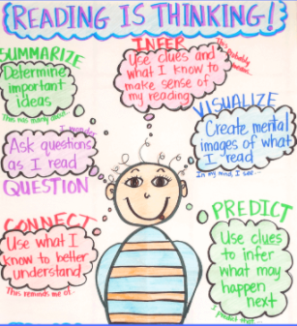

There are different activities for the children to have a go at today. I would like ALL CHILDREN to have a go at the activity below. This activity is a MUST.

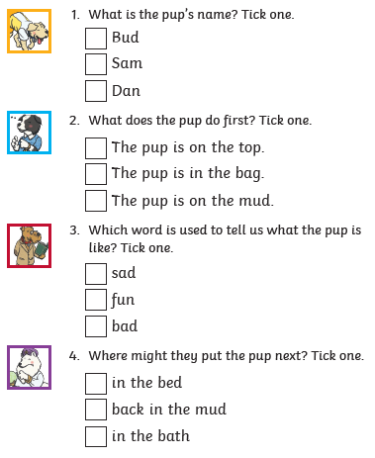
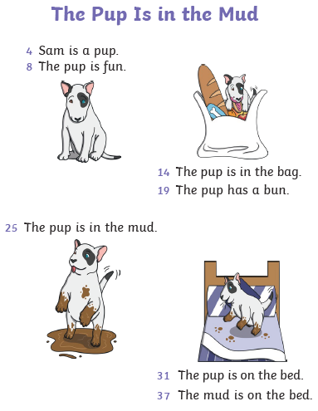
Read the text below and then answer the questions after it. Remember sound out and words you get stuck with. If you need help – ask someone at home.

Well done for having a go at those questions. Now this activity the children COULD do. Remember to sound out any words you get stuck on and if you are still struggling ask someone who is at home with you.
The work is going to be on a separate document. Read page 1 carefully and then answer the questions on page 2. Below is a small picture of what page 1 and page 2 will look like.
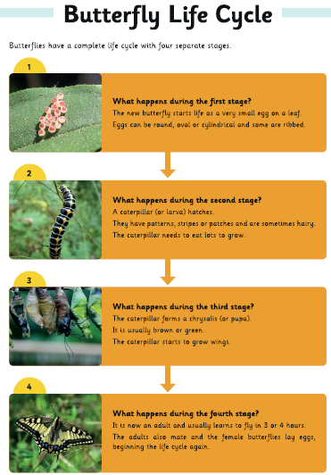
Read this page and have it next to you when you answer the questions on the next page.

Now have a look at the questions on the next page and see if you can answer them. Remember all of the answers will be on the first page so read the question carefully and then look at the page with the information on.
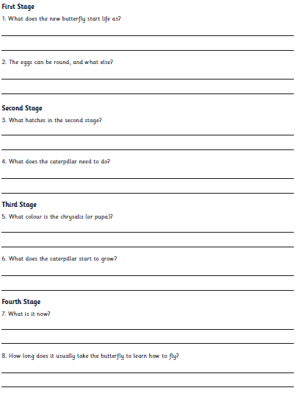
Remember the questions are on a full sheet so make sure you get someone at home to print it off.

Well done for having a go at these questions year 2s. You have worked extremely hard so far this week. One more day to go and then the weekend!! Keep it up!!

