Good morning year 2s. I hope you have had a good weekend and are ready for your English lesson. Hopefully you have managed to complete your Maths lesson and your phonics lesson.
L.I. – To complete a story map about the rainbow fish

We have all been learning about The Rainbow Fish in Year 2 and we are back in school tomorrow. For the last lesson I would like you to listen and watch the video which tells the story and then complete the activity by putting the pictures in the correct order.
https://www.youtube.com/watch?v=Z3cmddZh6t8

Now you have watched the video think about each of the pictures and see if you can cut them out and put them in order on a new piece of paper. (If you don’t have any scissors then just put numbers next to each picture so they are in the correct order).
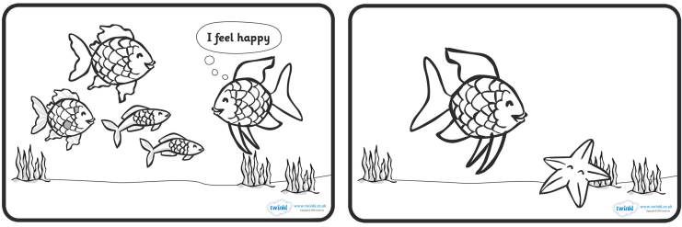
You can also colour in the pictures!! ALL CHILDREN MUST DO THIS.
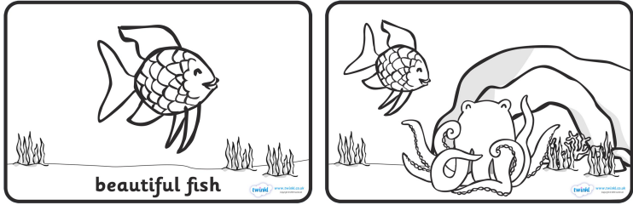
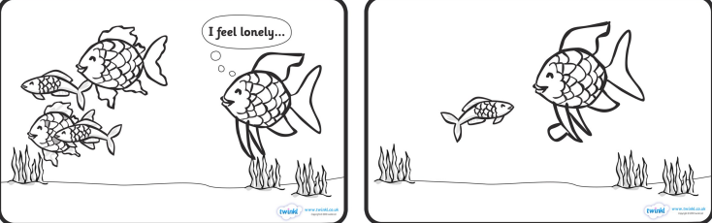

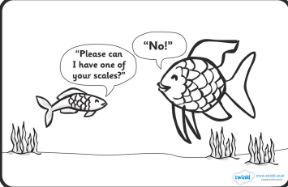

Children COULD do this activity.
I would like the children to have a go at writing a sentence below each picture to explain what they think is happening at that point in the story. Remember to include capital letters, finger spaces, full stops and neat handwriting.
Well done for working so hard Year 2s. All the teachers are looking forward to seeing you tomorrow!!!

