Good morning year 2s. Hopefully you have managed to have a go at your Maths lesson this morning and done your daily phonics. You are working incredibly hard and all the teachers are very proud of you. This is your English activity for the day.
L.I. – To Answer questions about a picture in a DIAL format.

First of all we need to go through what a DIAL activity is so that we understand what each letter means.
DIAL stands for 4 words.
D – Deduction. You are a detective, try to work out the answer
I – Inference. What have you learned? What can you tell me?
A – Authorial Intent – what is the author trying to tell you?
L – Literal. An easy one! – look for key words in the text and look at the pictures.
Using these tips can you answer these DIAL questions below?
All children should answer these DIAL questions.
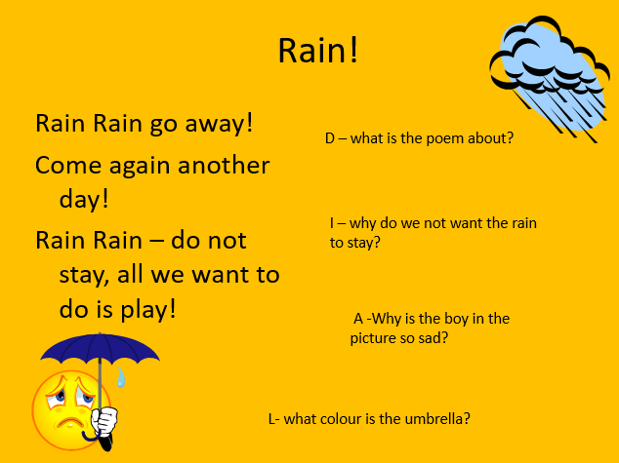

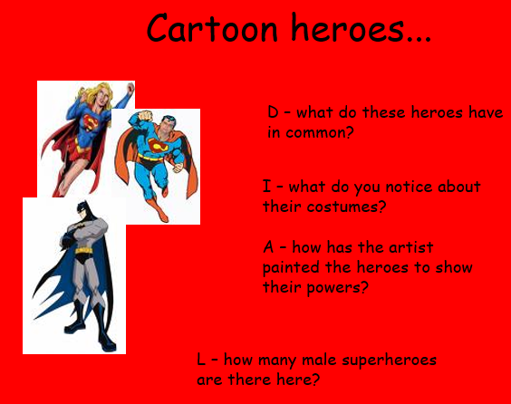
The children COULD answer these DIAL questions.

Well done for working hard again Year 2s. You are doing such a fantastic job working at home. Keep up the amazing work and know that all the teachers are very proud of you.

