Good morning year 2s. Hopefully you have managed to have a go at your Maths lesson this morning and done your daily phonics. This is your English activity for the day.

L.I. – To follow an example set of instructions and then write your own.
We read instructions almost every day. Instructions are there to tell us what to do. We give you instructions in school all the time. For example sit down, show 5 and listen carefully. Below is an example set of instructions. Read them and I would like you to think about the word at the start of each instruction. This is called an imperative verb (a BOSSY verb). This tells the person reading the instructions what to do.

How to make a smoothie.
You will need the following things:
- Knife
- Chopping board
- Blender or mixer
- 1 banana
- 5 strawberries
- Milk
- A cup or glass

- Peel the banana and chop it up.
- Slice the top off the strawberry.
- Cut the strawberry in half.
- Put the strawberries and banana into the blender.
- Twist the lid off the milk.
- Pour the milk into the blender.
- Twist the lid on the blender tightly.
- Turn the blender on.
- Pour the smoothie into the cup.
Now you have read the instruction I want you to think about the word at the start of each instruction. This is the imperative verb. This tells you what to do. You have to make sure each instruction you write has this at the start of the sentence.
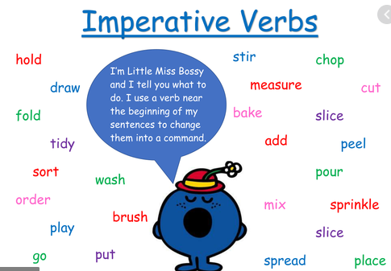
Here are some examples of bossy verbs.

Now you have read my example – have a go at writing a set of instructions. Below are some ideas as to what you could write about that would be fun at home.
- Making a sandwich or a toastie
- Making a smoothie or interesting drink
- How to bake a cake
- How to brush your teeth
- How to cook tea with your mum or dad
- How to get to school
Any other ideas you can think of then have a go!!
Write your instructions and then use them to make or do whatever it is you have written about. I would love to see your ideas so if you can put them on Twitter for all the teachers to see.

Well done on working hard Year 2s. Keep it up!!!

