L.I – Using the make ten strategy.

Today we are going to be using the make ten strategy to help us with our addition questions. Firstly the link below will take you to a short video that will explain in more detail what we are learning about.
https://classroom.thenational.academy/lessons/using-the-make-ten-strategy-6dj62d?activity=video&step=2
If you have any issues accessing the link don’t worry. I will explain as we go along what the make ten strategy means.
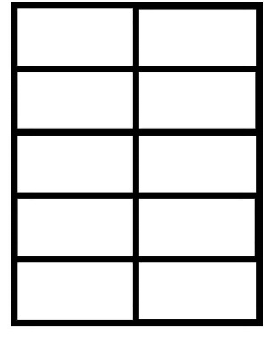
Below is a make ten grid. We are going to use this to help us add two digits together.

Example question 8 + 5 =
When adding 8 and 5 together we could start at 8 and count on. Today we are going to use the make ten grid and objects or pictures to add the two numbers together.
Step 1 - Start with make ten grid, 8 shapes and 5 different shapes.

Step 2 – Put the 8 shapes into the make ten grid.

Step 3 – Add the yellow circles into the make ten grid until you have made ten.

Step 4 – Add the remaining yellow circles to the ten and you will have your answer. Therefore 8 + 5 = 13.

Which tens frame matches this equation? Say the answer out loud. A or B.
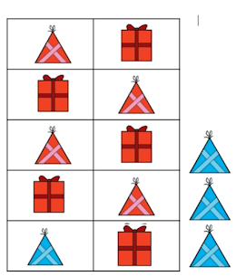
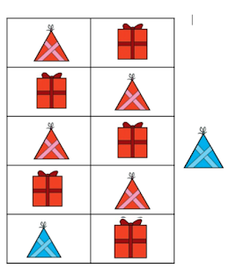
9 + 4 =
A B

Which equation matches this tens frame?
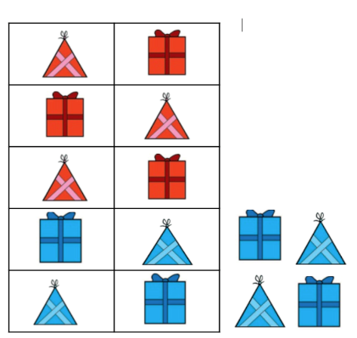
Is it 6 + 9 = or is it 6 + 8 =
Now you have had a go at these questions can you use a blank ten grid to work out these questions. There is a blank ten grid at the bottom of this page. If you don’t have any counters or objects then you can draw your own pictures for each question.
The questions have been split up into 3 sections. There is a MUST (all children must do it), a SHOULD (all children should have a go) and COULD (have a go if you think you can).
MUST – RED
SHOULD – GREEN
COULD - BLACK
Question 1 – 4 + 8 =
Question 2 – 7 + 4 =
Question 3 – 9 + 5 =
Question 4 – 6 + 7 =
Question 5 – 3 + 9 =
Question 6 – 5 + 8 =
Question 7 – 8 + 9 =
Question 8 – 7 + 8 =
Question 9 – 5 + 9 =
Question 10 – 4 + 9 =

Hopefully you have managed to get these questions right – ask an adult to check your answers and Well done for working hard!

