L.I – Choosing calculation strategies to solve calculations.

Like with the lesson yesterday here is a short video explaining in more detail what the lesson is about today. Please watch this to give you a good idea of what we are learning about.
https://classroom.thenational.academy/lessons/choosing-calculation-strategies-to-solve-calculations-cgu3jd?activity=video&step=2

If the adult could ask the question and the children try and think which strategy would be best.
What strategy would you use for 7 + 8 =?
I think choosing the near doubles strategy would be best.
7 doubled = 14 and 14 + 1 = 15

What about 12 + 6 =
Hopefully the child will either use the number bond 2 + 6 = 8 and then work out 12 + 6 = 18 or count on from 12.

Circle the strategy which has solved this equation correctly.
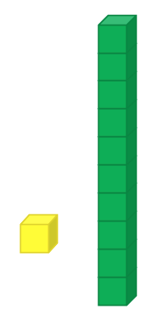
4 + 5 =
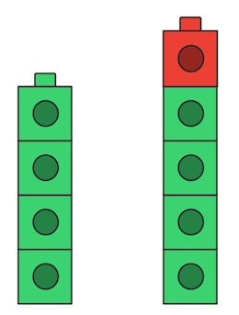

Circle which tens frame is correct for this equation?
9 + 6 =
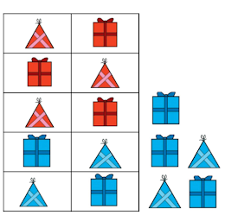
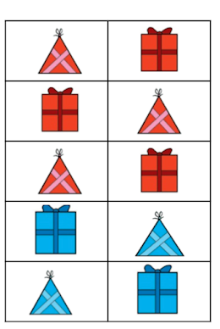

Can you solve these questions using the strategy you think is most suitable? Today I would like these questions to be for a MUST FOR ALL children.
Top Tip – pick from these strategies.
- Make ten, Near doubles or known number bonds

- 9 + 6 =
- 7 + 8 =
- 5 + 8 =
- 4 + 15 =
- 7 + 9 =

