L.I – To use part, whole models to help you find the missing number in different equations.
Firstly here is a link of today’s lesson that will help you. If possible it would be great if you could access it.
https://classroom.thenational.academy/lessons/using-number-bonds-when-subtracting-c9h3jd?activity=video&step=1

For today’s lesson I would like the children to work on understanding the numbers up to 20. They must start understanding how 3 numbers are part of a family that create 4 equations as shown in the example below.
3, 17, 20
3 + 17 = 20
17 + 3 = 20
20 – 3 = 17
20 – 17 = 3
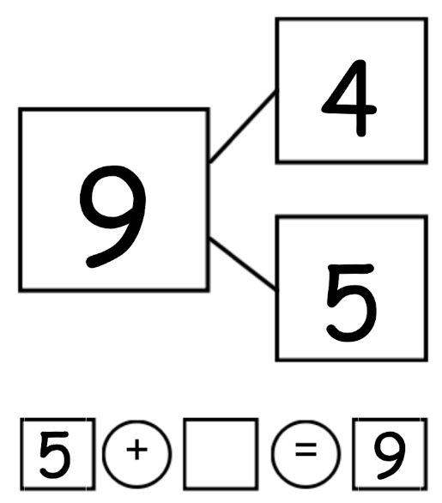
Use this part, whole model to help you find the missing number in the addition equation.

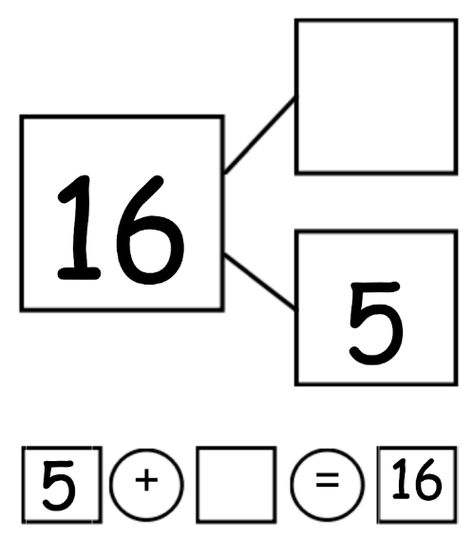
What is the missing number in this part, whole model and equation?

What is the missing number?
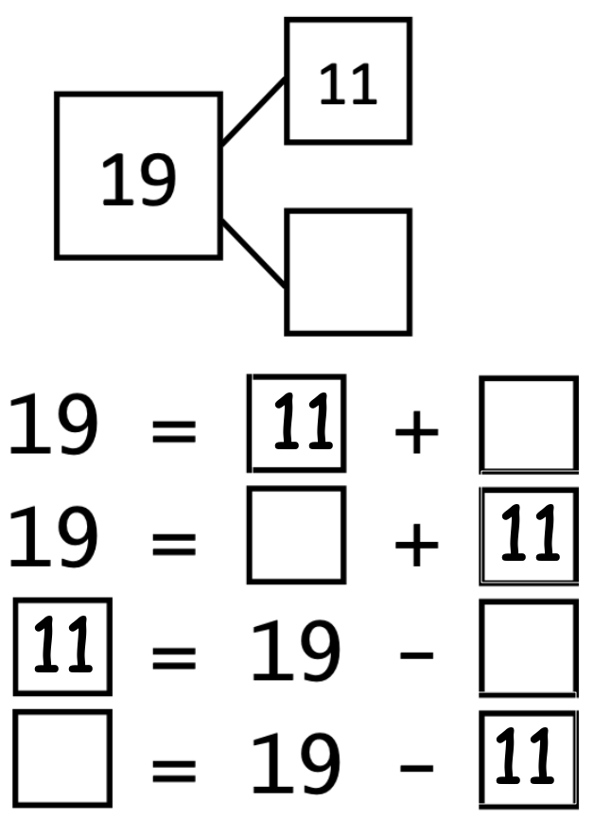
Remember the equals symbol can go either at the start of the equation or the end. You must make sure you have the same on both sides.

Using the model above can you make 4 equations using the numbers below.
The questions have been split up into 3 sections. There is a MUST (all children must do it), a SHOULD (all children should have a go) and COULD (have a go if you think you can).
MUST – RED
SHOULD – GREEN
COULD - BLACK

Question 1 – Use the numbers 4, 6 and 10
Question 2 – Use the numbers 7, 3 and 10
Question 3 – Use the numbers 8, 2 and 10
Question 4 – Use the numbers 5, 15 and 20
Question 5 – Use the numbers 9, 11 and 20
Question 6 – Use the numbers 8, 12 and 20
Question 7 – Use the numbers 14, 6 and 20
Question 8 – Use the numbers 2, 12 and 14
Question 9 – Use the numbers 3, 13 and 16
Question 10 – Use the numbers 7, 8 and 15

Hopefully you have managed to get these questions right – ask an adult to check your answers and Well done for working hard!

