L.I – Understanding that the = symbol represents equivalence.

Like with the lesson yesterday here is a short video explaining in more detail what the lesson is about today. Please watch this to give you a good idea of what we are learning about.
https://classroom.thenational.academy/lessons/understanding-that-the-symbol-represents-equivalence-6tgk4c?activity=video&step=2
Now you have watched the video here are some questions I would like you to have a go at. Remember the = symbol just means you must have the same on both sides.
2 + 7 = 5 + ?
4 + 6 = 2 + ?
3 + 4 = 6 + ?
Which equations match the part, whole models.
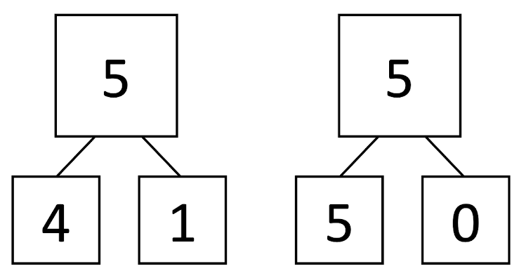
4 + 1 = 5 + 0 or 4 + 2 = 4 + 1
Ask an adult to check your answer.

What could the missing numbers be?

See how many different answers you can think of.

Using the examples above can you answer the following questions.
The questions have been split up into 3 sections. There is a MUST (all children must do it), a SHOULD (all children should have a go) and COULD (have a go if you think you can).
MUST – RED
SHOULD – GREEN
COULD – BLACK
Question 1 – 4 + 2 =3 + ?
Question 2 – 5 + 5 = 3 + ?
Question 3 – 3 + 6 = 5 + ?
Question 4 – 5 + 8 = 2 + ?
Question 5 – 9 + 4 = 7 + ?
Question 6 – 8 + 7 = 3 + ?
Question 7 – 6 + 5 = 10 + ?
Question 8 – 11 + 12 = 10 + ?
Question 9 – 18 + 5 = 14 + ?
Question 10 – 24 + 6 = 22 + ?
Hopefully you have managed to get these questions right – ask an adult to check your answers and Well done for working hard!

