L.I – Grouping and counting in tens

Like with the lesson yesterday here is a short video explaining in more detail what the lesson is about today. Please watch this to give you a good idea of what we are learning about.
https://classroom.thenational.academy/lessons/grouping-and-counting-in-tens-60t3ee?activity=video&step=2

Starter activity
Fill in these number sequences.
13 | 14 | 15 |  | 17 |  | 19 |  |  | 22

32 | 33 | 34 | 35 |  |  | 38 | 39

The learning intention today is to be able to recognise groups of ten and be able to count in tens. Before you do anything else count out loud in tens using these sequences.
33, 43, 53, 63, 73, 83
26, 36, 46, 56, 66, 76
If you have internet access see if you can follow this link to answer these starter questions. If not I will put some further questions below.
https://classroom.thenational.academy/lessons/grouping-and-counting-in-tens-60t3ee?activity=worksheet&step=3

Complete the sentence - there is ____ group of ten.
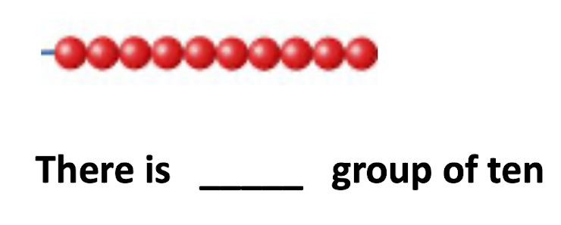
Complete the following:
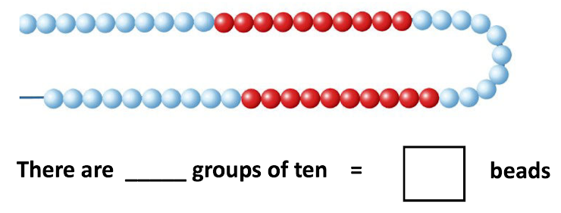
What is the missing number?
What is the missing number?
What is the missing number?

