L.I – Using doubles to calculate near doubles.
Maths starter activity
Pick a number from below, double it and then add 1. What number do you have?
2, 3, 4, 5, 6, 7, 8, 9
Ask someone to check if you got the right answer.
Like with the lesson yesterday here is a short video explaining in more detail what the lesson is about today. Please watch this to give you a good idea of what we are learning about.
https://classroom.thenational.academy/lessons/using-doubles-to-calculate-near-doubles-60rk6t?activity=video&step=2

Today I would like you to work on doubling numbers. If you have something at home like counters or counting bricks or any object you could use to represent the numbers that would be helpful. If not use the pictures for the questions below to answer the following:
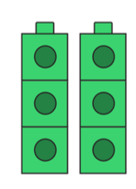
What is double 3?

Answer =

What is double 4?
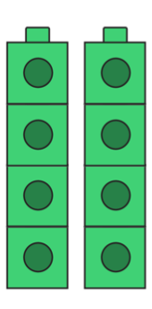

Answer =

If I know that double 4 is 8 then what is 4 plus 5?
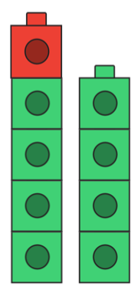

Answer =
Using the models above can you answer the following questions.
The questions have been split up into 3 sections. There is a MUST (all children must do it), a SHOULD (all children should have a go) and COULD (have a go if you think you can).
MUST – RED
SHOULD – GREEN
COULD - BLACK

Question 1 – What is 4 + 5 =
Question 2 – What is 3 + 4 =
Question 3 – What is 5 + 6 =
Question 4 – What is 2 + 3 =
Question 5 – What is 6 + 7 =
Question 6 – What is 8 + 9 =
Question 7 – What is 6 + 7 =
Question 8 – What is 11 + 12 =
Question 9 – What is 14 + 15 =
Question 10 – What is 12 + 13 =

Hopefully you have managed to get these questions right – ask an adult to check your answers and Well done for working hard!

