13.10.20
L.I – To identify every day 2D shapes
Good morning Year 3s!
Today you’re going to go on a 2D shape hunt! See if you can spot some or all of these shapes around your home and garden.
Draw or take pictures of any 2D shapes that you find.
Use the 2D shape mat to remind you of what these shapes look like and which ones you’re looking out for.
HAVE FUN!
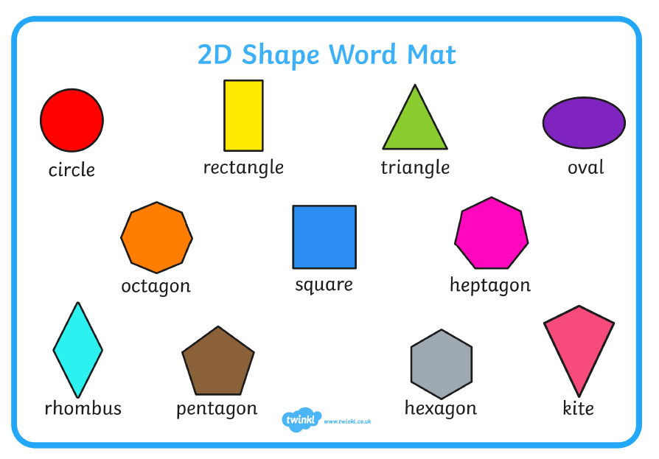

Are there any shapes you could NOT find around your home or garden?
Why do you think this is?

