6.10.20
L.I – To read and write 3 digit numbers
Firstly, tell me what this number is and what it can be partitioned into – 156
(You could draw how many hundreds, tens and ones it is made up of)
Try this again with the number 378 and write or draw what this number can be partitioned into.
Here are some dienes that have been partitioned into a place value grid.
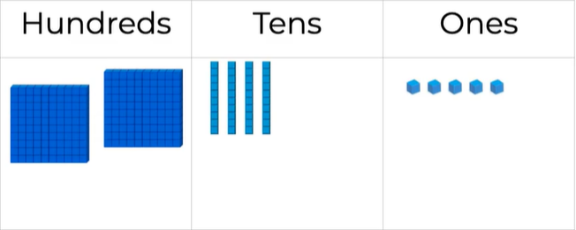
Can you tell me what this number is?

Task 1 –
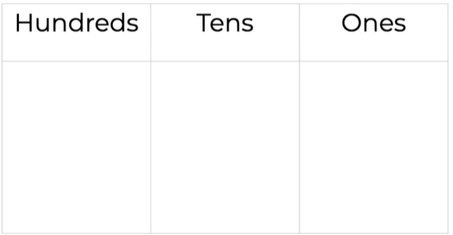
Here is a place value grid. Your task is to partition the number on the left and draw the dienes into each column to represent the number.

- 527

- 841

- 763

6.10.20
Task 2 –
I’m thinking of a 3 digit number.
It has 6 hundreds, 4 tens and the ones are odd.
Which numbers could it be?

Well done for trying so hard with this work today! Please get an adult to check your answers if you can.

