6.10.20 Year 3 PSHE
L.I – To know that rules are there to keep us safe
Hi Year 3s
Last week in school we looked at rules in school to keep us safe
Some ideas we chose were
Walk
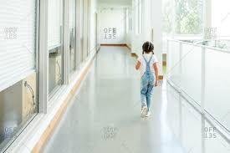
Use kind words
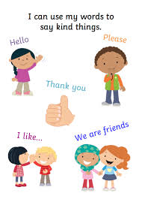
Put your hand up if you want to say something in class
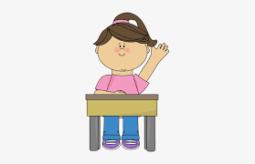

Task -
Can you think of any rules you have when you are with your family at home or while you're outside?
Can you make a poster of what you do to be safe?

Have fun!

