Good afternoon Year 2s. Hopefully you have had a good morning working on your Maths and English work. This is your last lesson of the day so keep up the amazing work and then time to have a rest.
L.I – To create a healthy meal plan for a week.

Last science lesson we talked all about different foods that you eat. We discussed which foods are healthy and which foods are unhealthy.
We know that fruit and vegetables are really healthy, we know that we should eat meat and fish regularly and we know that food like cake, chocolate and other sugary foods should be eaten only once a day.
The first challenge this afternoon is to organise these foods into healthy or unhealthy.
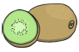
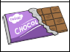
Unhealthy
Healthy

Well done for organising these foods into healthy and unhealthy. Now for your next challenge. I would like you to create your own food diary. Using the example below I would like you to over the next 7 days record what you eat. Try and make it as healthy as you can and remember only one unhealthy snack a day.
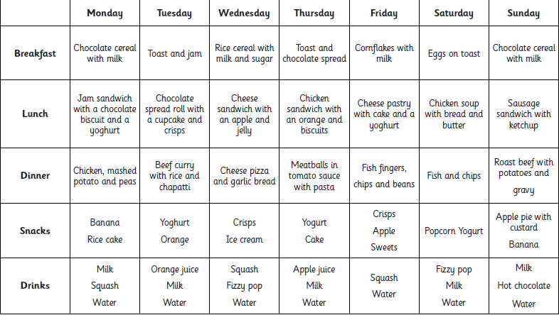
Use this grid below to complete your food diary and once you have finished the 7 days you can upload them to twitter for me to see.
 | Monday | Tuesday | Wednesday | Thursday | Friday | Saturday | Sunday
Breakfast

Lunch

Dinner

Snacks

Dinner

Well done for working hard Year 2s. Keep up the amazing work!

