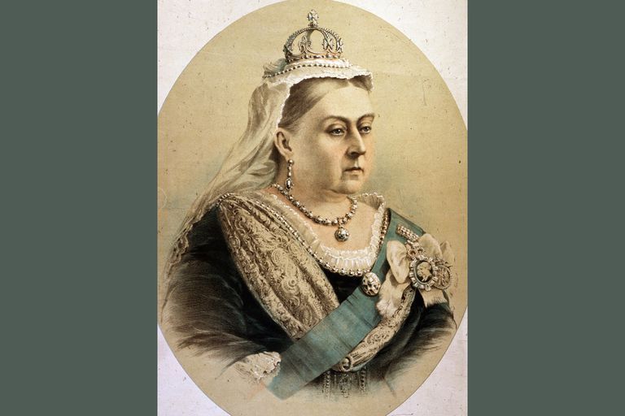
The Good Old Days
Year Two Spring Term 2025

Areas of Learning
As SCIENTISTS we will be looking at how different materials are used in everyday life.
AS DESIGNERS AND CREATORS we will design and make pop up cards and discuss their functions. We will use cutting and sticking skills to make our products in technology. We will also be exploring how to make Victorian style toys.
In PSHCE we will learning about the importance of hygiene, how to look after our teeth, keeping safe with medicines and the importance of exercise and keeping healthy.
AS HISTORIANS we are going to be learning about the life of Queen Victoria and events that happened during her reign. We will compare different Victorian toys to toys of today using rich and poor as a comparison.
As well as learning about Queen Victoria, we will learn about significant people and events outside of living memory.
AS ARTISTS we will look at the work of William Morris and explore patterns and printing techniques. As a group we will explore ideas, collect information and materials to develop our ideas.
As ATHLETES we will be learning how to take part in simple games and learning new skills, we will also be improving our basic gymnastic skills. In R.E. we will be learning about the Jewish faith and how important Easter is to Christians.
MATHEMATICS
We will be following the Year Two 2014 curriculum for Mathematics. The emphasis will be on: money, multiplication and division, length and height and mass, capacity and temperature. We will practise mental arithmetic every day.
As GEOGRAPHERS we will use simple compass directions and locational and directional language to describe the location of features and routes on a map.
In COMPUTING we will research a topic linked with ‘The Good Old Days’ topic and research a significant person from that era. We will also be learning the importance of keeping safe when using the internet.
AS MUSICIANS we will be learning about folk songs and create sounds to represent three contrasting landscapes; seaside, countryside and city.
COMMUNICATION: READING, WRITING, SPEAKING AND LISTENING
We will be following the 2014 curriculum for English. We will read a variety of books and talk about what we have read. We will develop our writing skills through our topic on The Good Old Days. We will develop our speaking and listening, reading and writing skills through Market place activities, quick on the draw, VIPERS activities and debates in PSHE.
OUR SCHOOL DRIVERS
Our school drivers help us learn how to learn. This term we are focussing on becoming Effective Participators and Creative Thinkers. To become an Effective Participator we will learn to respect other people, share ideas, be positively engaged and be an evaluator. To become a Creative Thinker we will ask relevant questions, take risks, solve problems and present our ideas and learning.
Helping your child
- Join the local library.
- Read books about life in the Victorian times.
- Research your family tree.
- Use the Internet to research how people lived in the past.
- Talk about famous people who lived in the past.
- Keep up the daily reading with your child.
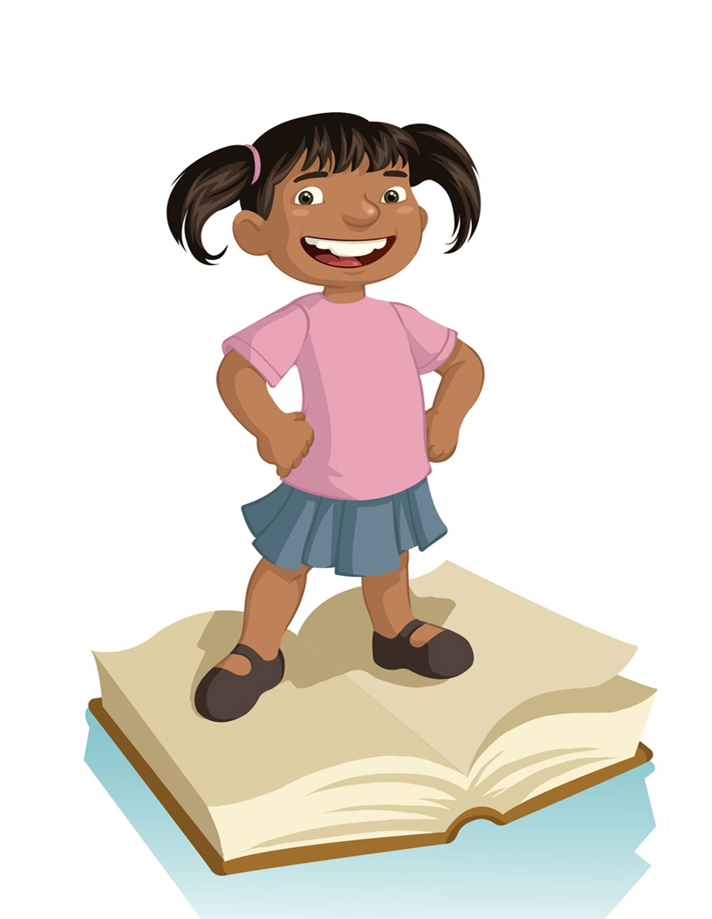
- Do some counting every day.
- Keep practising telling the time.
- Practise tying shoelaces.
- Help your child complete their learning log tasks.

Information

- P.E will be on Tuesday and Wednesday, please ensure that your child has a full P.E kit in school. If your child wears earrings, please provide tape.

- Label ALL items of clothing with your child’s name please.

