Scrumdiddlyumptious
Year Four Summer Term 2021

Areas of Learning
Year Four
As SCIENTISTS we will be recognising that environments can change and that this can sometimes pose dangers to living things, and constructing and interpreting a variety of food chains.
AS TECHNOLOGISTS we will be finding out where and how a variety of ingredients are grown, reared, caught and processed in different countries.
PSHCE we will be looking at legal and illegal substances and understanding the effects of things on the body.
AS HISTORIANS We are going to be learning about Britain’s settlement by Anglo-Saxons and Scots.
As MUSICIANS we will be listening to, appreciating and understanding a wide range of high-quality live and recorded music drawn from different countries and cultures and comparing them to our own country’s traditions.
As ARTISTS we will look at the work of Andy Warhol and design our own collages based on his work. We will also be looking at designs on food packaging and creating our own.

As ATHLETES we will be learning how to play competitive games, such as cricket, rugby, athletics and rounders and apply basic principles suitable for attacking and defending. In R.E we will be learning about the Hindu faith and finding out how different religions explain what’s right and wrong.
MATHEMATICS
We will be following the year 4 2014 curriculum for Mathematics.
We will practise times tables every day.

In Computing We will be designing and making an on-screen prototype of a computer-controlled toy and practising research skills to write for a target audience using a wiki tool.

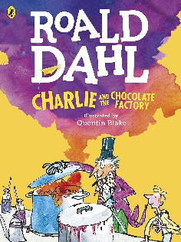
COMMUNICATION: READING, WRITING, SPEAKING AND LISTENING
We will be following the 2014 curriculum for English. We will read a variety of books and talk about what we have read. We will develop our writing skills through our English class book of Charlie and the Chocolate Factory. We will develop our speaking and listening, reading and writing skills through Market place activities, quick on the draw, DIAL activities and debates in PSHE.
OUR SCHOOL DRIVERS
The key elements of our school drivers are that we will become independent learners who understand the strategies we need to use in order to be independent enquirers and reflective learners.
As INDEPENDENT ENQUIRERS we will ask and answer questions about Issues which arise in PSHCE. We will learn that it is always appropriate to ask for help and guidance from our friends, teachers and families. We will develop group success criteria to help in our lessons. We will reflect on the way we learn the best. At all times throughout the year, we will consider our rights as children and raise issues that concern us through our school council.

On top of this we will be reviewing and consolidating previous drivers.

Helping your child
- Find out about food production in different countries around the world.
- Read books about life in South America.
- Research how chocolate is produced.
- Use the Internet to research Fairtrade and how it helps workers in different countries.
- Keep up the daily reading with your child.
- Do some times tables practice every day.
- Keep practising telling the time.
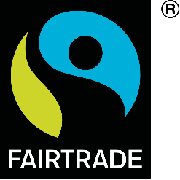
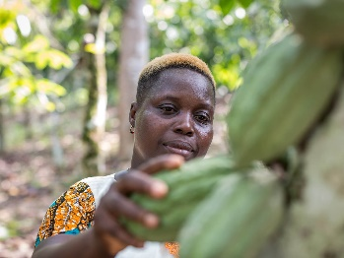
- Research Andy Warhol and look at different pieces of his art.

