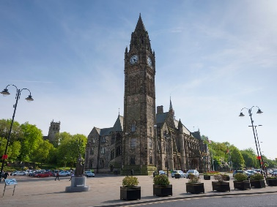

Year Five - Summer Theme 2021
English
We will be researching to retrieve and collect information to write explanation texts linked to our Science Topic. We will also read and compare fables before having a go at creating our own.
Maths
As Mathematicians we will be learning more about fractions (adding and subtracting them as well as converting between improper and mixed), 3D shapes and their visual representations, solving problems involving money and statistics through the interpretation of line graphs.
Science
In Science, we will continue our work on forces and investigate how they act on moving objects. We will be investigating the life cycles of animals from the different groups of the animal kingdom.
DT
As designers, we will look at matting and layering different textures to create coat of arms.
Art
As artists we will be looking at folk art, local artists and their artistic styles, including L.S Lowry.
Music
We will (try again) to look at the evolution of music through history. We will also be comparing old and new local music using musical vocabulary. We will look at using instruments to create jingles for our own ‘radio station’.
History / Geography
As Historians / Geographers we will undertake a local history study of Rochdale, looking at places of importance and how our town compares to towns in other countries.

R.E
We will be discussing and enquiring into the question ‘What does it mean to be a Muslim in Britain’ and ‘If God is everywhere, why go to a place of worship’, in accordance with our RE syllabus.
PSHCE
We will be thinking about the positive and negative life choices which can affect our health. We will also have a health week where we will look at our RSE (Relationships and Sex Education) topic.
Computing
We will be developing our programming skills by creating and debugging code using the programme Scratch.
P.E & Games
We will develop our teamwork skills through athletics and work on our agility and strength in circuits.

