Whole school theme – Dinosaurs
Year group | Online resources | English activities | Maths activities | Games to play
Nursery | https://www.bbc.co.uk/cbeebies/shows/andys-dinosaur-adventures  Games to play, crafts to make, songs.  https://www.bbc.co.uk/iplayer/episodes/b03wh7vl/andys-dinosaur-adventures  Dinosaur programmes to watch on BBC iplayer | Dinosaur begins with the sound ‘d’. How many things can you find around your home that also begin with the sound ‘d’?  Set up a dinosaur egg treasure hunt. Hide some dinosaur eggs inside or out and have written clues for children to follow. They need to listen carefully to the clue and decide where to look next for the next clue.  Read Harry and the Bucketful of Dinosaurs (if no book watch on youtube at https://www.youtube.com/watch?v=uWoopkMgLqM  Read and discuss the story. Imagine that you found an old box in your attic, what would you like to find inside the old box?  Choose a dinosaur to find some more information on. Use the computer and any non-fiction books you might have at home to create a ‘Dino Fact’ poster. | Using chalks, draw dinosaur footprints in a number line. Provide children with a beanbag or similar and challenge them to jump on from and back from the number the beanbag lands on whilst counting.  Have a bucket and a selection of small toys (maybe dinosaurs) that will fit in the bucket. Count some toys into the bucket. Hold up another toy and say if I add one more how many will I have? Take suggestions, count to check.  Have a bucket and a selection of toys (maybe dinosaurs) that will fit in the bucket. Count some toys into the bucket. Say I am going to take one toy away (Take it out) how many will I have left? Take suggestions, count to check.  Collect some leaves and flowers as well as two dinosaur cut-outs or soft toys. Challenge the children to share the leaves equally between the two dinosaurs. | Throwing and catching games (if children are not yet able to throw and catch a ball try a scarf)  PIN THE TAIL ON THE DINOSAUR  For this game you will need a large dinosaur drawing hung on the wall. Give each child a dinosaur tail cut out with blu-tack or sticky tape on the end. The children take in turns being blindfolded and attempting to pin the dinosaur tail closest to the actual tail on the poster. To make it more challenging, you may want to spin the children around a couple of times before their turn.
 | Creative things to do | Physical activity | The world around us | Skills to practise
 | Create your own dinosaur. Draw a picture of your dinosaur and why don’t you give it a name. Will your dinosaur have a long neck, spikes or wings?  Make a paper plate dinosaur or you could use card 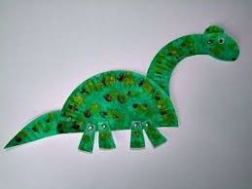  Make some salt dough dinosaur bones  https://www.65millionyears.com/how-to-make-salt-dough-dinosaur-bones/  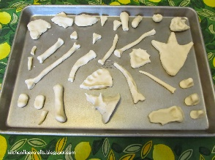 | Play some dramatic classical music and dance like a dinosaur, swing your tail like an Ankylosaurus, stomp like a T-Rex.  Children walk around the jungle, shout out dinosaur themed instructions e.g. stretch up tall like a diplodocus, fly like a pterodactyl, stomp like a t-rex etc..  Tiny the T-Rex cosmic yoga  https://www.youtube.com/watch?v=BqtPZ9OKa94 | Take a blanket outside and watch the clouds. Do any of the clouds look like dinosaurs? Do they have spikes or long tails?  Talk about where in the world dinosaurs lived. How do we know that dinosaurs lived there?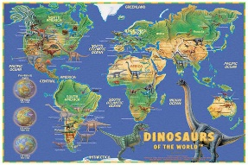  Dinosaurs lived a very very long time ago. Do you have something old in your house that you could have a look at and talk about maybe an old camera, toy or jewellery? | Say to your child  “Put your hands on your h-ea-d” Can they follow the instruction?  Other examples to try  “Stamp your f-ee-t”  “Touch your t-oe-s”  etc..  Learn how to cross the road safely.

