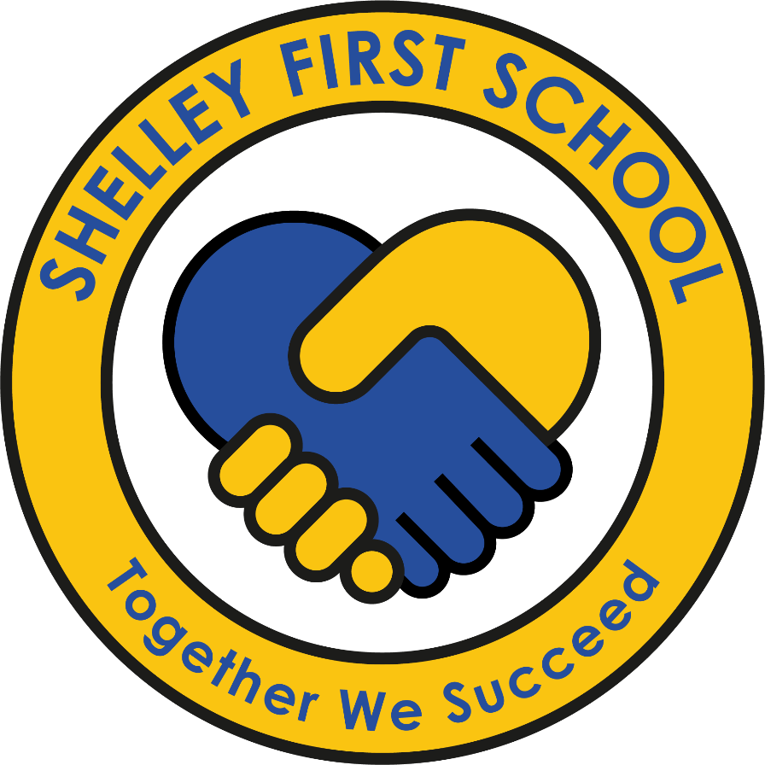

PSHE Policy
Including PSHE, Relationships Education and Health Education

Together We Succeed

Reviewed July 2026

Contents

DfE RSE Policy Checklist / Minimum requirements 3
Aims 3
Definitions 4
What is PSHE? 4
Legislation and Statutory Guidance for Relationships Education and Health Education 5
Content and Delivery of PSHE including RSHE 6
Contextual Considerations 7
RSE & PSHE in EYFS: Reception 8
Roles and responsibilities 9
RSE Policy Development 9
How the delivery of the content will be made accessible to all pupils including those with SEND. 10
How the subject will be monitored and evaluated. 10
Explanation of the right to withdrawal from sex education. 10

DfE RSE Policy Checklist / Minimum requirements
All schools and academies, except maintained nursery schools, are required to have a written policy for relationships and sex education. This should include:
• A definition of relationships education and a definition of sex education.
• Requirements on schools in law (e.g. The Equality Act, 2010).
• Content and delivery of RSHE (e.g. through science, health education or RSHE/PSHE education).
• Roles and responsibilities (who is responsible for teaching it).
• How the policy was produced (including engagement with parents).
• How the delivery of the content will be made accessible to all pupils including those with SEND.
• How the subject will be monitored and evaluated.
• Explanation of the right to withdrawal from sex education.
• Confirmation of the review date

Aims
Section 2.5 of the National Curriculum Framework states that all schools should make provisions for PHSE education, drawing on good practice. Shelley First School uses the Kapow scheme of work which covers all of the statutory content as well as vital non-statutory content, including that related to economic wellbeing and careers. As a school we aim to support pupils’ spiritual, moral, cultural, mental and physical development and prepare them for the opportunities, responsibilities and experiences of life. The work we do in PSHE also flows through all other curriculum areas including assemblies. In line with the most recent DfE statutory guidance for Relationships Education, RSE and Health Education and the latest version of Keeping Children Safe in Education., Health Education and Relationships Education aspects of PSHE (personal, social, health and economic) education are now compulsory in all primary schools.
Relationships Education enhances and is enhanced by learning related to topics including anti-bullying; keeping safe on and off line; keeping physically and mentally healthy, economic wellbeing, learning about drugs, alcohol and tobacco; and the development of skills and attributes such as communication skills, managing peer pressure, risk management, resilience and decision making.
We follow the key aims of providing pupils with:
• accurate, balanced and relevant knowledge
• opportunities to turn that knowledge into personal understanding
• opportunities to explore, clarify and if necessary challenge, their own and others’ values, attitudes, beliefs, rights and responsibilities
• the skills, language and strategies they need in order to live healthy, safe, fulfilling, responsible and balanced lives
• opportunities to develop positive personal attributes such as resilience, self-confidence, self-esteem, and empathy
At Shelley First School, we believe that PSHE helps to give pupils the knowledge, skills and understanding they need to lead confident, healthy, independent lives, in order to become informed, active and responsible citizens. At Shelley we have chosen to adopt the Kapow scheme of learning for PSHE, Relationships Education and Health Education.

Definitions
- PSHE: Personal, Social, Health and Economic (PSHE) education.
- RSHE: Relationships education, relationships and sex education and health education.
- Health education: Physical health and mental wellbeing.
- Relationships education: The physical, social, legal and emotional aspects of human relationships including friendships, family life and relationships with other children and adults.
- Sex education: There is no agreed definition in the new RSHE guidance. In this policy the definition of sex education is ‘how a baby is conceived and born’ (reproduction and birth).
- RSE: Relationships and sex education.

What is PSHE/RSE?
Personal, Social, Health and Economic (PSHE) education is a planned programme of learning that helps children develop the knowledge, skills and attributes they need to thrive both now and in the future. It supports pupils to understand themselves and others, build positive relationships, keep themselves healthy and safe, manage risks, understand their rights and responsibilities, and prepare for life in modern Britain. PSHE contributes to pupils' personal development, wellbeing, safeguarding and readiness for future learning and life.
What is Relationships Education (RSE)?
Relationships Education is the statutory part of PSHE taught in all primary schools. It focuses on helping children develop the building blocks of healthy, respectful and safe relationships. Pupils learn about families, friendships, respect, kindness, inclusion, online relationships, personal boundaries and how to seek help when they have concerns. Through Relationships Education, children develop the knowledge and skills needed to form positive relationships and recognise unsafe situations, both online and offline.

What is Health Education?
Health Education is also a statutory part of the primary curriculum. It supports pupils to understand and manage their physical health, mental wellbeing and personal safety. This includes learning about healthy lifestyles, mental health, emotions, hygiene, physical activity, healthy eating, online safety, basic first aid, medicines and the importance of seeking support when needed.

Legislation and Statutory Guidance for Relationships Education and Health Education
At Shelley First School, we are required to provide relationship education and health education to all pupils. This policy has regard to the most recent versions of:
- Relationships Education, Relationships and Sex Education (RSE) and Health Education Statutory Guidance (DfE).
- Keeping Children Safe in Education.
- Working Together to Safeguard Children.
- Equality Act 2010.
- SEND Code of Practice
Section 80A of the Education Act 2002: as part of the Education Act 2002/Academies Act 2010 all schools must provide a balanced and broad-based curriculum which promotes the spiritual, moral, cultural, mental and physical development of pupils at the school and of society, whilst also preparing pupils for the opportunities, responsibilities and experiences of later life.
Teaching will be inclusive and age-appropriate and will reflect the protected characteristics identified within the Equality Act 2010. Children will learn that families may look different from their own and that all people should be treated with respect.

Content and Delivery of PSHE including RSHE
At Shelley First School, we teach Personal, Social, and Health Education as a whole-school approach to underpin children’s development as people and because we believe that this also supports their learning capacity. This significantly contributes to the school’s Safeguarding and Equality Duties, the Government’s British Values agenda and the SMSC (Spiritual, Moral, Social, and Cultural) development opportunities provided for our children. The DfE’s statutory ‘Keeping Children Safe in Education (Sep 2020)’ guidance states that ‘Governing bodies and proprietors should ensure that children are taught about safeguarding, including online safety. Schools should consider this as part of providing a broad and balanced curriculum’. In response to the child-on-child abuse updates to Section 5 of Keeping Children Safe in Education (DfE, 2022), our curriculum introduces and revisits ideas of personal boundaries; consent; developing, recognising and nurturing positive relationships. This prepares pupils for the challenges and responsibilities they will face in the future.
The Kapow Programme offers us a comprehensive, carefully thought-through Scheme of Work which brings consistency and progression to our children’s learning in this vital curriculum area. The overview of the programme can be seen on the school website. The scheme aims to give children the knowledge, skills, and attitudes that they need to effectively navigate the complexities of life in the 21st Century. The curriculum covers key areas which will support children to make informed choices now and in the future around their health, safety, wellbeing, relationships, and financial matters and will support them in becoming confident individuals and active members of society.
The scheme covers wider PSHE learning, in line with the requirement of the National curriculum (2014) that schools ‘should make provision for personal, social, health and economic education (PSHE).’ Children’s learning through this scheme would significantly contribute to their personal development as set out in the Ofsted Inspection Framework and promotes the four fundamental British values which reflect life in modern Britain: democracy; rule of law; respect and tolerance and individual liberty.
Sex education is not compulsory in primary schools, beyond what is laid out in the National Curriculum for Science:
● Year 1: Identify, name, draw and label the basic parts of the human body and say which part of the body is associated with each sense.
● Year 2: Notice that animals, including humans, have offspring which grow into adults
● Year 5: Describe the life process of reproduction in some plants and animals; describe the changes as humans develop to old age [They should learn about the changes experienced in puberty.]
Pupils will be taught the medically correct terminology for body parts in an age-appropriate way to support safeguarding, health and understanding of their bodies.
Our PSHE, Relationships and Health Education covers the following areas:
- Families and people who care for me
- Caring friendships
- Respectful relationships
- Online relationships
- Being safe
- Mental wellbeing
- Physical health and fitness
- Healthy eating
- Drugs, alcohol and tobacco
- Health prevention
- Basic first aid
- Changing adolescent body

These are grouped under key themes, which return in each year group, making pupils’ prior and future learning clear.
Key areas
- My healthy self – learning how to look after mental and physical health and making choices that support wellbeing.
- Connecting with others – learning to build positive relationships, communicate with respect and understand the importance of kindness and boundaries.
- The online world – learning to use the internet safely, recognise risks and behave responsibly when communicating or accessing information online.
- Citizenship – learning how to take part in their communities, understand rules, rights and responsibilities, appreciate diversity and fairness and develop early financial literacy.
- Staying safe – learning how to recognise risks, respond safely in different situations and seek help when something feels wrong or unsafe.
- Growing up – learning about the changes that happen as they grow, including puberty and developing bodies and how to manage these changes with confidence.
- Health protection – learning how to prevent illness, manage basic first aid and understand how hygiene, vaccines and healthy habits help keep people well.
Please see our Long Term Plan on the school website for further detail. It has been designed as a spiral curriculum. Teaching will include online relationships, online safety, privacy, personal data, scams and online financial harms, responsible image sharing and understanding age restrictions on online services.

Contextual Considerations
When developing our PSHE, Relationships Education and Health Education curriculum, we carefully considered our school’s context to ensure our contextual needs are addressed and supported. Our school is in a predominantly White British, generally affluent, rural area. Many of our children have access to mobile phones and internet enabled devices from a young age, many play out on the small roads amongst the housing estate, some children get pocket money and a wide variety of out-of-school clubs and activities are attended. As such, we have ensured that our PSHE, Relationships Education and Health Education includes teaching on economic wellbeing, first aid, safety around medicines, online and road safety, democracy diversity and community. We supplement our teaching offer in these areas by arranging extra-curricular activities including road safety training, Bikeability and Balanceability, Careers weeks and Creative Week and visits and visitors which support democracy and diversity. We continually strive to provide a broad and balanced curriculum and extra-curricular offer to support our pupils’ personal development.

RSE & PSHE in EYFS: Reception
Personal, social and emotional development is one of the three Prime Areas in the Statutory framework for the early years foundation stage. The prime areas, Communication and language, Physical development and Personal, social and emotional development, lay the foundations for children to achieve in all areas of learning and life.
The early learning goals (ELG) below summarise the knowledge, skills and understanding that all young children should have gained by the end of the reception year in the Personal, social and emotional development prime area.
In Reception, RSE & PSHE learning focuses on developing the skills set out in the Early Years Framework for Personal, Social and Emotional Development. These include:
- Self-regulation – understanding feelings, managing emotions and beginning to control behaviour.
- Managing self – developing independence, resilience, understanding rules and looking after personal needs.
- Building relationships – learning to work and play with others, form friendships and show care for others.
Kapow Primary’s Reception units are designed to support these areas through age-appropriate activities, stories and discussions, helping pupils develop the foundations they need for learning and relationships as they move through school.

Roles and responsibilities
Class teachers are responsible for teaching PSHE, relationships and Health Education. Each year-group is provided with a clear overview of learning objectives, learning outcomes and suggested teaching activities for RSE. This overview is overseen by our PSHE Subject Leader and Headteacher. Any visitors contributing to PSHE or Relationships Education will work under the direction of school staff and in line with this policy, complementing staff work rather than replacing it.

RSE Policy Development
In developing our policy and curriculum we have given due regard to the Government’s statutory guidance for RSHE issued under Section 80A of the Education Act 2002 and Section 403 of the Education Act 1996.
The three key stages of policy development:
INFORM | Share the facts about the new guidance, including the statutory content.
CONSULT | Gather stakeholder views (children, staff, parents and Governors)
SUPPORT | Share the policy, resources and activities. Help parents complement the teaching in school

The RSHE policy at Shelley First School, was developed following consultation with with pupils, parents, staff and governors.
Feedback informed the final version which was approved by the Governing Board.

How the delivery of the content will be made accessible to all pupils including those with SEND.
The Education Act 1996 ensures that children with SEND have the same entitlement to sex education as their peers. Timing, methods and learning process will differ according to their needs. It is important to differentiate materials accordingly. RSE must be accessible for all pupils and this is particularly important when planning teaching for pupils with SEND.
High quality teaching that is differentiated and personalised will be the starting point to ensure accessibility. Schools should also be mindful of the preparing for adulthood subjects to those with SEND. Schools should be aware that some pupils are more vulnerable to exploitation, bullying and other issues due to the nature of their SEND. RSE can also be particularly important subjects for some pupils; for example, those with Social, Emotional and Mental Health needs or learning disabilities. Such factors should be taken into consideration in designing and teaching these subjects.

Lessons will be adapted through:
- visual supports
- pre-teaching vocabulary
- small-group support
- adapted resources
- additional pastoral support where appropriate

Reasonable adjustments will be made where necessary so that all pupils can access learning and achieve intended outcomes.

How the subject will be monitored and evaluated.
As a subject PSHE is monitored and evaluated in school by Head Teacher Liz McLoughlin and other senior leaders, and Quality Assured by The MAST. Monitoring may include:
- learning walks
- pupil voice
- planning scrutiny
- curriculum evaluation
- governor monitoring
- parental feedback
- assessment of pupil knowledge and understanding
Teachers use formative assessment, knowledge organisers, discussion, retrieval activities and observation to monitor pupils' progress and inform future teaching.

Safeguarding & Confidentiality
Staff cannot offer pupils complete confidentiality. If a pupil discloses information which raises safeguarding concerns, staff will follow the school's safeguarding procedures and share information with the Designated Safeguarding Lead where appropriate.

Ground rules will be established within lessons to create a safe learning environment. Questions will be answered in an age-appropriate manner and pupils will be signposted to trusted adults and support services.

Explanation of the right to withdrawal from sex education.
Parents have no right to withdraw their child from Relationships Education, Health Education or National Curriculum Science at First School.

If the school chooses to teach any additional sex education beyond the National Curriculum, parents may request withdrawal from those specific lessons. However, Shelley First School currently does not teach any non-statutory sex education.

Should a parent have concerns around the content or delivery of the PSHE and Relationships and Health Education curriculum, they are encouraged to meet with the school’s headteacher to discuss these in the first instance. As a school, we are committed to providing parents with support to deepen their knowledge and understanding of our RSE teaching, how this progresses and the benefits to their child.

