The Big Bang Theory

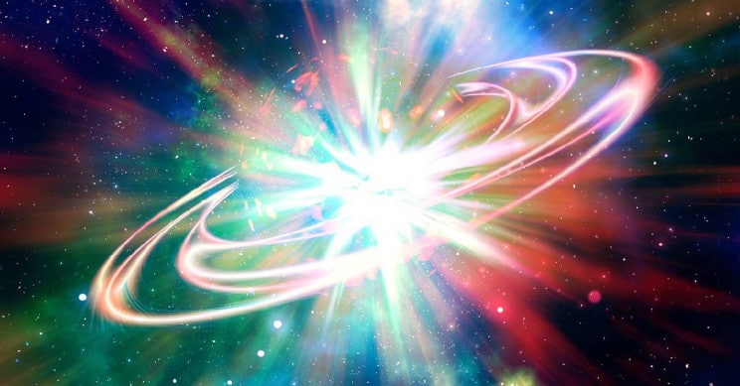

Everybody has heard of the Big Bang Theory, but what is it, exactly?
It is called a theory because we cannot be certain it actually happened; nobody was around 13.8 billion years ago to see it happen. We can only collect data on things that are existing today.
When we look at the Universe, we can see that it seems to be made up of 2,000,000,000,000 galaxies (that’s 2 trillion). Each galaxy has about 100,000,000 stars, and our Sun is just one of those stars.
About 100years ago astronomers started to notice that the galaxies were not stationary but were moving away from each other. This was the first piece of data that they could not explain. The data they collected also showed that the galaxies furthest away were moving the fastest away from us and from each other.
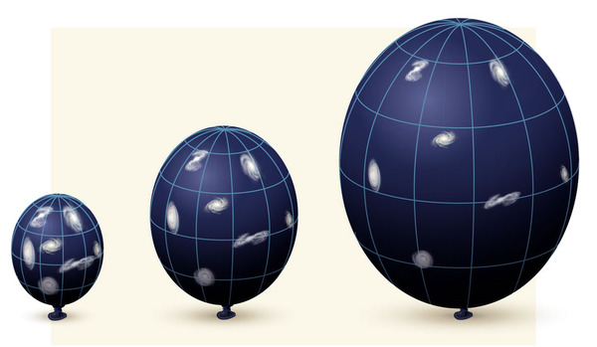
All galaxies are moving away from each other, a bit like dots on a balloon that is getting blown up.
However the explanation was suggested that if you could wind back time the galaxies must have been much closer together in the past. So if you wound back time to a single start point all the universe would be a tiny point called a ‘singularity’ This would be a point when the universe and time itself started.
They then noticed that wherever they looked in the Universe they could see a faint energy signature called cosmic microwave background radiation (CMB). It comes from all directions so it also must have started from a single point and expanded with the universe as an enormous expanding fireball, (it’s like a cosmic fire ember). Hence the term the Big Bang.
So the theory (explanation) fits with the observations and data we can collect. However a problem with the Big Bang theory is that when we look at the Universe, we still cannot see a lot of it.
We know that a lot of the mass is missing it’s called ‘dark matter’. We know its there, but its impossible to see it directly, It gives out no light and it does not reflect any light. Because of this ‘missing mass’ we don’t yet know if the Universe will expand forever in time, or if a some point it will start to slow down and then if gravity might one day pull it all back to a single point in time again.
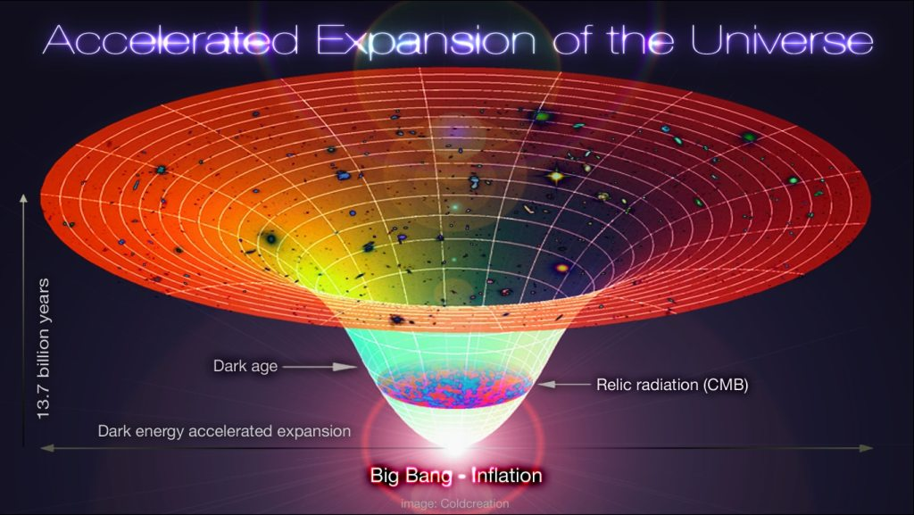
It also raises interesting questions because if nothing existed before the big bang, what caused the big bang? Also what happened before time started? Some scientists think the universe may one day contract back to a point, and then another big bang may restart time and the Universe all over again.

