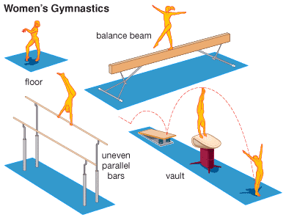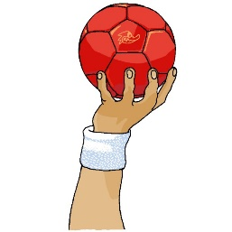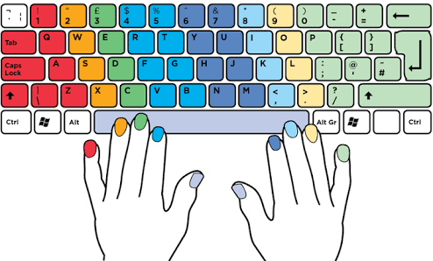

**ENGLISH**

The Jolly Postman by Janet and Allan Ahlberg

Bog Baby by Jeanne Willis

**P.E.**

Gymnastics

Handball

**Computing**

Touch typing

Coding

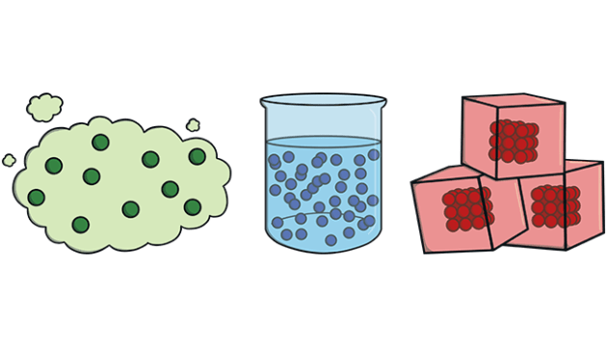

**SCIENCE -** States of matter

Compare and group materials as liquids, solids and gases. Observe how materials change state. Measure the temperature at melting and solid states. Understand evaporation and condensation.

**PHSE/RSE**

‘Dreams and goals’

‘Healthy Me

**R.E**

What festivals do we celebrate at Spring?

What makes Guru Nanak a special teacher?

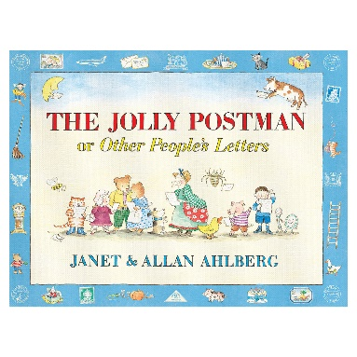

**Rivers and the water cycle**

**GEOGRAPHY**

Oceans of the world

British rivers

Rivers near us

The water cycle

**ART**

Weaving

Collage

Observational drawings

Mark making.

**MATHS**

Calculate the perimeter of a shape

Find the fractions of amounts

Understand the denominators of unit fractions

Measure mass in kilograms and grams

