**Computing**

Simulations

Presenting with Powerpoint

**P.E.**

Rounders

Athletics

**PHSE/RSE**

Relationships

Changing me

**ENGLISH (Dragons)**

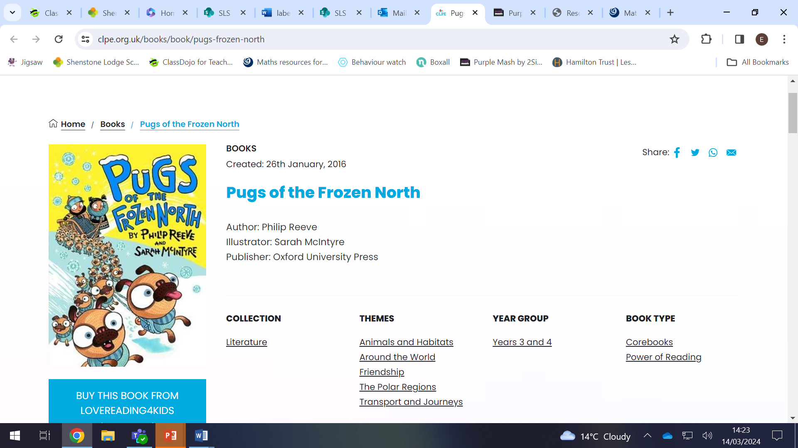

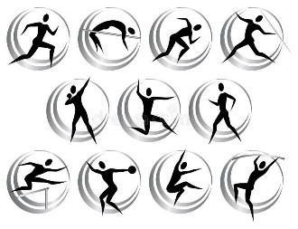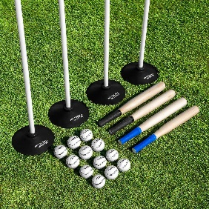

**SCIENCE –** Forces and magnets

Compare how things move on different surfaces. Notice that some forces need contact between two objects, but magnetic force can act as a distance.

Identify some magnetic materials and group a variety of everyday materials on this basis.

Describe magnets as having two poles that repel or attract. and group materials as liquids, solids and gases. Observe how materials change state. Measure the temperature at melting and solid states. Understand evaporation and condensation.

**R.E**

What do the creation stories teach us?

Who was St Francis and what did he teach us about caring for animals?

**Ancient Egypt**

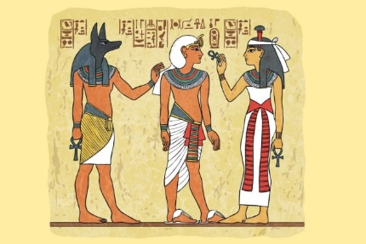

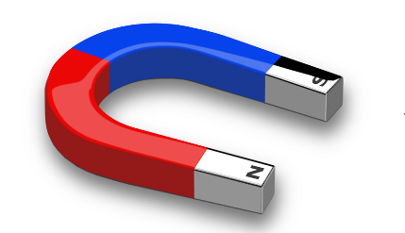

**HISTORY**

The ancient Egyptians.

How to use a timeline.

Beliefs that the ancient Egyptians had.

Compare and contrast how life was for the Egyptians in comparison to today.

**MATHS (Dragons)**

Multiplication and division

Fractions

Position and direction

Place value

Money

Time

**ART**

Ipad photography and drawing combined to create Egyptian Pharaoh designs.

Ancient Egyptian masks – use cards, newspaper, pva glue to create masks, decorate with paint, paper, fabric and beads/sequins.

Press print hieroglyphics.

Mark making.

