**Rainfor**

**Art**

Make marks with different materials.

Draw animals from the rainforest.

Explore and replicate the art of Henri Rousseau.

Design, make and evaluate a rainforest animal mask.

**Geography**

Find out what a rainforest is and where they are found.

Identify some features and weather of rainforests.

Find out about the people and settlements of the rainforest.

Explore why the rainforest is under threat and the measures taken to protect it.

**RE**

How and why are celebrations important?

How do Jewish people welcome and say goodbye to Shabbat?

What can we learn from visiting a church?

**PSHE**

Share the things that I do well.

Say how I learn best.

Celebrate my achievements.

Share how I feel when I am faced with my challenge.

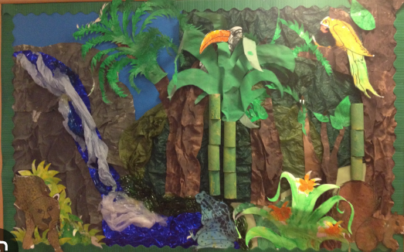 **Rainforests**

**Computing**

Creating pictures

Coding

**Science**

Observe and describe how seeds and bulbs grow into mature plants.

Explore the requirements of plants for life and growth

Find out and describe how plants need water, light and a suitable temperature to grow and stay healthy.

**English**

Read Write Inc Phonics

Read Write Inc Storybooks

**Maths**

Place value within 50

Addition and subtraction within 20

Length and height

Mass and volume

Money

Multiplication and division