English – Key Stage 3
Image One:

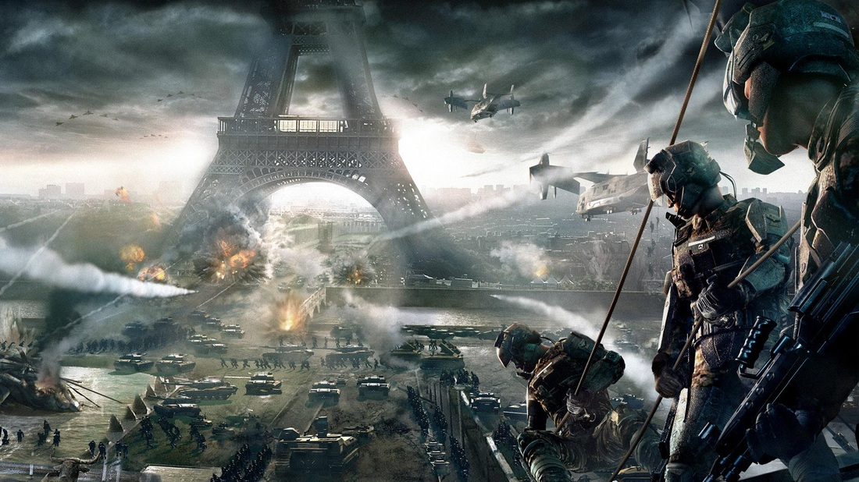

Image Two:

Your task:
You need to choose one of the images and use it as inspiration to create a piece of writing. This could be a story, a piece of descriptive writing or a poem, it is your choice.

However, within your piece of writing you MUST include:
- Correct basic punctuation (capital letters and full stops)
- Adjectives
- Simple and compound sentences using conjunctions (but, or, so, because, however)
- At least three paragraphs

You should try to include:
- A simile or metaphor
- Commas, colons, semi colons
- Adverbs
- Complex sentences using a subordinate clause

This extended piece of writing can either be typed or handwritten on the paper provided. Remember to read over your work when you think you have finished to ensure it makes sense and has correct spellings and punctuation. I look forward to reading them .

