**RSE**

**Changing Me**

**Coping positively with change**

**READING**

Inference Explanation

Retrieval Discussion

**COMPUTING**

Can I save an image document as a .gif or .jpeg

Can I choose images to import into a word document?

Can I choose the correct text wrapping tool for the purpose I need?

**SCIENCE**

What did the Mayans know about the planets?

What scientific discoveries did the Mayans have?

What science did the Mayans use which we use today?

**ENGLISH**

Role Play

Retell

Sequencing

News Programme Report/ Drama

Diary Entries

Instructions

**GEOGRAPHY**

What is the weather like in Mexico?

How do plants and animals in Mexico differ to plants and animals in the UK?

How did the environment contribute to the way the Mayans built their homes?

Can I explain what the Mexican biome is like?

Can I describe Mexico using terms such as climate zone and vegetation belt?

**Mayans**

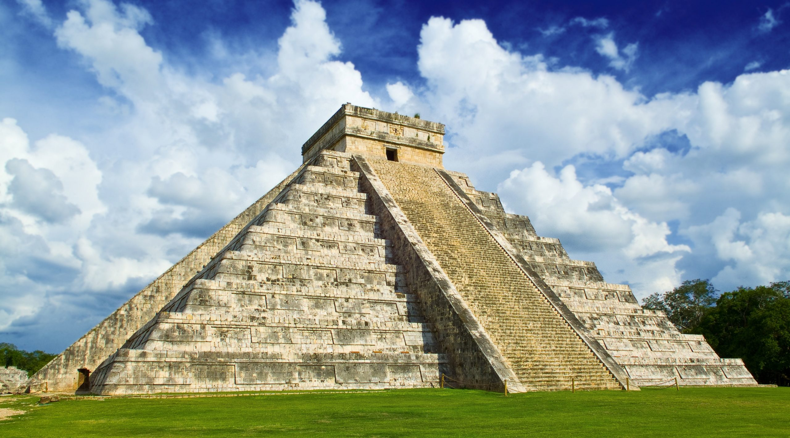

**HISTORY**

What was it like for Mayan men, women and children?

What was Mayan religion like?

What jobs did Mayan people do?

What was daily life like for the Mayans?

What impact did the Spanish discovery of the Mayans have on their culture?

How did Mayan civilisation change over time?

**ART**

Can I use bincato create a piece of sewing with more complicated stitches and create a design?

Can I create a wire sculpture?

Can I embellish my sculpture?

Can I look at my design work critically and explain what I would do differently next time?

**P.E**

Swimming