Pupil premium strategy statement

School overview

Detail | Data
School name | Shenstone Lodge School
Number of pupils in school | 120
Proportion (%) of pupil premium eligible pupils | 84%
Academic year/years that our current pupil premium strategy plan covers | 2023/2024
Date this statement was published | Oct 2023
Date on which it will be reviewed | Oct 2024
Statement authorised by | Neil Toplass
Pupil premium lead | Chris Husband / Sam Rock / Ian Mitchell

Funding overview

Detail | Amount
Pupil premium funding allocation this academic year PP Funding £71685, LAC PP Funding £18760 | £86115
Recovery premium funding allocation this academic year | £39864
Pupil premium funding carried forward from previous years (enter £0 if not applicable) | £ 0
Total budget for this academic year | £125979

Statement of Intent
Our curriculum is ambitious and has been devised to allow students to develop resilience, confidence and independence, as well as achieve scholastic and personal outcomes, that will enable them to move on to further education or the workplace and make a positive contribution to society. Students across all key stages are able to access a wide range of academic subjects and pastoral activities that are adapted, where appropriate, to suit their individual SEMH needs.

Students benefit from tailored and personalised educational programmes which are underpinned by the National Curriculum, in an environment where they know they are valued and safe.

It is our intention to ensure all students leave the school with the emotional resilience and academic skills that will support them to achieve their career and educational aspirations.

With Pupil Premium funding we will target the most vulnerable within the school community to ensure that they are given support where needed at the time they need it. This can take many forms but will be needs led after identification from many sources such as parents / carers, external professionals and staff.

Intended Outcomes
Our Pupil Premium and Recovery Premium Grant will be used to :

Intended outcome | Success criteria
Improve Whole School Attendance, reduce RPIs and days lost to suspension from previous year | Attendance increase to above 85%  Student engagement improved  Reduction of RPI’s and days lost to suspension (against previous year)
To provide students with a wider range of extended curriculum activities | Increase in numbers of clubs, trips and excursions and external school visitors
Accelerate Progress in Reading | Progress in reading accelerated  School reading levels improve
To provide targeted academic and mental health interventions | To improve the outcomes or accelerate progress (academic/ pastoral) for higher need and more gifted students

Activity 2023/24 Budget: £125979

Activity | Evidence that supports this approach
To provide a broader range of curriculum enrichment opportunities which includes music production mentor and Kart Mechanics at The Brades  To provide Box Clever sessions across the schools  To support the funding of theme weeks at the schools | Providing high quality mentor support which raises aspiration and increases school engagement will improve the outcomes of our students as self esteem and skill sets develop.
To provide a broader therapeutic offer across the schools | More complex students are able to understand their emotions and start to explore causality. This allows them to focus on their education in larger chunks of time and so increase their learning capacity, motivation and aspirations
To provide broader range of high quality reading material appropriate to age and ability across the schools | Magazine subscriptions and purchased books targeting specific areas of interest (personalized) will raise levels of engagement and promote reading for pleasure
Maths Interventions | Targeted and specialist Maths support improves knowledge understanding and attainment
English/ Reading interventions | Targeted and specialist English / Reading support improves knowledge understanding and attainment
To enhance the outdoor education provision at the Shenstone Lodge site through the provision of a more formal curriculum offer delivered by a specialist or current staff with further training | The benefits of active an outdoor learning provision for students is well documented  https://ltl.org.uk/wp-content/uploads/2020/05/ofsted-learning-outside-the-classroom.pdf

Impact of Grant Allocation in the 2022/23 academic year (Pupil Premium £71685 / Recovery Premium £26000)
Students receiving the PP grant made progress in line with the whole school cohort for the school year 2022/23.

Quality of Education: IMPACT
 | Subject / Area | % Expected and Above
 | Maths KS2 | 69%
 | English KS2 | 84%
 | KS2 Maths and English PP | Maths 70%  English 86%
 | Maths KS3 | 75%
 | English KS3 | 55%
 | KS3 Maths and English PP | Maths 77%  English 53%
 | Maths KS4 | 70%
 | English KS4 | 47%
 | KS4 Maths and English PP | Maths 71%  English 43%

Behavioural Data shows that the number of RPIs and negative slips for PP students
reduced over the academic year 2022/23 on each of the school sites.

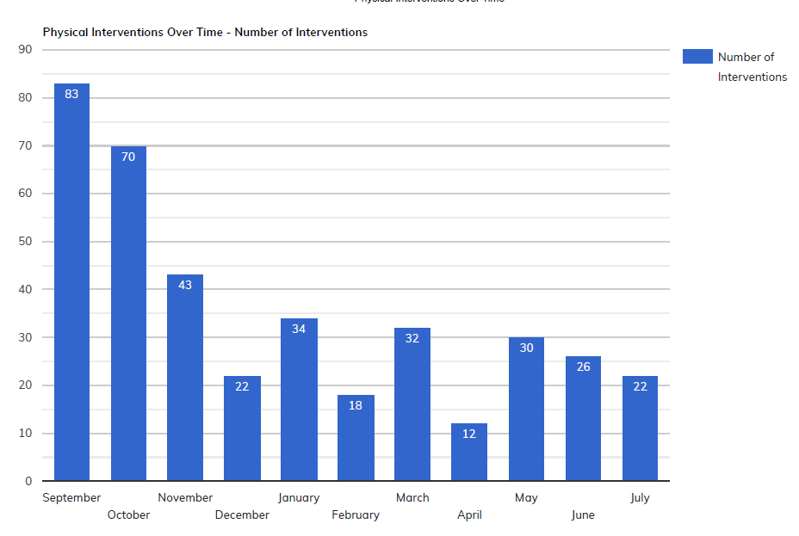

Furthermore the number of RPIs for those students eligible for PP were proportionately lower than those of the rest of the school. As a ‘broad overview’, PP is received by approx.. 80% of students and they accounted for approx. 60% of RPIs

This demonstrates that interventions linked to PP have ensured that the most disadvantaged students do not fall behind their peers academically and have additional protective factors in place which have improved their levels of self regulation.

