Child Speak Anti – Bullying Policy

Author | Written | Next review
S. Rock and D. Hart | Autumn 2023 | Autumn 2024

What is bullying?
Bullying is when somebody hurts you Several Times On Purpose. This can be in lots of different ways. Their words and behaviour can make you feel upset and frightened. It isn’t always easy to see all types of bullying that is why it is so important to talk to a trusted adult (parent, carer, school staff).

Cyber-bullying: saying unkind things by texts, emails, social media or online.
Rosie - Unicorns
Ben - Pegasus
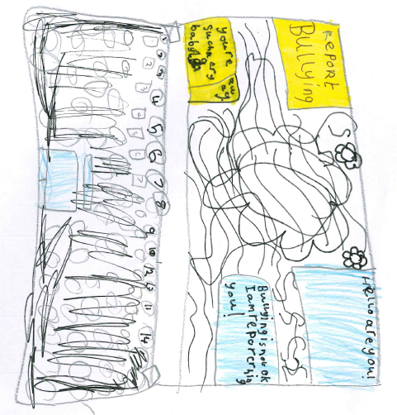
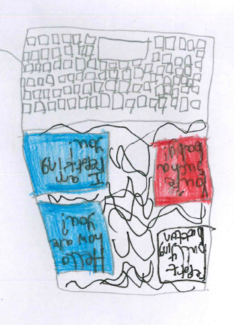

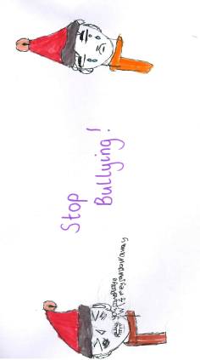

Verbal bullying: being teased, name calling and rude comments.

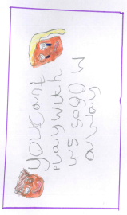
Dantai - Dragons

Rhylei - Dragons

Emotional bullying: hurting people’s feelings, leaving you out and being bossed around.
Isobel - Minotaur
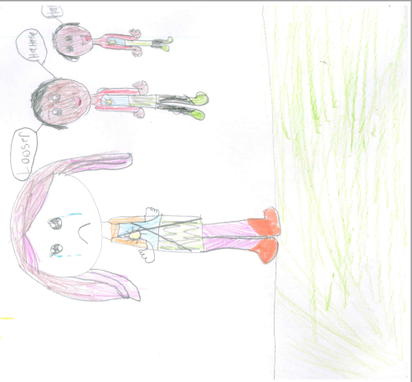
Physical bullying: punching, kicking, spitting, hitting, pushing.
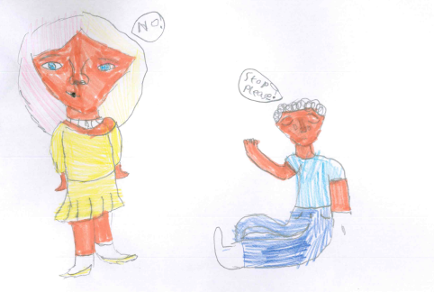

Miah - Minotaur

Homophobic and biphobic bullying: saying unkind things about another person because of their actual or perceived sexual orientation.
Racist bullying: saying nasty things about you because of the colour of your skin, your religious beliefs and your culture.

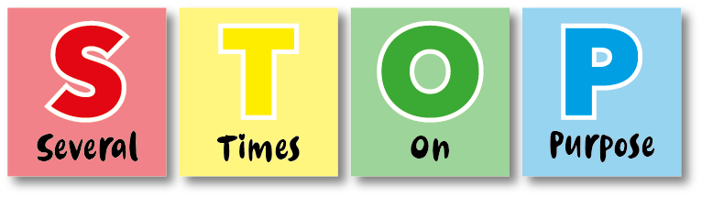

Sexist Bullying: saying unkind things about you due to your sex
Bullying is not:
- A ‘fall out’ with a friend.
- An accident.
- Something that happens only once.
- A one off physical act of aggression e.g. pushing someone.

What should I do if I’m being bullied?

At Shenstone /Brades Lodge, we want to make everyone feel safe and happy. Bullying can make people feel frightened and unhappy. We don’t want this to happen so we help everyone to:
- Respect and understand each other.
- Believe that everyone has a right to be who they are.
- Respect people’s own emotions and personal space.
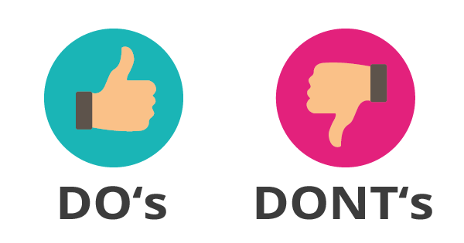

Ask them to STOP, if you can.
Ignore them and walk away.
Talk to a friend, a teacher or parent/carer (trusted adult).
Go into well-being and ask for support.
Speak to someone!
If it’s online, block and report them.

Get angry or fight back – try not to react.
Hurt them.
Think it’s your fault.
Hide it.
Do as the bully says.

What should I do if I see someone else being bullied?
- Tell an adult straight away. Don’t stay silent or the bullying will keep happening.
- Tell the bully to STOP if it is safe to do so. However, don’t get too involved as you may get hurt.
- Comfort the person who has been the victim of bullying and tell them to speak to someone. Reassure them that it isn’t their fault.
Who can I talk to?
It is important that you tell someone as soon as you are being bullied, or you notice someone else being bullied.
You can speak to someone, or, if you find that difficult then please write it down, and share it with someone like your parents, carers or teacher this will mean that we can make sure the bullying stops and doesn’t happen again.
Our helping hand tells us who we can talk to at Shenstone/Brades Lodge.
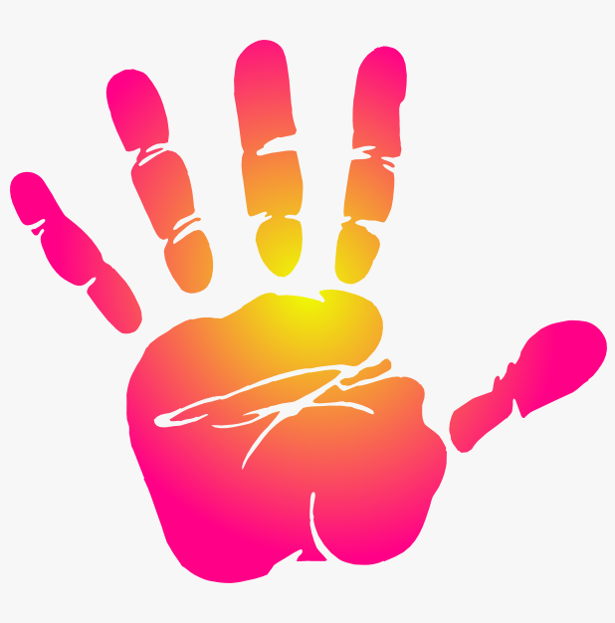
A friend
Teachers
Teaching Assistants
Mr Mitchell
Miss Rock
Mrs Bridgewater
Mrs Jukes
Well-being

