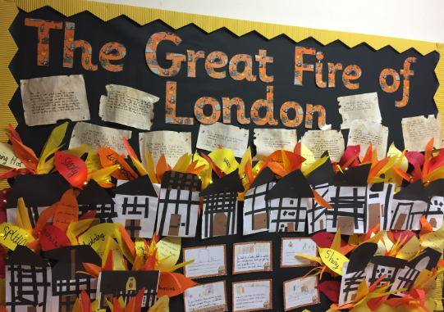

**RSE**

Aspirations, how to achieve goals and understanding the emotions that go with this

**READING**

Inference Explanation

Retrieval Discussion

**COMPUTING**

**Using non-fiction books and the Internet, research how volcanoes are formed and why they erupt.**

**Using cameras or tablets, create a stop-motion short video about an earthquake or volcano eruption**

**SCIENCE**

Forces

Gravity

Resistance

**ENGLISH**

Role Play

Retell

Sequencing

News Programme Report/ Drama

Diary Entry/S

Instructions

**GEOGRAPHY**

Locate the continents and Europe

Locate the UK

Maps

Volcanoes

**Volcanoes**

**HISTORY**

Pompei

**ART**

Volcano art in the style of Margaret Godfrey

Hokusai-Themed Art Activity

Volcano artwork by UK artist Nick Rowland

**P.E**

Swimming