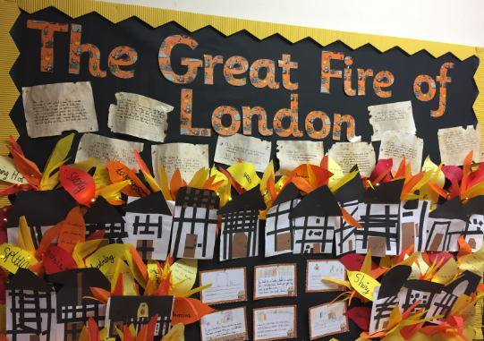

**RSE**

Fire Safety

MUSIC

Singing

Percussion Instruments

Composing and Performing

**COMPUTING**

Drawing software

Word

Research tasks

Music siftware

**SCIENCE**

Properties of Materials

Suitability of Materials

**ENGLISH**

Role Play

Retell

Sequencing

News Programme Report/ Drama

Diary Entry/S

Instructions

**GEOGRAPHY**

Locate the continents and Europe

Locate the UK

Name the countries and locate England

Locate London the capital city and other cities

**THE GREAT FIRE OF LONDON**

**HISTORY**

Timeline

Houses now and then

Fire fighting now and then

Research artefactskey people

Samuel Pepys

**ART**

Line drawings

Collage

Painting

Jackson Pollock

3D sculpture

Research using IT

**P.E**

Dance