Tricky

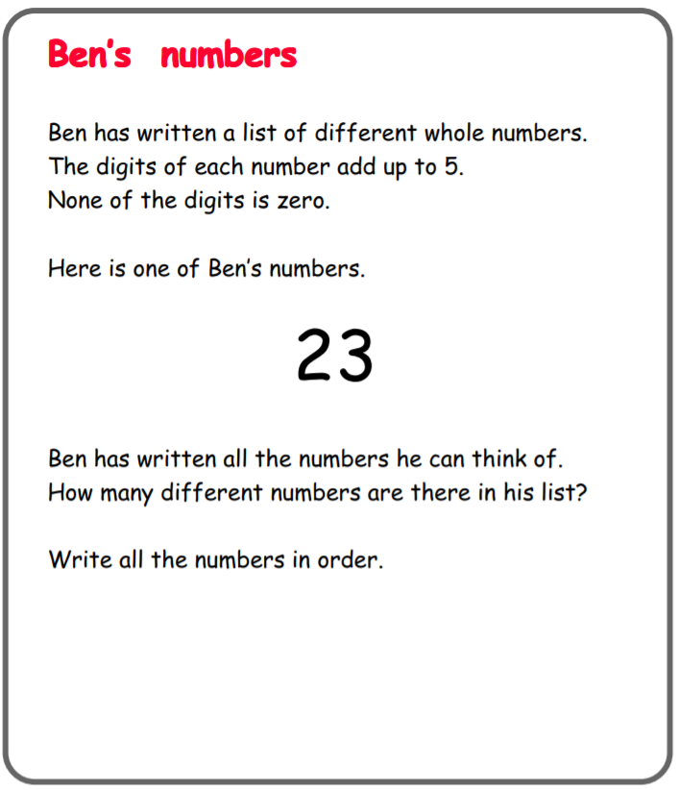

Questions to ask:
How do you know you’ve found they all?
Can you try it now if the digits of the number add up to 6? What different numbers can you make now?

Trickier

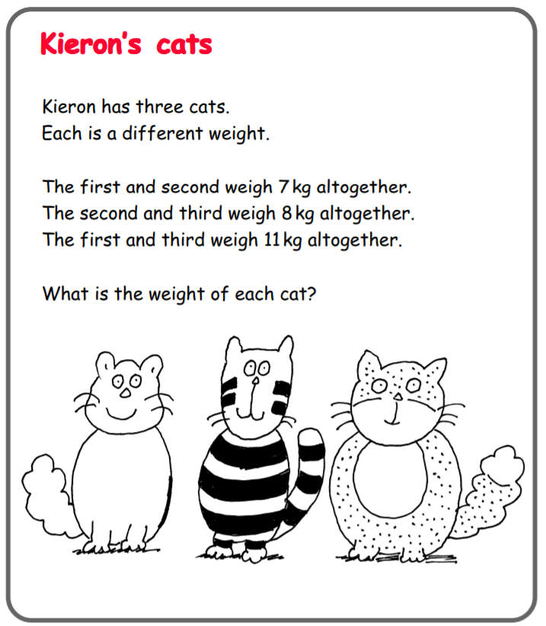

Questions to ask:
Where do you need to start to answer this question?
How can you use your number facts to help you?

