Tricky

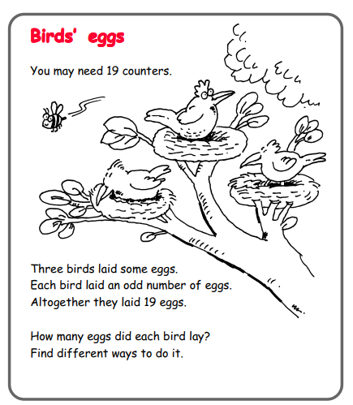

Questions to ask:
What is an odd number?
How will you record this?
Can you be systematic?

Trickier

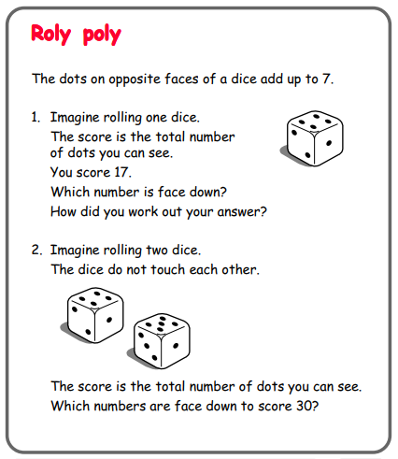

Questions to ask:
What does ‘opposite’ mean?
How can you work this out?
How do you know you’re correct?

