Tricky

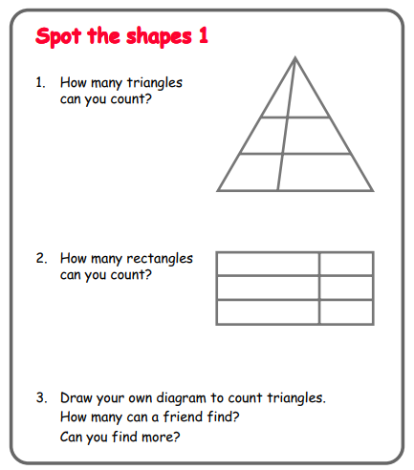

Questions to ask:
What is a ‘triangle’ and what is a ‘rectangle’?
How do you know you’ve found they all?

Trickier

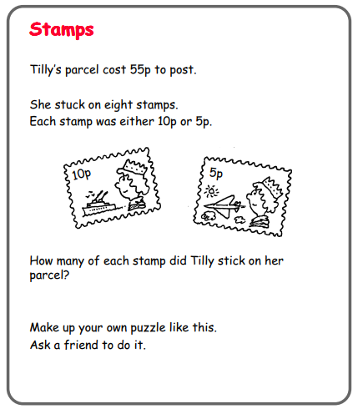

Questions to ask:
What do you know about the numbers 5 and 10?
How can you make this puzzle trickier?

