Tricky

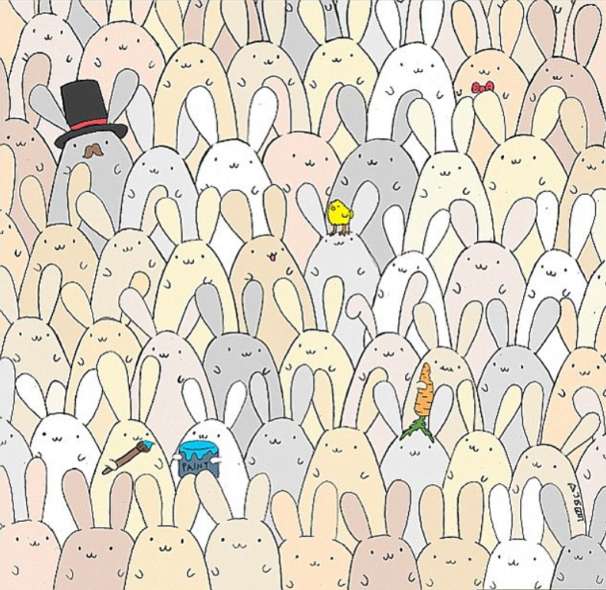

How many bunnies are in the picture?
How many bunnies are white?
How many ears are there in total?
If 20 bunnies hopped away, how many would be left?

Questions to ask:
What calculations can you use to help you?
What other questions could you ask about this picture?

Trickier
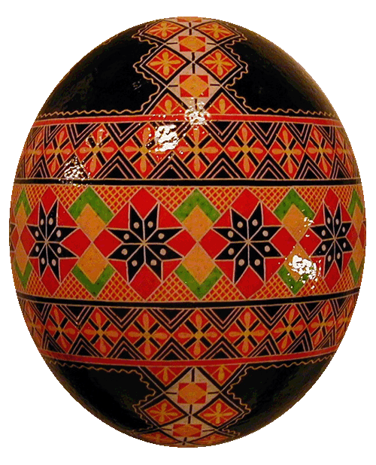

What shapes can you see on the egg?
What lines of symmetry can you see?
What patterns do you notice?
Can you estimate how many triangles are painted on the egg?

Questions to ask:
What does ‘symmetry’ and ‘estimate’ mean?
What can you use to estimate?

