Tricky

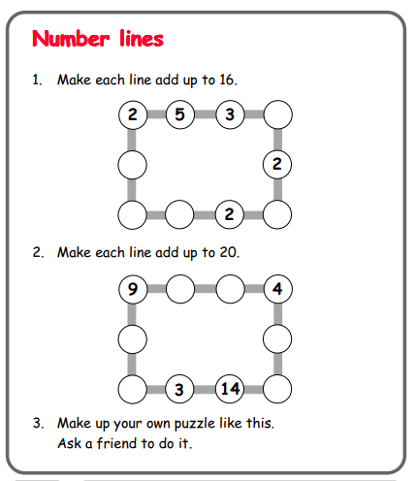

Questions to ask:
What patterns do you notice?
How many different ways can you find?
Was one easier to work out than the other? Why?

Trickier

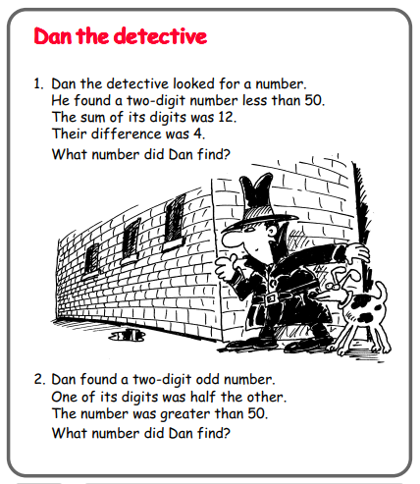

Questions to ask:
What does ‘less than’, ‘sum’ and ‘difference’ mean?
How can you work this out? Where do you start?
How do you know you’re correct?

