Tricky

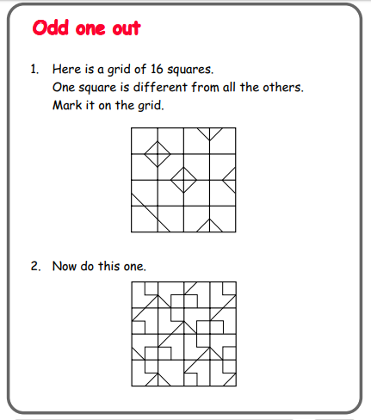

Questions to ask:
How can you work this out? What will help you?
How do you know you’re correct?

Trickier

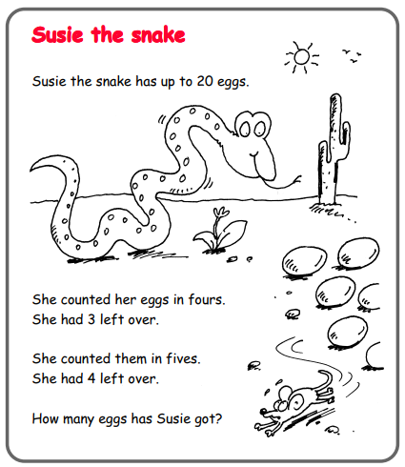

Questions to ask:
How can you work this out? Where do you need to start?
How do you know you’re correct?

