Tricky

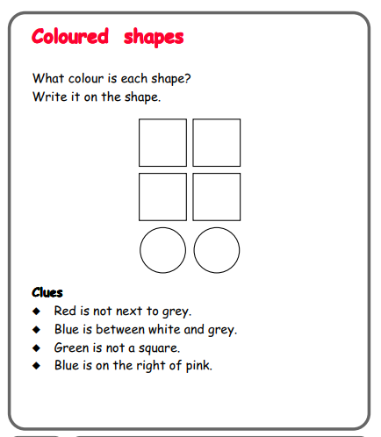

Questions to ask:
Where do you need to start?
What can you use to help you?

Trickier

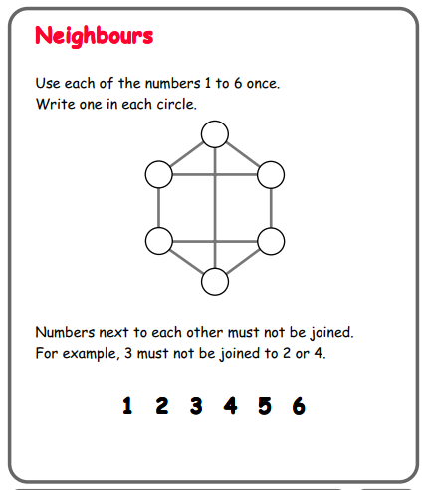

Questions to ask:
What do you notice about the numbers? Which numbers can be next to each other?

