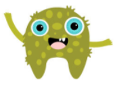
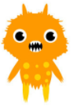


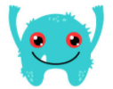
My Monster Phonics Pack!

Name: _________

Parents and Guardians
Please find within this booklet resources to help your child practise the skills needed for the phonics screening test. Remember practising a little and often has a huge impact on reading skills.

Support

How to sound button
A dot represents a single sound and a line a digraph (two letters making one sound). When a split digraph is present a curve goes between the two letters.

ship girl cake

Trash and Treasure
Once cut out children will need to read words and decide if they are real or ‘monster’ words. They can then place them on either the treasure chest (real) or bin (monster).

Contents

- Monster words to sound button and read.

- Real words to sound button and read.

- Trash and Treasure words to cut out.

- Trash and Treasure sorting page.

- Flash cards to sound button and cut out to practise with your grown up.

rop | zut
hes | mek
sheb | chis
reng | roop
waim | geap
hurj | coid
kirs | stoad
garx | esc
rabe | gife
shoop | trark
croin | hoyl
payf | feme
worg | chaid
heang | ooster
hit | not
zap | box
shop | much
with | sing
books | feet
wink | cake
rice | waves
dream | theme
toys | mixer
ditch | appear
crawl | belief
flies | shroud
goes | haul
jewels | whisk

flute | clown | wishing | melp
thazz | rude | vap | lied
stroke | baim | tram | smale
yune | fuzzy | rain | queen
spreat | brighter | chom | thump
spray | thoft | treat | chayp
phone | uke | author | chin
fuel | waves | strabe | jimp

Please cut and sort onto the trash and treasure page.



