Talking to Your Child About Periods

What causes a period?
A period happens because of changes in hormones in the body. Hormones are chemical messengers. The ovaries release the hormones oestrogen and progesterone. These hormones cause the lining of the uterus (or womb) to build up. The built-up lining is ready for a fertilized egg to attach and start developing. If there is no fertilized egg, the lining breaks down and bleeds. Then the same process happens all over again. It usually takes about a month for the lining to build up, then break down. That is why most girls and women get their periods around once a month.

When do most girls get their period?
Most girls get their first period when they're between 10 and 15 years old. The average age is 12, but every body has its own schedule.
Although there's no one right age for a girl to get her period, there are some clues that it will start soon. Typically, periods begin about 2 years after breasts start to develop. Another sign is vaginal discharge fluid (sort of like mucus) that might be seen or felt in underwear. This discharge usually begins about 6 months to a year before a first period. The first period can be very light – just a few spots.

Do periods happen regularly when menstruation starts?
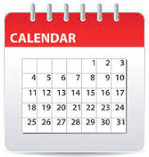
For the first few years after periods start, they may not come regularly. This is normal at first. By about 2–3 years after the first period, they should settle to around once a month.

How often do periods happen and how long do they last?
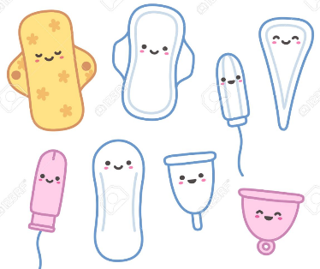
Periods usually happen about once a month - but they can be as often as every 3 weeks or as far apart as every 6 weeks. Periods usually last about 5 days, but this can vary.

What products can girls use?
Pads, tampons, period underwear and cups absorb or collect the blood and tissue that comes out of the vagina during a period.
What if I can’t afford these products?
Schools are provided with sanitary products and teachers in years 5 and 6 all have access to these, so please have a conversation with your child’s teacher who will be able to help.
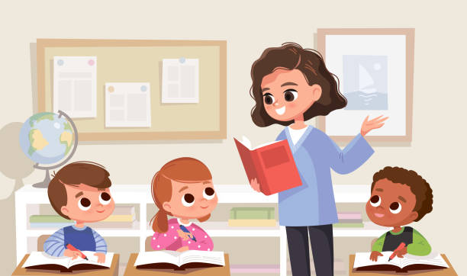
Can my child still come to school?
Yes! Children should definitely still come to school when they have their period. Please let their class teacher know. Year 5 and 6 teachers have sanitary products in their classrooms which they can give to children discreetly, and some of the toilet cubicles have special bins to dispose of used sanitary products. It is important that these are not flushed.

What is PMS?
PMS (premenstrual syndrome) is when a girl has emotional and physical symptoms that happen before or during her period. These symptoms can include moodiness, sadness, anxiety, bloating, and acne. The go away after the first few days of a period.

Can a girl get pregnant as soon as her period starts?
Yes, a girl can get pregnant as soon as her period starts. A girl even can get pregnant right before her very first period. This is because a girl's hormones might already be active. The hormones may have led to ovulation (releasing of the egg from the ovary) and the building of the uterine wall. If a girl has sex she can get pregnant, even though she has never had a period.

How can we celebrate periods starting?
For a girl, beginning her periods is a type of initiation - a transition to a new stage of life. This is recognised in different ways in different cultures, but some families like to tale the girl for a celebratory meal with her female relatives, or give the girl a gift box with some things in it such as new pyjamas, a book about menstruation or body changes, some easy-to-use sanitary products such as period pants and pads etc.

What if I Have Trouble Talking to My Kids About Periods?
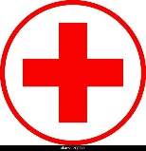
If you don't feel comfortable talking with your kids about periods, make sure they have another way to get this information. Maybe watching a video or reading a website or book together would be easier. You also can ask your doctor, nurse, or a trusted family member to talk to your child.

When Should I Call the Doctor?
Most girls don't have any problems with their periods. But call your doctor if your child:
- is more than 2 years from her first period and her periods still do not come every 3–6 weeks (especially if she misses three or more periods in a row)
- has severe cramps, not relieved by ibuprofen (Advil, Motrin, or store brand) or naproxen (Aleve, Midol, or store brand)
- has very heavy bleeding (bleeding that goes through a pad or tampon faster than every 2 hours)
- has severe PMS that gets in the way of her everyday activities

Looking Ahead
The more that kids understand about their bodies, the better they're able to make good, healthy choices. Make sure your children get reliable information from you or another trusted source.
Helpful links
Please see the useful links below on the sanitary products available for young people:
https://amaze.org/video/period-hygiene-tampons-pads-menstrualcups/ (Amaze is a great resource for kids to learn about puberty in general)
https://www.plannedparenthood.org/learn/health-and-wellness/menstruation/how-do-i-use-tampons-pads-and-menstrual-cups
https://www.mooncup.co.uk/blog/young-persons-guide-period-products/
https://www.always.co.uk/en-gb/tips-and-advice-for-girls-and-parents/parents-and-carers/
NHS video about the different options: https://www.youtube.com/watch?v=D_XeQqIX8gk
https://www.nhsinform.scot/healthy-living/womens-health/girls-and-young-women-puberty-to-around-25/periods-and-menstrual-health/choosing-period-products

