Pupil premium strategy statement – Sholing Infant School 2024-25
This statement details our school’s use of pupil premium (and recovery premium) funding to help improve the attainment of our disadvantaged pupils.
It outlines our pupil premium strategy, how we intend to spend the funding in this academic year and the outcomes for disadvantaged pupils last academic year.

School overview
Detail | Data
Number of pupils in school | 262
Proportion (%) of pupil premium eligible pupils | 17.6%
Academic year/years that our current pupil premium strategy plan covers (3 year plans are recommended – you must still publish an updated statement each academic year) | 2024-25  2025-26  2026-27
Date this statement was published | September 2024
Date on which it will be reviewed | Annually, as part of the three year plan.
Statement authorised by | Lisa Houghton
Pupil premium lead | Lisa Houghton
Governor / Trustee lead | James Knight

Funding overview
Detail | Amount
Pupil premium funding allocation this academic year | £69,699
Pupil premium funding carried forward from previous years (enter £0 if not applicable) | 0
Total budget for this academic year | £69,699

Part A: Pupil premium statement of intent.
Sholing Infant School aims to ensure the highest levels of achievement, personal development and wellbeing for all pupils, irrespective of their background or the challenges they face. Our approach underpins our belief that every pupil, regardless of background or barrier to learning, can attain well.
We aim for our school to be a place where disadvantaged pupils enjoy learning, build strong relationships with staff and peers and experience the wider aspects of school life. In essence, we want our disadvantaged pupils to thrive!
We recognise the long-term impact of socio- economic disadvantage in terms of pupils ‘social, cultural and financial capital. To this end, school leaders will focus on ensuring that we use our Pupil Premium funding to make a real difference in achieving this aim. Closing the gap between disadvantaged children and their peers is a key component of our strategy plan, along with raising standards and raising aspirations for all children.
We will consider the challenges faced by vulnerable pupils, such as those who have a social worker, those who are or have been looked after and young carers. The activity we have outlined in this statement is also intended to support their needs, regardless of whether they are disadvantaged or not.
All staff at Sholing Infant school are responsible for meeting the pastoral, social and academic needs of disadvantaged children within our school so that they have an equal opportunity to thrive and achieve their fullest potential. We believe that enabling our disadvantaged pupils to thrive means that we should focus on a relentless approach to delivering a small range of actions well. We are determined that our disadvantaged pupils will:
- Receive quality first teaching through delivery of a well sequenced and delivered curriculum, so that they know and remember more.
- Meet the expected standard in phonics and reading, enabling them to be ready for the next stage in their education.
- Have the opportunities afforded to other children in the school such as music tuition, sports tuition, extra-curricular activities.
- Receive support where necessary either on a one-to-one basis or in groups.
- Receive appropriately timed and precise interventions
- Be able to read fluently for pleasure, as reading is the gateway to the whole curriculum and beyond.
- Attend school every day.
- Benefit from a relational approach to working with families

The School tracks disadvantaged children’s progress robustly, both in terms of their academic progress as well as participation and attendance so that Pupil Premium funding can be targeted in areas which will have the greatest impact on pupils’ long term development and success.
Implicit in the intended outcomes detailed below, is the intention that non-disadvantaged pupils’ attainment will be sustained and improved alongside progress for their disadvantaged peers.

Statement of intent

Our review process
A Pupil Premium review will take place each year. During the review, we will assess the success of each aspect of the strategy, based on evidence, and determine the most effective approach moving forwards. Individual targets are set for each pupil in receipt of the PPG and their progress towards achieving these targets is analysed every term at pupil progress meetings (with the head teacher, class teacher and SENCO)

During all monitoring by both senior and middle leaders, as well as governors, there is a spotlight upon the progress, quality of work and attainment of pupils in receipt of PPG. The head teacher is responsible for ensuring that the Pupil Premium Strategy is effective.

Throughout the year, provision and impact of the PPG funding will be reviewed in terms of impact for each child at termly progress review meetings.

Accountability
The school publishes its strategy for using the Pupil Premium on the school website. The school publishes a link to the school and college performance tables and the schools’ performance tables’ page on the school website.

The school has a named governor, James Knight, to monitor the impact of the school’s use of PPG funding. Reports on the effectiveness of the spending are shared termly with the governing body through governor reports

Challenges
This details the key challenges to achievement that we have identified among our disadvantaged pupils.
Challenge number | Detail of challenge
1 | Baseline assessments and observations indicate that entry levels in EYFS in CLL are not as high for disadvantaged pupils. Assessments, observations, and discussions with pupils indicate oral language skills and vocabulary gaps for disadvantaged pupils are challenges These are particularly evident in EYFS but also carry through to KS1.  Vocabulary and spoken language (including comprehension) for disadvantaged pupils needs to be in line with that of other pupils, giving all pupils the confidence to talk with purpose to a range of audiences, thus improving the depth and quality of teaching and learning.  .  On entry, significant gaps are evident between disadvantaged pupils and others, particularly in CL where, in 2024, only 45% of D pupils compared to 64 % of other pupils. were on track in the baseline.  At the end of EYFS in 2025, the % of disadvantaged EYFS pupils achieving a GLD was below other pupils with 57% of disadvantaged pupils achieving the GLD in all areas of CL compared to 82% of other pupils. In terms of the areas of learning, whilst disadvantaged pupils were below other pupils in all AOL the most significant disparity was in Listening and Attention, Communication and Language and Writing.
2 | Disadvantaged pupils are less likely than their peers to achieve well in phonics at the end of Y1 This assertion is based on our SSP assessment data and pupils phonic screen data. This negatively impacts pupils’ attainment as readers as they progress through KS1  In 2025 56% of disadvantaged pupils in Y1 achieved the standard of the phonic screening check compared to 90.5% of other pupils.
3 | Disadvantaged pupils are less likely to achieve the expected standard in reading by the end of both EYFS and KS1 based on historic data. In 2025 outcomes in reading for disadvantaged pupils at the end of KS1 were significantly improved with a higher % of disadvantaged pupils achieving the EXS+ than other pupils.  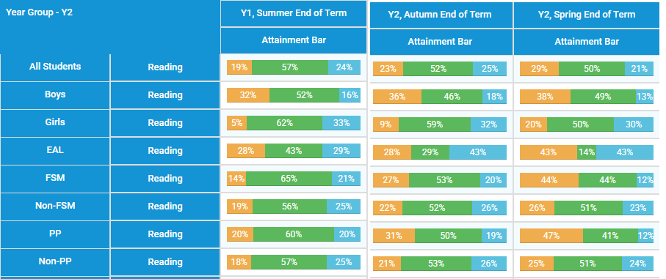  We need to continue to focus on this priority throughout this strategy as outcomes at the end of EYFS and Y1 for disadvantaged pupils were not as strong in reading at the end of the school year 2024-25.  Parents of disadvantaged pupils say that time and child refusal to comply are the biggest barriers for them in terms of reading at home with their child, so our response to this challenge needs to recognise and address this.  Pupil conferencing indicates that disadvantaged pupils require more support around the cultural and contextual content of reading, as well as fluency, if we are to develop confident pupils who love reading.  School also needs to have a strong reading offer for those pupils who do not read regularly at home. This will impact both on their knowledge and confidence as readers as well as enabling pupils to develop their social capital e.g. accessing social opportunities beyond school which in turn lead to a sense of belonging. (for example, reading celebration events/readathons)  As reading is the key to learning across all other subjects, and the biggest factor in terms of future educational success across all subjects we know that having high ambition for our disadvantaged pupils to be highly competent readers, who love reading is our highest priority.
4 | Disadvantaged pupils are more likely to experience barriers to good attendance, and we are aware that good attendance patterns develop a child’s sense of belonging and impact positively on their social capital.  In 2025 absence for disadvantaged pupils was 5.8% compared to 3.3% for other pupils. Whilst this shows improved attendance for disadvantaged pupils from the previous year (8.3%) we continue to have high ambition for our disadvantaged pupils to achieve the 96% attendance target in place for all pupils.  19% of disadvantaged pupils were PAs in 2024 compared to 4.6% of other pupils.  Whilst the absence data for disadvantaged pupils at this school is above the same group nationally, we recognise that pupils achieve well and enjoy school when attendance continuity is established.
5 | We know from research that children need to develop their social, cultural and financial capital to be successful at school and beyond. Some families require support to enhance experiences linked to the wider curriculum.  Exposure to a wide range of extra-curricular experiences impacts on both a child’s cultural and social capital, including exposure to art, science, sport and music. This exposure positively impacts on wellbeing, confidence and aspiration for disadvantaged pupils. We need to ensure that our disadvantaged pupils access our offer and enjoy a wide range of extra-curricular participation.
6 | Disadvantaged pupils may experience a greater need for around self-regulation, self-esteem or self-confidence. Parents of disadvantaged pupils requested support with managing behaviour from school providers to a greater extent than other parents.  Of the pupils working with our trauma informed practitioner around self -regulation, the majority of pupils were disadvantaged.  This impacts on resilience and independence in all aspects of school life including the academic. This results in a greater need in terms of support for pastoral, mental health and well- being.

Intended outcomes
This explains the outcomes we are aiming for by the end of our current strategy plan, and how we will measure whether they have been achieved.
Intended outcome | Success criteria
Improved oracy including vocabulary for disadvantaged pupils. | Assessments and observations indicate stronger oracy in disadvantaged pupils. This is evident when triangulated with other sources of evidence, including engagement in lessons, pupil books etc.  Voice 21 Pupil profiles will demonstrate improved confidence and competence in disadvantaged pupils’ ability to talk for a range of purposes and to talk across the curriculum.
Improved phonics outcomes for disadvantaged pupils in both Y1 and at the end of KS1. | 75% of disadvantaged Y1 pupils achieve the standard of the PSC in 2025, rising to 80% in 2026, and 85% in 2027.  90% of disadvantaged pupils have achieved the standard of the PSC by the end of KS1 in 2025, rising to 95% by 2027.
Disadvantaged pupils reading outcomes are comparable to outcomes achieved nationally at the end of EYFS and KS1 | The % of disadvantaged pupils achieving the ELG in reading is broadly in line with national all at the end of EYFS. (80%)  75% of disadvantaged pupils achieve EXS+ in reading at the end of KS1 in 2025 rising to 80% by 2026 and 83% in 2027.  All disadvantaged pupils access a strong in school reading offer and are consequently able to access reading rewards provided as well as enjoy quality 1:1 reading sessions with an adult.
Disadvantaged pupils attend school broadly in line with other pupils. | The attendance of disadvantaged pupils will be 95%+ (unless pupils have a significant medical need which impacts attendance, e.g. through extended periods of hospitalization) by 2027  Reduction in the percentage of disadvantaged pupils who are persistently absent to below 15% in 2025 and reduced further in the subsequent two years of this plan to below 10%.
Disadvantaged pupils access experiences that help develop the ‘whole child’ in terms of both social and cultural capital. Lack of financial capital is not a barrier to pupils accessing the full range of extra- curricular clubs on offer. | 95% + disadvantaged pupils in KS1 participate in at least one after school club each half term.  All disadvantaged pupils in KS1 access at least one peripatetic music class (violin or drumming)
Dysregulation including that which is a result of trauma, mental health and SEND is not a barrier to disadvantaged pupils being engaged and successful in all aspects of school life | Pupil’s successes in terms of managing their feelings and behaviour, will result in fewer incidents of negative behaviours, impacting positively on learning as evidenced in CPOMS.

Activity in this academic year
This details how we intend to spend our pupil premium (and recovery premium) funding this academic year to address the challenges listed above.

Teaching (for example, CPD, recruitment and retention) Budgeted cost: £31,584.00
Activity | Evidence that supports this approach | Challenge number(s) addressed
Develop a whole school approach to oracy by becoming a ‘Voice 21’ school with:  - subscription to the Voice 21 exchange for a second year.  - Continued training for two identified Oracy champions in school  - Extensive CPD for all staff on teaching effective speaking and listening, as well as vocabulary development across the curriculum.  - Jonathan Hannam – CPD for all staff on the use of oracy to deepen pupil knowledge across three specific subjects-History, Science and Art, with other subjects in focus in year 3.  - Be part of the HET oracy pilot group, to develop a three-year action plan for oracy.  - As part of the HET oracy group, Oracy champions will visit centres of excellence with the Standards Officer for Oracy, Lauren O Connor.  - Continue to develop Vocabulary offer across all subjects-Vocab Vicki to be replicated in all subjects to develop pupils confidence in using and applying a range of tier 2 and 3 vocab. Staff to expect pupils to use subject specific vocab throughout the day in a range of contexts and adults to model.  - English lead to develop CPD based on own learning and research. Monitoring by the English lead to focus on ‘oracy’ learning walks. | EEF Oral language Interventions  https://educationendowmentfoundation.org.uk/education-evidence/teaching-learning-toolkit/oral-language-interventions  The average impact of Oral language interventions is approximately an additional six months’ progress over the course of a year. Some studies also often report improved classroom climate and fewer behavioural issues following work on oral language.  Approaches that focus on speaking, listening and a combination of the two all show positive impacts on attainment.  EEF -  https://d2tic4wvo1iusb.cloudfront.net/production/eef-guidance-reports/literacy-ks-1/Literacy_KS1_Guidance_Report_2020.pdf?v=1726412882  d.9 Evidence indicates that success in literacy relies on the secure development of language,4 and these skills are amongst the best predictors of educational success.9 Phonological skills at age five, for example, predict reading ability at age seven and vocabulary at age five predicts child’s ability to complete the more complex tasks of reading at age 11.10 Research also indicates that from birth to six years of age is a key time when children’s capacity for metacognition and self regulation develops and that language skills, though ‘private’ and ‘inner’ speech, play a significant role in honing these skills.11 | 1
- SSP (Little Wandle) CPD for English lead, which will be cascaded through CPD for all staff to ensure that updated practice is shared and staff have sufficient knowledge and expertise.  - Disadvantaged pupils have 3X adult led reading sessions in class each week.  - Disadvantaged pupils who need reading in school ‘topped up’ to that received by many pupils at home, receive 3X 1:1 reading sessions delivered by staff trained in phonics.  - CPD including coaching from our English lead for all teachers to equip them with the skills and knowledge to teach high quality phonics lessons which impact pupil progress.  - Coaching and mentoring for all teachers by trained Teaching and Learning coaches to support further development of phonics, reading (comprehension) and writing.  - Feedback ‘in the moment’ for all disadvantaged pupils in reading and follow up writing lessons.  - Purchase of further Little Wandle resources for teachers to deliver high quality lessons.  - Teachers to visit a Little Wandle champion school to observe strong practice (X9) at Weston Park Primary school. | Phonics approaches have a strong evidence base that indicates a positive impact on the accuracy of word reading, particularly for disadvantaged pupils:  Phonics | Teaching and  Learning Toolkit | EEF  EEF -  https://d2tic4wvo1iusb.cloudfront.net/production/eef-guidance-reports/literacy-ks-1/Literacy_KS1_Guidance_Report_2020.pdf?v=1726412882 | 2, 3

Targeted academic support (for example, tutoring, one-to-one support, structured interventions)
Budgeted cost: £30,363.47
Activity | Evidence that supports this approach | Challenge number(s) addressed
Individual and small group speech and language support delivered, with specialist SALSA provision for disadvantaged pupils with the highest level of need.  Pre-teaching of stories, songs, rhymes and vocabulary for disadvantaged pupils in EYFS to develop confidence prior to whole class experiences (including discussion of character, themes and vocab) | https://d2tic4wvo1iusb.cloudfront.net/production/eef-guidance-reports/literacy-ks-1/Improving_Literacy_in_KS1_Recommendations_Poster.pdf?v=1726412882  Evidence indicates that success in literacy relies on the secure development of language,4 and these skills are amongst the best predictors of educational success.9 Phonological skills at age five, for example, predict reading ability at age seven and vocabulary at age five predicts child’s ability to complete the more complex tasks of reading at age 11. | 1
1:1 and small group daily Keep up in Y1 and Catch up in YR for disadvantaged pupils not keeping up in Phonics.  Additional daily phonics sessions targeted at disadvantaged pupils in Y2 who did not reach the standard of the phonics screen in Y1. | One to one tuition | Teaching and Learning Toolkit | EEF  Small group tuition | Teaching and Learning  Toolkit | EEF  Phonics | Teaching and  Learning Toolkit | EEF  Phonics approaches have a strong evidence base indicating a positive impact on pupils, particularly from disadvantaged backgrounds. Targeted phonics interventions have been shown to be more effective when delivered as regular sessions over a period up to 12 weeks: | 2, 3

Wider strategies (for example, related to attendance, behaviour, wellbeing)
Budgeted cost: £ 7751.60
Activity | Evidence that supports this approach | Challenge number(s) addressed
Whole school attendance policy and procedures to be reviewed alongside the Attendance action plan.  Attendance Officer to send regular facebook/email (Moments matter) updates to share the social and academic benefits of regular school attendance, with parents each week.  Attendance governor to conduct pupil and parent surveys to identify barriers to attendance.  Attendance awards for weekly and termly attendance and share this in a newsletter, assemblies and classrooms.  Ongoing CPD for the attendance champion and attendance officer to attend attendance network meetings lead by the HAMWIC trust alongside the strategic lead to ensure consistency of approach and implementation of new strategy, procedures and processes.  Attendance champion/officer to attend meetings with HAMWIC attendance allocated lead.  Attendance officer to attend termly parent meetings with attendance champion to review and support improving attendance outcomes for pupils who are PA.  CPD for all teaching and support staff on their role in positively impacting the attendance of their pupils.  Provide ELSA support to increase engagement in school/reduce barriers linked to mental health and wellbeing.  Fund a Family support worker to undertake home visits/ support with transport to school  where needed | Poor attendance at school is linked to poor academic attainment across all stages. Some parental communication approaches and targeted parental engagement interventions show promise in supporting pupil attendance.  EEF Working with Parents to Support Children’s Learning guidance report includes advice around how to support attendance. The EEF Rapid Evidence Review: Attendance Interventions examines the existing research on interventions that aim to improve attendance.  Children are more likely to learn effectively when they have had a healthy breakfast. Encouraging parents to provide this at home is one option; another is to provide a breakfast club in school. Children most likely to benefit should be sensitively targeted through personal contact with parents, sending personalised letters, and proactive efforts to get children into school on time. Where this approach was adopted, parents described feeling that staff cared about them and recognised some of the individual challenges that they faced. | 4
Trauma informed practitioner to lead interventions to support disadvantaged pupils to understand and manage emotions and ensure that pupils are in school and ‘learning ready’ This includes ELSA support sessions as well as lunch time nurture groups. | ‘A key component of the interventions was building effective partnerships between schools and parents, through discussions, meetings and conferences. The purpose of these partnerships was to identify issues leading to absences and collaboratively source effective solutions to the problems.’  EEF Social and emotional  learning | 4 6
Disadvantaged pupils have the opportunity to access a wide range of extra-curricular activities that develop their social and cultural capital free of charge.  Disadvantaged pupils supported to access peripatetic violin and drumming lessons. This in turn will enable a wide range of opportunities to perform to a range of audiences, as well as being the ‘experts’ in their instrument in our school. | Parental Engagement EEF  Lack of access to real life cultural and extracurricular experiences impacts on confidence and associated vocabulary for disadvantaged pupils.  EEF -Arts participation  Arts participation approaches can have a positive impact on academic outcomes in other areas of the curriculum. | 5 6
Cover for EYFS leader to run a four-week programme with new parents, as to how to support children with  CL/ Literacy in the Early  Years | Provide practical strategies to support learning at home EEF working with parents’ guidance report

Total budgeted cost: £69,699

Part B: Review of the previous academic year (2024-25)

Outcomes for disadvantaged pupils
We have analysed the performance of our school’s disadvantaged pupils during the previous academic year, drawing on national assessment data and our own internal summative and formative assessments.
The data demonstrated:

Oracy:

Voice 21 strategies have been implemented (year 1 of 3) and all staff have been trained by our Oracy champions on the implementation of high-quality oracy teaching. The quality of teaching of oracy is high and the strength of this work has been validated by Ofsted as the school was again graded outstanding in all aspects of its work in April 2025.
‘In particular, the school has considered the impact of the pandemic on pupils’ communication, language and social skills. Consequently, the school prioritises developing these skills throughout the curriculum. For example, pupils learn how to talk clearly and fluently about what they are being taught.’
Monitoring by SLT demonstrates the impact of our oracy work, especially for our disadvantaged pupils who develop a wide vocabulary alongside their peers and develop the skills to ‘stand to speak’ confidently and articulately in from of a range of audiences. Our focus on oracy has seen our disadvantaged pupils participating more widely in discussions in groups of all sizes, as they now have the language and supportive sentence stems to confidently share their ideas and expert knowledge.
The impact of our oracy is evidenced in the EYFS summative data, where in 2025, we have achieved an increased % of disadvantaged pupils achieving the ELG in speaking from the previous year.

Phonics
Our strategy aims to improve phonics outcomes at the end of KS1 in both Y1 and Y2 for disadvantaged pupils. This target was derived from the 2022-23 outcomes which saw only 58% of disadvantaged pupils achieve the required standard. To help us gauge the performance of our disadvantaged pupils we compare their results to those for non-disadvantaged pupils at national level.

The use of a validated SSP, supported by high quality, continuous CPD for all staff, and ‘rapid catch up’ for pupils falling behind their peers, continues to improve outcomes for all pupils. in 2024 the % of disadvantaged pupils achieving the expected standard was 79% compared to the national of 80% for non-disadvantaged pupils. The % of disadvantaged pupils achieving the highest mark band in the screen was significantly above the national picture for disadvantaged pupils and above the band for other pupils nationally.
In 2025, at the end of Y1, all disadvantaged pupils, except those with significant SEND, achieved the standard of the PSC.
Disadvantaged pupils with SEND in Y1 made significant progress over the course of Y1 in terms of their PSC scores, with all achieving just below the 32-mark threshold, at the end of the year from a low starting point. All will be provided with additional phonics support in Y2 and are expected to meet the standard at the end of KS1(except for two pupils with EHCPs )

The data demonstrates that progress in phonics for disadvantaged pupils is strong, although a focus on phonics continues to be a priority. We will continue to provide additional teacher led provision to enable disadvantaged pupils not reaching the standard in Y1, to achieve it at the end of KS1. This will be through 1:1 and small group tuition focusing on split digraphs, longer and pseudo words.

Three Y2 disadvantaged pupils who re-took the PSC in 2025 did not pass, all have additional significant SEND and all made significant progress from their end of Y1 scores, all scoring just below the threshold.

Reading:
Extensive CPD for all teaching and support staff, including coaching for all teachers on Little Wandle reading was impactful with all teaching at least good. The commitment of PPG funding to supporting reading was significant, with five adults required to support the methodology of the SSP. The Keep up and Catch up support provided by our HLTA Little Wandle champion’ significantly impacted outcomes.
In EYFS, a minority of pupils were disadvantaged (7/90) but the % achieving a GLD was below national other as was the % achieving the ELG in reading. Disadvantaged pupils made good progress from their starting points in their progress through the SSP (phonics and reading)
At the end of KS1, disadvantaged pupils achieved significantly above the national average in reading as well as above other pupils at this school
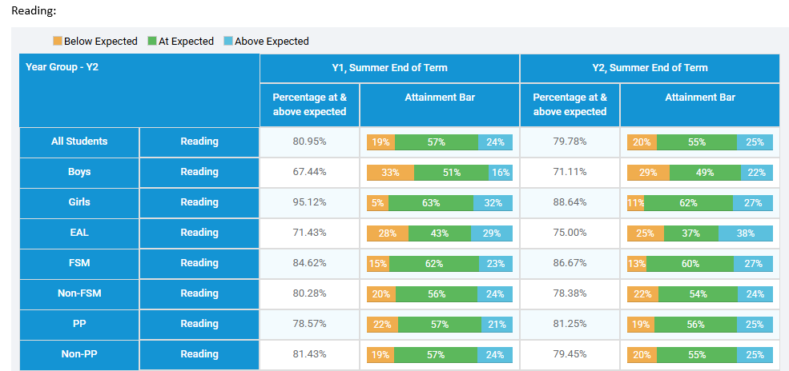

Improving attendance
Our strategy prioritised improving attendance for our disadvantaged pupils, to enable them to benefit from high quality teaching as well as the social opportunities and curriculum enhancements on offer, in line with their non -disadvantaged peers.

Our attendance action plan successfully reduced the % of PAs who were disadvantaged through a wide range of support mechanisms, including the opportunity to plan a support programme to secure improved attendance, with our Family support team. This enabled the school to enhance support, particularly for pupils where external referrals at Early Help could be beneficial in securing change.

Adapting the flow of information to parents supported improvements, with parents informed of days missed rather than % attendance, introducing a weekly ‘Moments Matter’ newsletter, showing parents what has been happening in school, and sharing what will happen the following week, for pupils to enjoy and introducing a range of rewards for improved as well as high attendance, all supported parents to improve their child’s attendance across the academic year.

Disadvantaged pupils attended above the group nationally, but we now need to focus on raising the attendance of the group to the level of other pupils. Equally we will be focusing on reducing the Persistent Absence of disadvantage pupils in line with that of other pupils. Whilst there is still progress to be made, the data demonstrates year on year improvement from previous academic years; in 2023-23 absence for disadvantaged pupils was 6.9% and Persistent Absence 20.6%, in 2024-25 absence for disadvantaged pupils was 6.7 and Persistent Absence 20.4%. Last year absence was reduced to 5.8 and Persistent Absent reduced to19.4%

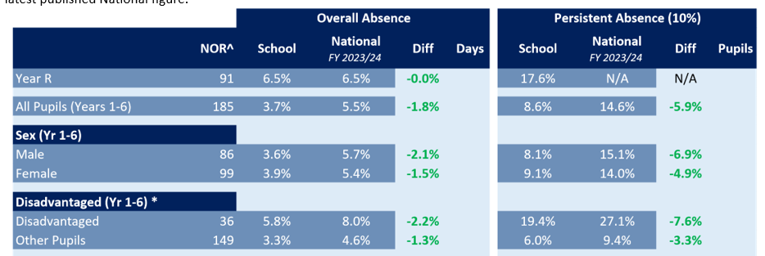

Our strategy included increasing participation by disadvantaged pupils in extra-curricular activities, representing both sport and the arts, The % of disadvantaged pupils attending extra -curricular clubs was high for disadvantaged pupils with 90%+ accessing at least one club in each term and many pupils accessing more than one.

Our offer of peripatetic music-violin/drumming has excellent uptake with over 100% of disadvantaged pupils in Y2 learning violin/playing drums and 100% of Y1 disadvantaged pupils accessing drumming.

Our evaluation of the approaches delivered last academic year indicates that Sholing Infant School has progressed towards achieving the outcomes set; however, all targets need to continue as priorities, particularly given the size of our disadvantaged group- below 20% overall and below that % in specific year groups, means that it is not statistically significant and there is year on year cohort variation. The targets set for outcomes for disadvantaged pupils in phonics, impacted positively on reading outcomes too. Our targeted and wider strategies impacted positively on the attendance and wellbeing of our disadvantaged pupils, as evidenced in our work in the areas of attendance and extra-curricular offer, increasing the cultural capital and aspirations of our disadvantaged pupils.

We have reviewed our strategy plan and made changes to how we intend to use some of our budget this academic year. The Further Information section below provides more details about our planning, implementation, and evaluation processes.

Externally provided programmes
Please include the names of any non-DfE programmes that you used your pupil premium (or recovery premium) to fund in the previous academic year.
Programme | Provider
N/A

Service pupil premium funding (optional)
For schools that receive this funding, you may wish to provide the following information: How our service pupil premium allocation was spent last academic year
One service child was on roll last academic year.
The impact of that spending on service pupil premium eligible pupils
Service pupil premium was used to enable the child to access peripatetic music provision and extracurricular clubs. Academically, our service pupil premium eligible child was working at Greater Depth in all subjects.

Further information
Our 2024-27 strategy will build upon last year’s successes further as we move into Year 2 of our Pupil Premium strategy. As we develop our expertise in delivering our SSP, we continue to set the highest targets for our disadvantaged pupils with continued investment in securing high quality first teaching from a highly trained staff.

Our focus on securing this quality will be enhanced by an increased focus on coaching, to secure the highest level of expertise in all teachers and support staff too. This focus on teaching and targeted intervention will ensue that the positive outcomes achieved in the previous strategy, will be strengthened further.

The addition of our focus on developing high levels of oracy amongst our disadvantaged pupils over the next two years will underpin our drive to improve the confidence, aspirations and outcomes of pupils, impacting on their ability to talk and to listen effectively in a range of contexts. Our ambition is that this will impact positively on their achievement across all areas of the curriculum.

Our ongoing drive to increase attendance further will be included in our strategy as we develop our pupil’s understanding of our ‘Moments Matter-Miss school- Miss out!’ mantra. Our target for our disadvantaged pupils in terms of attendance in 2026 will be to reduce absence to 4.5% or below and to

Continuing to ensure that our disadvantaged pupils enjoy the wide range of Arts and sports opportunities will be an ongoing focus until we achieve 100% of our disadvantaged pupils accessing experiences that we hope will develop their future passions and expertise!

