

Reviewed on |  | April 2026 |  | Review frequency |  | Annually
Next review due |  |  |  | Template Yes / No |  | Yes
Owner |  | HET |  | Approved by |  | L.Houghton

Mobile Phone Policy

History of Policy Changes
Date | Page | Change | Origin of Change

1. Scope 3
2. Definitions 4
3. Responsibilities 4
4. Main Body: Use of mobile phones by pupils 4
5. Contacting your child in the school day 6
6. Exceptions to the policy 6
7. Monitoring & Review 6
8. Link to other HET policies and government guidance 6
9. Appendices 7

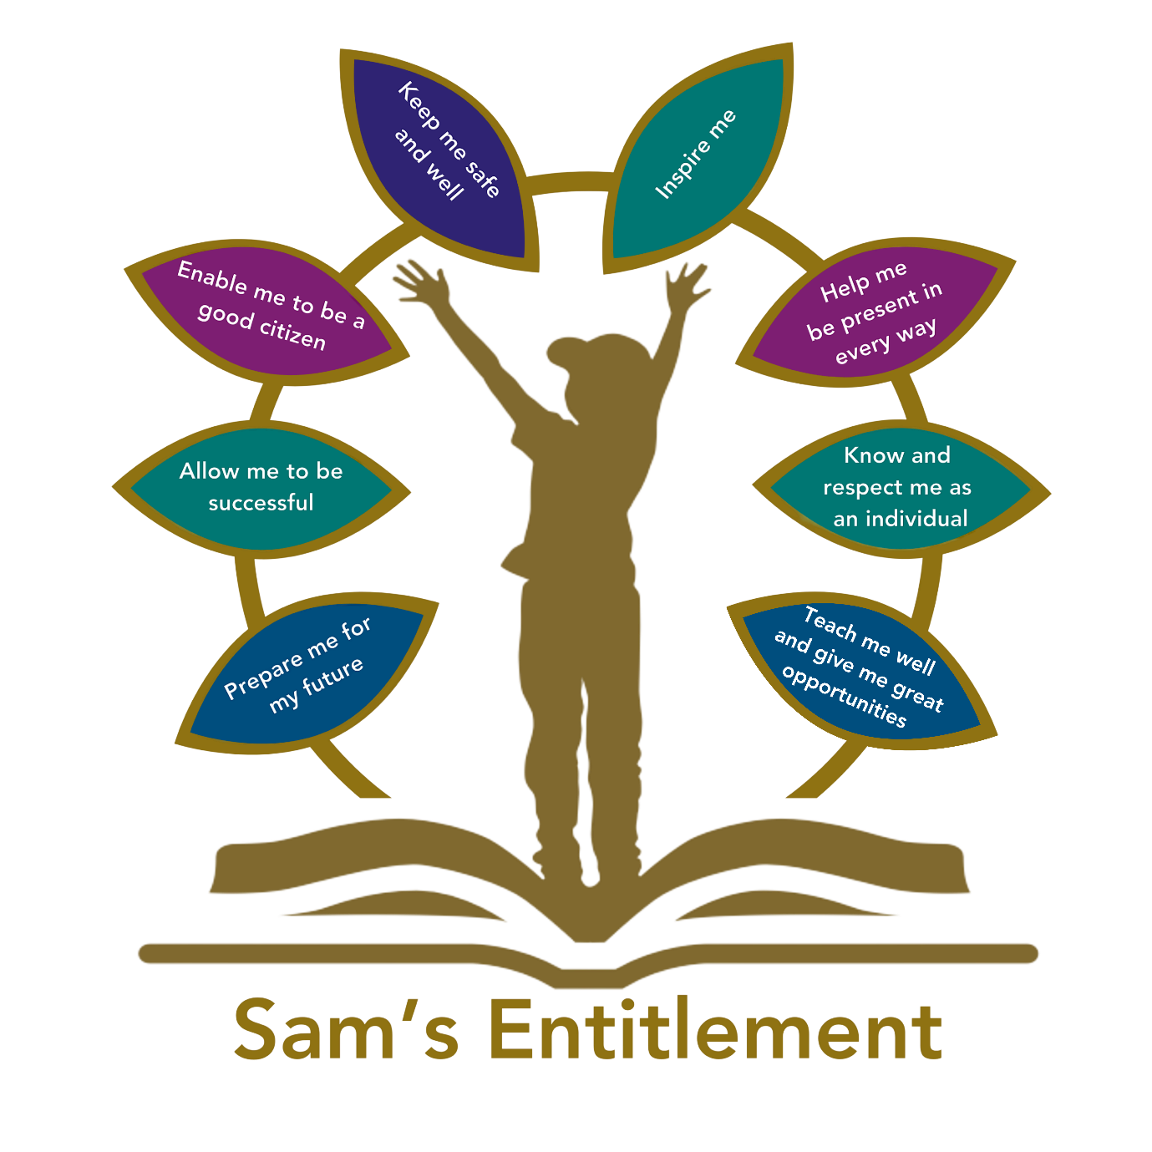
Introduction

Hamwic Education Trust (HET) believe that all pupils should receive a high quality, enriching, learning experience in a safe and inclusive environment, which promotes excellence through a broad curriculum that prepares them for their future and opens doors to a diverse array of opportunities as well as that all pupils and adults within HET flourish as individuals and together. This policy sets out the expectations for pupils regarding mobile phones in Sholing Infant School.

Scope

This policy is specifically for parents and children at Sholing Infant School.
Separate mobile phone expectations are written for HET staff in the Acceptable use of IT policy and the Employee Handbook (item 7 section 1).
This policy covers all parts of the school day, including social times.

Definitions
- Mobile phone includes telephones, tablets and other communication devices (such as smartwatches) that allow for sending and receiving messages or notifications, recording or videoing.
- DfE refers to the Department for Education
- Governors refers to the local governing committee for this school
- Pupils refers to all children on roll at Sholing Infant School .

Responsibilities

- It is the Headteacher’s and Local Governors’ responsibility to ensure this policy remains up to date with DfE expectations.
- It is the parents’/carers’ responsibility to ensure that children follow the expectations of this policy.
- It is responsibility of all school staff (including those who are contracted by agencies) to ensure this policy is enacted accurately and consistently
- It is the pupils’ responsibility to comply with expectations and behaviours in this policy

Main Body: Use of mobile phones by pupils

The DfE expect that all schools should be mobile-free environments for pupils. This is to ensure that interruptions to learning are minimised and that behaviour is not adversely affected by the access to a range of media and communication supported by mobile phones.

In line with DfE guidance, our expectations are that mobile phones should not be brought to school. If a staff member sees a pupil with a mobile phone or hears a mobile phone ringing in a child’s bag, it will be removed and taken to the main school office where it can be collected by a parent. A phone will not be returned directly to the pupil.

Headteachers, or staff they authorise, have a statutory power to search a pupil or their possessions where they have reasonable grounds to suspect that the pupil is in possession of a prohibited item as set out in legislation (Education Act, 2006) or any item identified in the school rules as an item that may be searched for. This applies to mobile phones as stated in our behaviour policy. Staff should refer to the government guidance on searching, screening and confiscation in schools guidance regarding searching a pupil.

Exceptions to the policy

There will be exceptional occasions where a pupil might require their phone, for example due to monitoring a diagnosed medical condition. In these situations, the parent should contact the Headteacher so that an appropriate plan can be put in place.

Residential visits and school trips

The above policy applies to all school day visits.

Monitoring & Review

This policy will be reviewed biannually by Governors and the Headteacher of Sholing Infant School School. Where updates from government are provide ahead of a review date, the policy will be updated accordingly.

Link to other HET policies and government guidance

Acceptable use of IT policy – Employees. 2025-2025 (HET)
Acceptable use of IT policy – Pupils. 2025-2025 (HET)
Behaviour Policy 2026
Education and Inspections Act 2006, Section 89
Employee Handbook 2025- 2026 (HET)
Equalities policy 2024-2024 (HET)
First Aid and Medical Conditions Policy 2025-2026 (HET)
Mobile phones in Schools – DfE guidance Feb 2026 Mobile phones in schools - GOV.UK
Searching, Screening and Confiscation DFE July 2022
Visitor Guidance School

Appendices

Appendix 1: Parental agreement template

Appendix 2: Permission form allowing a pupil to bring their phone to school

Please only hand this permission slip in at the school office.
PUPIL DETAILS
Pupil name

Year group

Class

Parents/Carers name(s)

The school has agreed to allow pupils in year xxxx to bring their mobile phone to school because they travel to or from school by themselves.

Pupils who bring a mobile phone to school must abide by the school’s policy on the use of mobile phones, and its code of conduct/acceptable use agreement.

The school reserves the right revoke permission if pupils do not abide by the policy.

Parent signature: ___________________________ Date: _________

Pupil signature: _______________________________________

