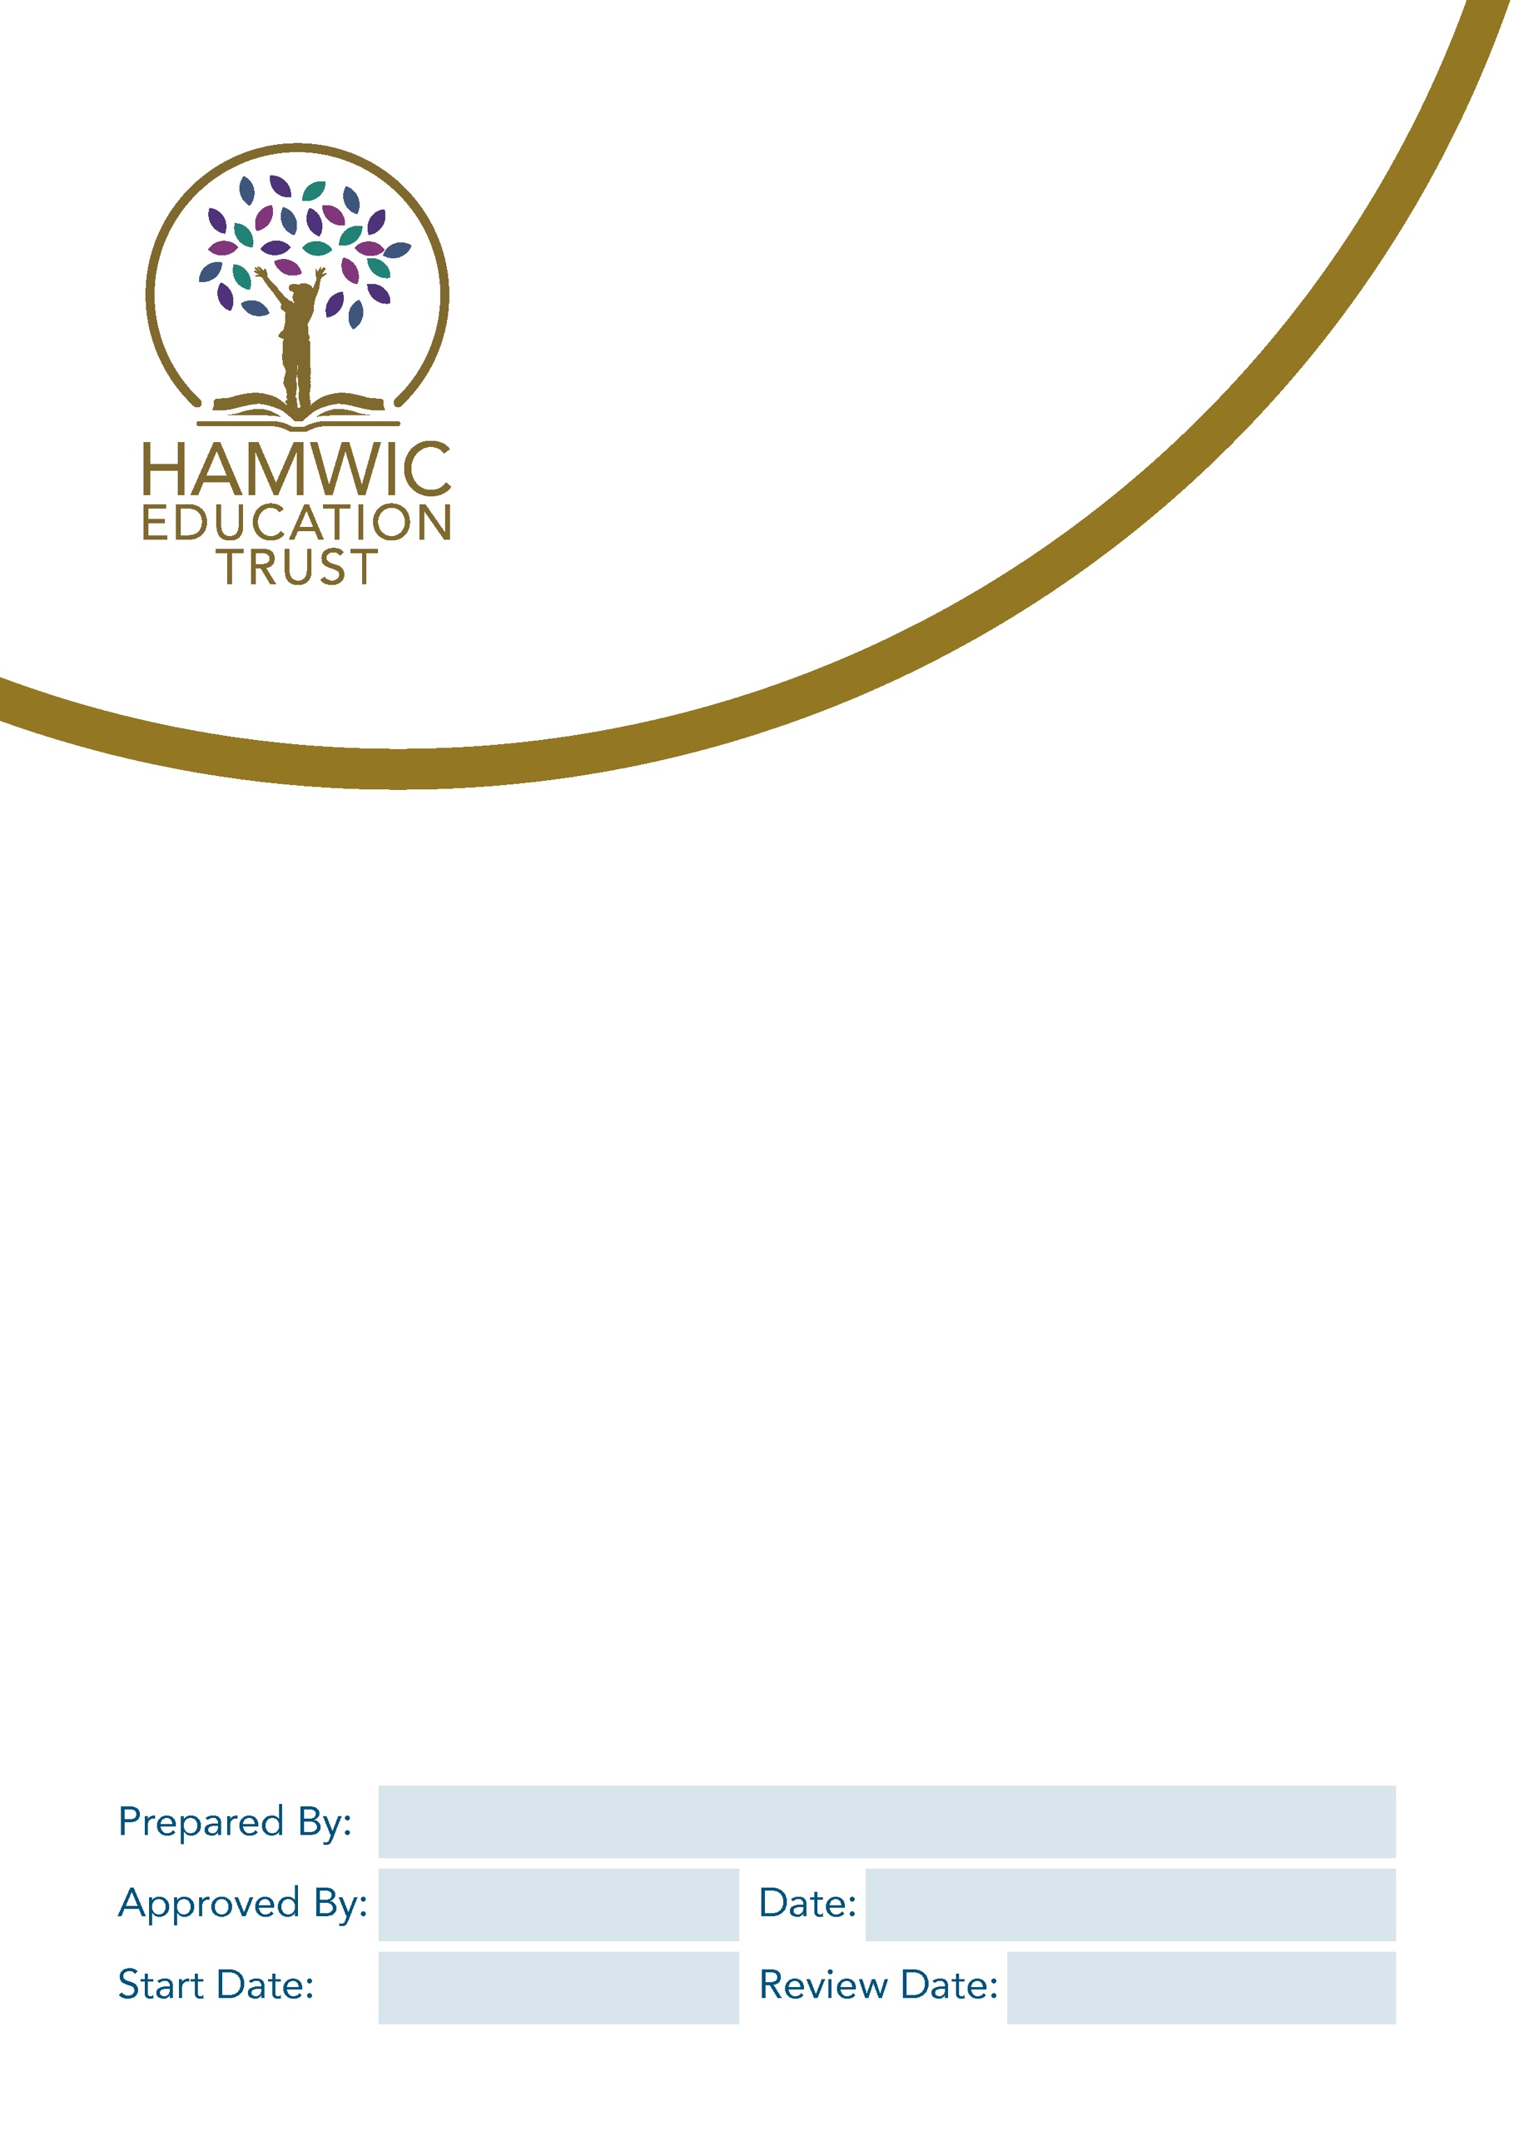

Relationships Education, Relationships
Sex Education (RSE) and Health Education Policy

Director of Education – Primary
September 2026
September 2025
September 2025
CEO
Contents
1. Introduction and statutory guidance 3
2. Definitions and key areas of teaching 3
3. The Science Curriculum - body changes and life cycles 4
4. Health and wellbeing 4
5. Relationships and health curriculum delivery-primary 5
6. Ensuring the church values are reflected (church schools only) 6
7. Roles and responsibilities 7
8. Training 8
9. Monitoring of RHE 8
APPENDIX 1 – Expectations for Relationships Education – By the end of Primary 8
APPENDIX 2 – Expectations of Health Education -By the end of Primary Education 10
APPENDIX 3 – RHE curriculum overview 12

Introduction and statutory guidance
This Policy is written in line with the Relationships Education, Relationships and Sex Education (RSE) and Health Education Statutory Guidance September 2021. The policy has been produced in partnership with Hamwic Education Trust.

The statutory guidance used to inform this policy is listed below
- As a primary academy school we must provide relationships education to all pupils as per section 34 of the Children and Social work act 2017.
- We do not have to follow the National Curriculum but we are expected to offer all pupils a curriculum that is of similar breadth and depth to the National Curriculum. This includes the requirement to teach the elements of sex education contained in the science curriculum. At Sholing Junior School we follow the national curriculum for science.
- In teaching Relationships and Health Education, we are required by our funding agreements to have regard to guidance issued by the secretary of state as outlined in section 403 of the Education Act 1996.

Definitions and key areas of teaching
Relationship Education – Primary
Relationship Education will focus on teaching the fundamental building blocks and characteristics of positive relationships, with particular reference to friendships, family relationships, and relationships with other children and adults.

All teaching will reflect the Equality Act 2010 ensuring there is no discrimination for any pupil or family with protected characteristics. This does not prevent church schools from teaching about a faith perspective regarding relationships as part of the wider teaching.

Children will be taught in an age-appropriate way about the characteristics and values of healthy relationships, including area such as differences, boundaries, respect, trust and kindness. Teaching will focus on both face-to-face and online relationships recognising the significance of the digital world we now embrace. Teachers will also take all opportunities to discuss positive emotional and mental well-being with children. The characteristics that will be taught are also reflected in the school values of…
- Kindness, Curiosity, Success
- Being Safe, Ready and Resectful

Learning will be planned to meet the objectives set out in the Relationships Education, Sex Education (RSE) and Health Education Statutory Guidance 2021 (see appendix 1), under the broad headings of
- Families and people who care for me
- Caring friendships
- Respectful relationships
- Online relationships
- Being safe

The Science Curriculum - body changes and life cycles
Sex Education beyond the requirements of the science national curriculum is not compulsory in primary schools; however, we recognise the importance of preparing children well for secondary school. At Sholing Junior School, children will be taught about puberty as set out in the expectations of the science National Curriculum. In line with year group expectations, children will learn about external body parts, changes in the human body from birth to old age, and reproduction in some plants and animals. As part of the life cycle objectives, Year 6 pupils will be taught the science of how a baby is conceived and born. In our school, we only teach the body changes and life cycles required by the science national curriculum. As a consequence, parents do not have the right to withdraw children from these scientific lessons. (Parents will have the opportunity to discuss and view the content of the Year 5/6 curriculum before it is taught.)

We recognise that during such lessons, children may have questions as a result of their learning. We are mindful that unanswered questions often lead to misconceptions and will aim to avoid this where possible.
When questions arise, they will be dealt with as follows.
- Questions directly linked with the science taught will be answered factually for the class or individual. Children will be given the opportunity to write anonymous questions submitted via a question box
- Questions of a personal nature directly linked to the teaching may need to be dealt with by talking directly to the child with an additional adult also present. If deemed necessary, teachers will inform parents of the questions asked. Wherever possible, questions will be answered in front of all pupils via the question box.
- Where a question relates to sex education beyond the scientific teaching, children will be advised to ask their parents or carers.

Health and wellbeing
Health and wellbeing education will focus on the characteristics of good physical health and mental wellbeing. It will include aspects such as the importance of exercise, good nutrition and the normal range of emotions we experience. Pupils will be taught about moderation, including online and the positive two-way relationship between good physical health and good mental wellbeing.

Learning will be planned at an age-appropriate level to meet the objectives set out in the Relationships Education, Sex Education (RSE) and Health Education Statutory Guidance 2021 (see appendix 2), under the broad headings of
- General wellbeing
- Internet safety and harms
- Physical health and fitness
- Healthy eating
- Drugs, alcohol and tobacco
- Health protection and prevention
- Personal safety
- Basic first aid
- Developing bodies

Relationships and health curriculum delivery-primary
Relationships and Health Education (RHE) is taught through weekly lessons and links with the whole school assembly programme. An overview of the broad topics covered and the linked Relationship and Health objectives can be found in appendix 3.
Biological aspects of sex education are taught within the science curriculum in line with the age expectations set out in the National curriculum. A number of aspects of the RHE link closely to science, computing, PE and DT. Where this is the case, messages will be reinforced within these subjects (appendix 4).
The areas of learning are taught within the context of family life taking care to ensure that there is no stigmatisation of children based on their home circumstances (families can include single parent families, LGBT parents, families headed by grandparents, adoptive parents, foster parents/carers amongst other structures) along with reflecting sensitively that some children may have a different structure of support around them (for example: looked after children or young carers).
We are mindful that some children with SEND may need additional support to understand the themes and learning within the relationships and health education curriculum. Teachers will draw on their knowledge of the child to ensure learning is differentiated appropriately.

We will keep abreast of local contextual issues and support these through our curriculum where possible.
In Southampton, we are aware that the locality is towards the end of the 2017-2025 Health and well-being plan and that the pandemic has slowed progress. The locality also now has a 2022 – 2027 Education Strategy plan with the vision of: we want all children and young people in Southampton to get a good start in life, live safely, be healthy and happy and go on to have successful opportunities in adulthood. A rise in domestic abuse and violence against women and girls has led the city council to produce a targeted 2023-2027 plan.

Roles and responsibilities
The local governing committee
The local governing committee will consult parents, suggest amendments to the headteacher and approve the RHE policy. They will hold the headteacher to account for its implementation.
The headteacher
The headteacher is responsible for ensuring that RHE is taught consistently across the school, and for managing requests to withdraw pupils from any non-scientific components of sex education (in line with the science national curriculum).
The Headteacher will determine whether any aspects of the curriculum will be delivered by professionals outside of the school (e.g., the school nurse may deliver information about menstruation).
Staff
Teaching staff are responsible for:
- Delivering Relationships and Health Education in a sensitive way and in accordance with their year group expectations
- Modelling positive attitudes to Relationships and Health Education
- Monitoring progress
- Responding to the needs of individual pupils
- Responding appropriately to pupils whose parents wish them to be withdrawn from non-statutory components of RSE and Health Education
Staff do not have the right to opt out of teaching RHE. Staff who have concerns about teaching RHE are encouraged to discuss this with the headteacher. The leader for RHE at Sholing Junior School is Danielle Lebbern (Deputy Headteacher).
Pupils
Pupils are expected to engage fully in RHE and, when discussing issues related to RHE, treat others with respect and sensitivity.

Training
Staff are trained on the delivery of RHE and biologic aspects of the science curriculum as part of their induction and it is included in our continuing professional development calendar. Staff have access to the RHE Policy and revisit this when changes occur.
The headteacher will also invite visitors from outside the school, such as school nurses or sexual health professionals, to provide support and training to staff teaching RHE.

Monitoring of RHE
The delivery of RHE is monitored by Senior Leaders and the RHE leader through:
- Planning scrutiny
- Lesson observation
- Analysis of pupils’ work and discussions with pupils
- Monitoring of SEN plans and IEPs where appropriate
- Sampling of pupils’ end of year reports

Pupils’ development in RHE is monitored by class teachers as part of our internal assessment systems.
This policy will be reviewed annually and will require approval by the local governing committee.

APPENDIX 1 – Expectations for Relationships Education – By the end of Primary
Families and people who care for me | Pupils should know  1. that families are important for children growing up because they can give love, security and stability.  2. the characteristics of healthy family life, commitment to each other, including in times of difficulty, protection and care for children and other family members, the importance of spending time together and sharing each other’s lives.  3. that others’ families, either in school or in the wider world, sometimes look different from their family, but that they should respect those differences and know that other children’s families are also characterised by love and care.  3. that stable, caring relationships, which may be of different types, are at the heart of happy families, and are important for children’s security as they grow up.  4. that marriage represents a formal and legally recognised commitment of two people to each other which is intended to be lifelong.  5. how to recognise if family relationships are making them feel unhappy or unsafe, and how to seek help or advice from others if needed.
Caring friendships | Pupils should know  1. how important friendships are in making us feel happy and secure, and how people choose and make friends.  2. that through no fault of their own, not every child will have the friends they would like, that most people feel lonely at some point and that there is no shame in feeling lonely or talking about it.  3. the characteristics of friendships, including mutual respect, truthfulness, trustworthiness, loyalty, kindness, generosity, trust, sharing interests and experiences and support with problems and difficulties.  4. that healthy friendships are positive and welcoming towards others, and do not make others feel lonely or excluded.  5. that most friendships have ups and downs, and that these can often be worked through so that the friendship is repaired or even strengthened, and that resorting to violence is never right.  6. how to recognise who to trust and who not to trust, how to judge when a friendship is making them feel unhappy or uncomfortable, managing conflict, how to manage these situations and how to seek help or advice from others, if needed.
Respectful relationships | Pupils should know  1. the importance of respecting others, even when they are very different from them (for example, physically, in character, personality or backgrounds), or make different choices or have different preferences or beliefs.  2. practical steps they can take in a range of different contexts to improve or support respectful relationships.  3. the conventions of courtesy and manners.  4. the importance of self-respect and how this links to their own happiness.  5. that they can expect to be treated with respect by others, and that in turn they should show respect to others, including those in positions of authority.  5. about different types of bullying (including cyberbullying), the impact of bullying, responsibilities of bystanders (primarily reporting bullying to an adult) and how to get help.  6. what a stereotype is, and how stereotypes can be unfair, negative or destructive.  7. the importance of respecting boundaries, including understanding permission-seeking and giving in relationships with friends, peers and adults.
Online relationships | Pupils should know  - 1. that people sometimes behave differently online, and that this can lead to dangerous situations. For example, someone pretending to be someone they are not, or an adult presenting as a child, to  get another person to do something for them that they don’t want to do or shouldn’t do.  2. that children should be respectful in online interactions, and the same principles apply to online relationships as to face-to-face relationships, including when we are anonymous.  3. the rules and principles for keeping safe online, how to recognise risks, harmful content and contact, and how to report them.  4. how to critically consider their online friendships and sources of information including awareness of the risks associated with people they have never met.  5. how information and data is shared and used online, including the risks of sending images and information (without discussing details of sexual imagery).  6. about online risks, including that any material someone provides to another has the potential to be circulated online and that once a picture or words has been circulated there is no way of deleting it everywhere and no control over where it ends up.  7. that there is a minimum age for joining social media sites (normally age 13) in part to protect children from inappropriate content or unsafe contact with older social media users, who may  be strangers, including other children and adults.  8. the importance of avoiding putting pressure on others to share information and images online, and strategies for resisting peer pressure. This should be covered without discussing details of  sexual imagery.  9. who to go to for advice and support when they feel worried or concerned about something they have seen or engaged with online. Pupils should understand what they should do if they see something online that makes them feel worried. Pornography should not be referenced in primary education.
Being safe | Pupils should know  1. what sorts of boundaries are appropriate in friendships with peers and others (including in a digital context). This can include learning about boundaries in play and in negotiations about space, toys, books, resources and so on.  2. about the concept of privacy and its implications for both children and adults; including that it is not always right to keep secrets if they relate to being safe.  3. that each person’s body belongs to them, and the differences between appropriate and inappropriate or unsafe contact, including physical contact.  4. how to respond safely and appropriately to adults they may encounter (in all contexts, including online), including those they do and do not know.  5. how to recognise and report feelings of being unsafe or feeling bad about any adult.  6. how to ask for advice or help for themselves or others, and to keep trying until they are heard.  7. how to report concerns or abuse, and the vocabulary and confidence needed to do so.  8. where to get advice e.g. family, school and/or other sources.

APPENDIX 2 – Expectations of Health Education -By the end of Primary Education
General Wellbeing | Pupils should understand  1. the benefits of physical exercise, time outdoors, and helping others for wellbeing and happiness. Simple self-care techniques, including the importance of rest, time spent with  friends and family and hobbies, interests and community participation.  2. the importance of promoting general wellbeing and physical health.  3. the range and scale of emotions (e.g. happiness, sadness, anger, fear, surprise, nervousness) that they might experience in different situations. Pupils should understand that worrying  and feeling down are normal and affect everyone at different times and are not in themselves a sign of a mental health condition.  4. how to recognise feelings and use varied vocabulary to talk about their own and others’ feelings.  5. how to judge whether what they are feeling and how they are behaving is appropriate and proportionate.  6. that isolation and loneliness can affect children, and the benefits of seeking support.  7. that bullying (including cyberbullying) has a negative and often lasting impact on mental wellbeing.  8. that change and loss, including bereavement, can provoke a range of feelings; that grief is a natural response to bereavement, and everyone grieves differently.  9. where and how to seek support (including recognising the triggers for seeking support), including who in school they should speak to if they are worried about their own or someone  else’s mental wellbeing or ability to control their emotions (including issues arising online).  10. that it is common to experience mental health problems, and early support can help resolve problems.
Healthy eating | Pupils should know  1. what constitutes a healthy diet (including understanding calories and other nutritional content).  2. the principles of planning and preparing a range of healthy meals.  3. the characteristics of a poor diet and risks associated with unhealthy eating (including, for example, obesity and tooth decay) and other behaviours (e.g. the impact of alcohol on diet  or health).
Drugs, alcohol, tobacco and vaping | Pupils should know  1. the facts about legal and illegal harmful substances and associated risks, including smoking, vaping, alcohol use and drug-taking.
Health  protection and  prevention | Pupils should know  1. how to recognise early signs of physical illness, such as weight loss, or unexplained changes to the body.  2. about safe and unsafe exposure to the sun, and how to reduce the risk of sun damage, including skin cancer.  3. the importance of sufficient good quality sleep for health and the impact of poor sleep on weight, mood and ability to learn.  4. about dental health and the benefits of good oral hygiene and inter-dental cleaning, including regular check-ups at the dentist.  5. about personal hygiene and germs including bacteria, viruses, how they are spread and treated, and the importance of handwashing.  6. the facts and science relating to allergies, immunisation and vaccination
Personal safety | Pupils should know:  1. about hazards (including fire risks) that may cause harm, injury or risk and ways to reduce risks.  2. how to recognise risk and keep safe around roads, railways and water, including the water safety code.
Basic First Aid | Pupils should know:  1. how to make a clear and efficient call to emergency services if necessary, including the importance of reporting incidents rather than filming them.  2. concepts of basic first aid, for example dealing with common injuries and ailments, including head injuries.
Developing  bodies | This should not be taught before year 4.  Pupils should know:  1. about growth, change and the changing adolescent body, this topic should include the human lifecycle. Puberty should be mentioned as a stage in this process.  2. the key facts about the menstrual cycle, including physical and emotional changes.

 | Relationships |  |  | Living in the wider world |  |  | Health and Wellbeing
 | Autumn Term |  |  | Spring Term |  |  | Summer Term
Year 3 | Growing and  Changing:  Personal strengths  and achievements;  managing and re-  framing setbacks | Keeping safe:  Risks and hazards;  safety in the local  environment and  unfamiliar places | Belonging to a  Community:  The value of rules  and laws; rights,  freedoms and responsibilities | Respecting ourselves and others: Recognising  respectful behaviour;  the importance of  self-respect;  courtesy and being polite | Media literacy and  digital resilience: How the internet  is used; assessing  information online | Safe relationships: Personal boundaries; safely responding to others; the  impact of hurtful  behaviour | Physical health and Mental wellbeing:  Health choices and  habits; what affects  feelings; expressing  feelings | Families and  Friendships:  What makes a  family; features of  family life | Money and work: Different jobs and  skills; job stereotypes; setting  personal goals
Year 4 | Respecting ourselves and others: Respecting differences and similarities; discussing difference sensitively | Keeping safe: Medicines and  household products;  drugs common to  everyday life | Belonging to a  Community:  What makes a  community; shared  responsibilities | Families and  Friendships:  Positive friendships,  including online | Media literacy and  digital resilience: How data is shared  and used | Physical health and Mental wellbeing:  Maintaining a balanced lifestyle; oral  hygiene and dental  care | Money and work: Making decisions  about money; using  and keeping money  safe | Growing and  Changing:  Healthy sleep  habits; sun safety;  medicines, vaccinations, immunisations  and allergies | Safe relationships: Responding to  hurtful behaviour;  managing confidentiality; recognising  risks online
Year 5 | Families and  Friendships:  Managing friend-  ships and peer  influence | Belonging to a  Community: Protecting the environment ; compassion towards others | Money and work:  Identifying job interests and aspirations;  what influences  career choices;  workplace stereo-  types | Safe relationships: Physical contact and  feeling safe | Keeping safe Keeping safe in  Different situations, including responding  in emergencies, first aid | Respecting ourselves and others: Responding respect-  fully to a wide range  of people; recognising prejudice and  discrimination | Physical health and Mental wellbeing: Personal identity;  recognising individuality and different  qualities; mental  wellbeing | Growing and  Changing:  Physical and emotional changes in  puberty; external  genitalia; personal  hygiene routines; | Media literacy and  digital resilience: How information  online is targeted;  different media  types, their role and impact
Year 6 | Belonging to a  Community:  Valuing diversity;  challenging discrimination and stereo-  types | Keeping safe: Keeping personal  information safe;  regulations and  choices; drug use  and the law; drug  use and the media | Respecting ourselves and others: Expressing opinions and respecting  other points of view,  including discussing  topical issues | Safe relationships: Recognising and  managing pressure;  consent in different  situations | Physical health and Mental wellbeing:  Health and ways  to take care of it;  managing change,  loss and bereavement; managing  time online | Money and work: Influences and  attitudes to money;  money and financial  risks | Media literacy and  digital resilience: Evaluating media  sources; sharing  things online | Growing and  Changing:  Human reproduction and birth;  increasing independence; managing  transition | Families and  Friendships: Attraction to others;  romantic relation-  ships; civil partner-  ship and marriage

APPENDIX 3 – RHE curriculum overview

