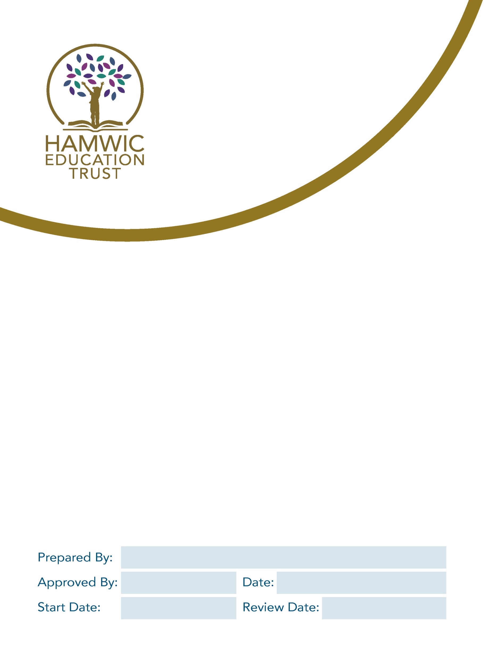

Guidance for Schools on Parent and Visitor Code of Conduct

Head of Compliance

DCEO
September 2024
September 2024
September 2027

1. Scope 3
2. Review the risk 3
3. Actions 3
4. Police assistance 4
5. Records 5
6. Support 5
7. Other relevant policies/guidance: 5
Appendix A: Model Wording for Parent and Visitor Code of Conduct Policy 6
Appendix B: Letter 1 - Template Warning Letter 10
Appendix C: Letter 2 - Withdrawing Permission to Enter/Access School Grounds Pending Review 11
Appendix D: Letter 3a - Withdrawal of Permission to Enter/Access School Grounds Confirmed 11
Appendix E: Letter 3b - Restoring Permission to Enter/Access School Grounds after Review 13
Appendix F: Letter 4a Continuing Ban following Formal Review 14
Appendix G: Letter 4b Ending Ban / Restoring Permission to Enter/Access School Grounds Following Review of a Banning Letter 15
Appendix H: Summary of actions in response to serious breaches of the Parent and Visitor Code of Conduct 16

- Scope
This guidance aims to assist school leaders in dealing with behaviour from visitors that raises cause for concern. In particular, the guidance deals with situations where visitors are being threatening, abusive or aggressive towards other members of the school community. Such behaviour will not be tolerated. Staff and pupils have a right to expect their school to be a safe place in which to work and learn.
Section 547 of the Education Act, 1996 makes it a criminal offence for a person who is on school premises, without lawful authority, to cause or permit a nuisance or disturbance.
For the purpose of this Policy ‘visitor’ also includes parents, carers, relatives of a pupil or associated person.
School leaders are encouraged to make all staff aware of this guidance and also to consider the guidance in relation to the School Emergency Response Plan.
Each school should have a written policy (see template Appendix A) setting out the behaviour expected of visitors and the procedures to be followed when a school wishes to restrict a visitor’s access to the school premises.
For any school without a LGB, please consult with the Trust as appropriate.
- Review the risk
If a visitor has behaved in an inappropriate way, the school leader should review and consider the situation before deciding on the next most appropriate course of action. School leaders may consider:
- Has the visitor been verbally or physically aggressive/threatening/intimidating?
- What evidence is there? Were there witnesses present?
- Have there been previous occurrences of this behaviour from the same visitor?
- Have pupils witnessed this behaviour?
- Have pupils been inappropriately approached by the visitor?
- Has the visitor been abusive to school staff, pupils or other visitors?
- Was the visitor provoked in any way and is there evidence of this?
- Is there a risk that there will be repeat behaviour from the visitor?

- Actions
In all circumstances school leaders should complete an incident report form online (which can be accessed via the Trust intranet).
After reviewing the risk, school leaders may decide to take the following actions:
- Invite the visitor to a meeting to discuss the event
The safety and well-being of staff should be considered when taking this action. Two members of leadership/school staff should be present at the meeting and the main points of discussion, and any agreed subsequent actions should be noted. A follow-up letter should be sent after the meeting confirming the school’s expectations and any agreed subsequent actions.

- Clarify to the visitor what is considered acceptable behaviour
It may be appropriate to clarify the school visitor Code of conduct with the visitor. This could be at a meeting or by letter. Any verbal confirmation should be followed with a written confirmation of any discussion.
- Form strategies for avoiding any potential future conflict
It might be possible to put in place some strategies to avoid future conflicts, for example, it may be appropriate that the visitor must make future appointments with school staff via reception, rather than approaching school staff directly.
- Send an initial warning letter
School leaders could send an initial warning letter if it is felt that there might be a repeat behaviour, or the case warrants such a letter (see appendices for template letters).
- Restricted communication plan
If a parent commits serious or repeated breaches of the policy, or where they display unacceptable conduct when communicating with the school / school staff such as vexatious emails / letters, then you may consider a Restricted Communication plan. This will restrict the way the parent can communicate with school and may include:
- Requiring contact in a particular form (e.g. in writing only)
- Limiting contact to one member of staff or a specific email address
- Restricting telephone calls to specified days and times

- Withdraw permission for the visitor to enter school premises
In serious or persistent cases, school leaders may need to consider whether it is safe for the visitor to still enter school premises. In this circumstance, school leaders should consult with their chair of governors or a member of the Trust executive team to review the case and agree options.
In some cases, it may be appropriate to ban a visitor from school premises. A template letter can be found in the appendices, which should be signed by the chair of governors (or relevant nominated body). The ban would take effect immediately; however the banned visitor must be enabled to make representations. A period of 10 school days is recommended to allow for this, at the end of which the chair of governors should consider any representations made, then make a decision as to whether the ban is confirmed or discontinued.
In cases where a ban is in place but is ignored and the visitor enters the school premises, the police should be notified immediately. Staff will need to be aware of any ban and the school procedures they should follow if the banned visitor enters the school premises.
- Police assistance
In an emergency and/or if there is an immediate threat to the well-being and health and safety of members of the school community, the police should be called.
In situations where there is no immediate threat to the school community or school property, school leaders may wish to inform their local PCSO.

- Records
Clear records should be kept of any situation, meeting or actions. Notes should be signed and dated. Any witness statements should also be kept and signed and dated.
- Support
If any member of staff is subject/witness to a situation, there is a variety of support available. Colleagues should be supportive and staff can contact the Hamwic Education Trust HR Team on hr@hamwic.org.
There is also the Trust counselling service and Employee Assistance Programme, Spectrum Life.
Trade unions can also be a source of assistance.
- Other relevant policies/guidance:
- Complaints Policy
- School Emergency Response Plan

Appendix A: Model Wording for Parent and Visitor Code of Conduct Policy

Introduction
- Sholing Junior School is founded on the principle of a positive and successful partnership between our school and parents; this is reflected in our approach to supporting learning, ensuring good attendance, providing enrichment and extra-curricular activities and working together to support pupils’ welfare.
- We understand that in some situations when working together to support children, parents and schools will have different views about what the approach should be. Usually, we find that constructive dialogue leads to a shared understanding of a situation and agreement about the way forward.
- On rare occasions, when parents or visitors behave inappropriately or unacceptably towards our staff or pupils, we need to take steps to resolve this, and this policy outlines our approach to this.

Purpose and scope
We will act to ensure Sholing Junior School is a safe place for pupils, staff and all other members of our school community.

We believe it is important to maintain positive relationships with all members of our school community and value our strong relationship with parents/carers which together helps us achieve the very best for the pupils in a mutually supportive partnership between parents, class teachers and the school community. If a parent/carer/visitor has concerns, we will always listen to them and seek to address them.
Our school staff strive to:
- Develop a positive partnership with parents to support the learning of our pupils.
- Create a safe, respectful and inclusive environment for pupils, staff and parents.
- Always model appropriate behaviour for our pupils.

To help us do this, we set clear expectations and guidelines on behaviour for all members of our community. This includes staff (through our staff code of conduct) and pupils (through our behaviour policy). This policy aims to help us work in partnership with parents, carers and other visitors by setting guidelines on appropriate behaviour.

This policy covers breaches of our code of conduct which occur:
- In the school buildings or on the school site
- By telephone to the school
- By email to the school
- On social media referring to the school
- In any other setting which, in the reasonable opinion of the school leader/chair of governors/HET, should be regulated by this policy.

Our expectations of parents/carers/visitors
We expect parents, carers and other visitors to:
- Respect the caring ethos, vision and values of our school.
- Work together with staff in the best interests of our pupils.
- Seek a peaceful solution to all issues.
- Communicate with the school in a respectful manner using appropriate non-aggressive or derogatory language.
- Treat all members of the school community with respect – setting a good example with speech and conduct.
- Correct their own child’s behaviour (or those in their care), particularly in public, where it could lead to conflict, aggression or unsafe conduct.
- Approach the right member of staff to help resolve any issues of concern.

Unacceptable conduct
Any form of communication that threatens the safety or well-being of our staff or pupils will be taken seriously and addressed immediately, with the goal of protecting our school community.

The following behaviours are considered unacceptable by the school:
- Disrupting, or threatening to disrupt, school operations (including events on the school grounds and sports team matches)
- Swearing or the use of other abusive, offensive or threatening language
- Displaying a temper, or shouting at members of staff, pupils or other parents
- Verbal or written threats of violence or harm to any member of the school community
- Physical violence, including damage to school property or injury to others
- Approaching someone else’s child to discuss or chastise them because of the (perceived/actual) actions of this child towards their own child
- Discriminatory conduct or use of discriminatory language (sexist, racist, other)
- Frequent, unwarranted and/or unnecessary correspondence which is hindering the proper running of the school
- Making deliberately false, malicious or vexatious accusations
- Defamatory, offensive or derogatory comments regarding the school or any of the pupils/parents/staff, at the school on Facebook or other social media sites
- Smoking or drinking alcohol on the school premises (unless alcohol has been allowed at a specific event).
- Possessing or being under the influence of alcohol or drugs while on the school premises.
- Bringing dogs onto the school premises (other than guide dogs).
- Any behaviour that violates the law or school policies
- Incitement of others to do any of the above

This is not an exhaustive list but seeks to provide illustrations of such conduct. It will ultimately be for the school to determine whether conduct is deemed to be unacceptable.

Note: Can parents please ensure they make all persons responsible for collecting their children aware of this policy
Inappropriate use of social network sites
- Any concerns you may have about the school, or your child must be made through the appropriate channels by speaking to the school or following the school complaints policy and procedure.
- Any inappropriate comments (including libellous or defamatory) made about the school, staff or pupils on any social media site will be reported to the appropriate ‘report abuse’ section of the site and the parent/carer will be asked to remove any such comment.
- The school take very seriously the use of cyber bullying by one child or a parent to publicly humiliate another by inappropriate social network entry. We will take and deal with this as a serious incident of school bullying.
- The school will consult with HET, to consider its legal options to deal with any such misuse on social networking and other sites.

Covert recordings
- Unless explicitly agreed in writing, the school does not consent to parents making audio or video recordings of any member of staff, governor or school volunteer, including during in-person meetings, remote/virtual meetings or telephone conversations.
- Making covert recordings without the consent of members of staff is regarded as a breach of the relationship of mutual trust and confidence between the parent and the school.
- If a parent is found to be recording a discussion, all members of staff have the right to terminate the meeting or telephone call immediately.
- A parent that records a member of staff, governor or school volunteer, without consent may be issued with a restricted communication plan (see below).
- If a parent is found to have recorded any audio or video footage on the school site without consent of any individual, this may result in the parent being immediately banned from the school premises and the involvement of external agencies.

Breaching the code of conduct
If the school suspects, or becomes aware, that someone has breached our code of conduct, we will gather information from those involved and speak to the person about the incident. The school leader will always try to respond to an incident in a proportional way.

Depending on the nature of the incident(s), the school may then:
- Invite the person into school to meet with a senior member of staff or the school leader
- Send a warning letter to the person
- Contact the appropriate authorities (in cases of criminal behaviour)
- Seek advice from Hamwic regarding further action
- Implement a restricted communication plan, stating the staff member(s) and communication method the person is allowed to use to contact the school
- Ban the parent from the school site; revoke their license to attend the premises

Whilst these sanctions are set out in the policy by way of a sequential process, they can be initiated at any stage if, in the reasonable judgement of the school, the severity of the behaviour warrants such a level of intervention. Where the behaviour is so extreme that it threatens the immediate safety and welfare of staff or others, the matter will be referred immediately to the police and trust.

A decision to ban a parent from the school site is a very serious one but unfortunately is necessary occasionally. The school leader will consult the chair of governors and/or trust before making such a decision. Decisions to ban are taken within the framework of the DfE Guidance and will be reviewed by the school. The letter banning the person from the school site will make clear how communications with the school can be maintained.

Linked Policies:
- Behaviour and Relationship Policy
- Child Protection and Safeguarding Policy
- Staff Code of Conduct Policy
- Health and Safety Policy
- Whistleblowing Policy

Other relevant guidance:
- DfE guidance for schools: Controlling access to school premises - GOV.UK (www.gov.uk)

This policy will be regularly reviewed considering changing circumstances.

Summary of actions in response to breaches of the Parent and Visitor Code of Conduct
Breach of Parent and Visitor Code of Conduct

Serious Criminal Act
All other breaches of the Code of Conduct

Police to be contacted immediately
Interaction, conversation or meeting terminated immediately.
Person asked to leave the school premises.

Following gathering of facts, all significant incidents will be reported to HET and shared with the Chair of Governors

Serious Criminal Act or Serious Breach

Person temporarily banned from the school premises and restricted communication plan may also be put in place
Minor Breach

Person issued with a warning letter and meeting may also be arranged to discuss the incident.

Information gathering and review of incident(s) by Chair of Governors and/or HET
Repeated breaches
of the code

Incidents involving alleged harassment or libel
Letter sent by Chair of Governors/HET confirming decision following review

School to seek legal advice via HET
(ban or restricted communication plan may be imposed)
Person coming onto school site once ban is imposed
plan
School will notify the police and seek legal advice via HET

