Number of tasks completed | Reward
1 – 15 | Individual work awards (stickers, stamps etc)
16 – 20 | 10 minutes extra break-time
21 - 25 | Homework Prize Invitation


Sholing Junior School
Year 3 Homework Grid
Spring Term
Hand-in date: 20th March All homework will be celebrated and acknowledged during a class feedback session in addition to rewards.
Tasks
Maths  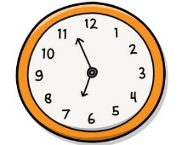 | Times Tables  Complete garage in TTRS for 4 days in one week. | Fractions  Using food at home, show ½, ¼ and ¾. | Pictogram  Ask the people in your family what their favourite colour is and create a pictogram showing the results. | Ordering sizes  Grab 5 items in your house and put them in order from smallest to largest. | Odd and even numbers  List all the odd numbers between 20 and 40, then all the even numbers.
Writing  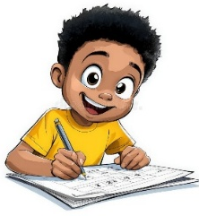 | Diary Entry  Imagine you are Howard Carter and you’ve just discovered Tutukahmun’s tomb. How do you feel? What will happen next? | Adventure Story  Write the beginning of an adventure story. You can set it anywhere and anytime you like – make the reader excited! | Describe your favourite place: Use adjectives and sensory language to paint a vivid picture. What does it look like? How does it feel? What can you hear? What can you smell? | • Compose a letter to your future self  Share your hopes, dreams, and what you’d like to be doing in 10 years. | Write a short story about a magical animal  Imagine a creature with special powers and describe an adventure it goes on.
Reading  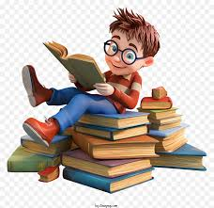 | • Book v Film  Find a film that is also a book. Was anything different? What was the same?• | Book Review  Write a book review for each of the books you have read recently. | Read  Challenge yourself to read 3 new books before the Easter Holidays. | Story Prediction  Read the first few pages of a book or a short story. Then, predict what you think will happen next. After finishing the story, compare your predictions with the actual plot. | Character Analysis  Choose a character from a book you are reading and write a paragraph describing the character's traits. Explain what the character says, does, and how other characters react to them.
Wider Curriculum    https://theinspirationboard.com/ science-experiments-for-kids/ | History  Create an artefact from the Ancient Egyptian era. You could draw it or create a 3D model of it. | Art  Create a collage at home using objects you find in nature. | Science  Create different shadows at home with a torch. Can you make a puppet show? | Computing  Create a poster about using the internet safely. What should you do when you are using it? How do you keep yourself safe? | Physical Activity Log  Keep a log of your physical activities for a week. Record what you do each day (e.g., playing outside, going for a walk, or riding your bike).
Wider World  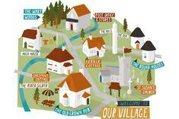 | Map Your Local Area  Create a simple map of your local area, marking where you live, nearby parks, shops, and schools. Label your map with names of places and landmarks. | Spain  Research 5 interesting facts about Spain and present them in a poster.  . | Cooking  Cook your favourite meal for your family. What ingredients did you use? Did everyone like it? | Visit a new place  Go and visit somewhere you have never been before. Could be a new park, forest, shop. Tell us what you thought about it. | Transport in Your Area  Draw or write about the different types of transport you see in your local, including walking. Which is the most popular in your area, and why?

