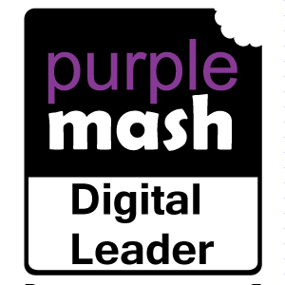 **Summer Term – Week 2**

What have year groups been getting up to in computing this week? Some of our Digital Leaders tell us:

**Year 3**

In Year 3 we used our computing skills to write newspaper reports about a boy getting eaten by a lion!

**Year 4**

In Year 4 this week we have been doing animations and it is fun!

We have been doing animations using 2Animate on Purple Mash. We animated silly faces.

**Year 5**

In Year 5 this week we have been doing some keyboard work and finding out what keys mean what.

**Year 6**

While we have not being doing any actual computing, we have been using the laptops a lot in our learning. In English, we are using the Chromebooks to do research on the some of the most dangerous animals in Texas for our book, 'Holes'.

In maths, we have been using TTRockstars to practice our times tables for SATS, which are coming next week!

In computing, we have been playing Times Table Rock stars and it has been helping me with my times tables. It is fun to play on the computers .