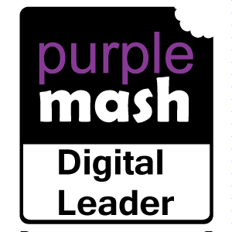 **Summer Term – Week 4**

What have year groups been getting up to in computing this week? Some of our Digital Leaders tell us:

**Year 3**

In 3C we’ve been doing spreadsheets and data on Google Classroom.

**Year 4**

In 4G we are making animations of Alice falling down and rabbit hole and Lucy going through the wardrobe into Narnia using 2Annimate on Purple Mash.

**Year 5**

In Year 5 this week we have been creating categories within a database on Purple Mash.

**Year 6**

“This week I made a platformer game on scratch. A platformer is a game where you jump from platform to platform to get to the end. My game was a multiple level game with 3 levels and you could not touch the top bottom or sides with obstacles bouncing around setting you back to where you started when you touched them.”