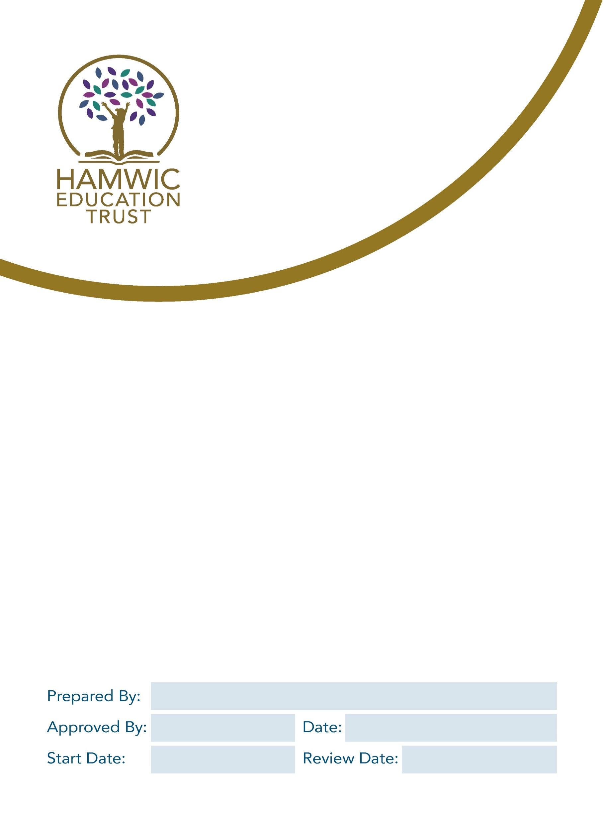

Hamwic Education Trust & Sholing Junior School
Parent Privacy Notice

Head of Compliance

1. Policy Statement 3
2. What information do we process in relation to you? 3
3. Where do we get your personal data from? 3
4. Why do we use your personal information? 3
5. Why do we use special category personal data? 4
6. Failure to provide this information 4
7. How long will we hold your personal data for? 4
8. Who will we share your personal data with? 5
9. Your rights in relation to your personal data 5
10. Concerns 6
11. Contact 6

Policy Statement
We are Sholing Junior School and we are part of the Hamwic Education Trust (HET). During your child’s time with us, we will gather and use information relating to you. Information that we hold in relation to individuals is known as their “personal data”. This will include data that we obtain from you directly and data about you that we obtain from other people and organisations. We might also need to continue to hold your personal data for a period of time after your child has left the school. Anything that we do with an individual’s personal data is known as “processing”.

This document sets out what personal data we will hold about you, why we process that data, who we share this information with, and your rights in relation to your personal data processed by us.

What information do we process in relation to you?
We will collect, hold, share and otherwise use the following information about you:
- personal information (such as name, address, home and mobile numbers, personal email address, emergency contact details and relationship marital status)
- financial details (such as bank account or credit card details), and other financial details such as eligibility for free school meals or other financial assistance
- CCTV footage and images obtained when you attend the school site
- your relationship to your child, including any Court orders that may be in place
We will also use special categories of data such as gender, age, ethnic group, sex or sexual orientation, religious or similar beliefs, information about health, genetic information and biometric data. These types of personal data are subject to additional requirements.

Where do we get your personal data from?
We will obtain an amount of your personal data from you, by way of information gathering exercises at appropriate times such as when your child joins the school and when you attend the school site and are captured by our CCTV system.
We may also obtain information about you from other sources. This might include information from the local authorities or other professionals or bodies, including a Court, which might raise concerns in relation to your child.

Why do we use your personal information?
We will process your personal data for the following reasons:
- Where we are required by law, including:
- To provide reports and other information required by law in relation to the performance of your child
- To raise or address any concerns about safeguarding
- To the Government agencies including the police
- To obtain relevant funding for the school
- To provide or obtain additional services including advice and/or support for your family

- Where the law otherwise allows us to process the personal data as part of our functions as a Trust and school, or we are carrying out a task in the public interest, including:
- To confirm your identity
- To communicate matters relating to the Trust and school to you
- To safeguard you, our pupils and other individuals
- To enable payments to be made by you to the school
- To ensure the safety of individuals on school site
- To aid in the prevention and detection of crime on the school site
- To manage school admissions and appeals.

- Where we otherwise have your consent

Whilst the majority of processing of personal data we hold about you will not require your consent; we will inform you if your consent is required and seek that consent before any processing takes place.

Why do we use special category personal data?
We may process special category personal data in relation to you for the following reasons:

- Where the processing is necessary for reasons of substantial public interest, including for purposes of equality of opportunity and treatment, where this is in accordance with our Data Protection Policy.

- Where the processing is necessary in order to ensure your health and safety on the school site, including making reasonable adjustments for any disabilities you may have.

- Where we otherwise have your explicit written consent.

There may also be circumstances where we need to use your information in relation to legal claims, or to protect your vital interests of those of your child, and where it is not possible to seek your consent.

Failure to provide this information
If you fail to provide information to us, we may be prevented from complying with our legal obligations.

How long will we hold your personal data for?
We will hold information your personal data for as long as necessary. How long we need to hold on to any information will depend on the type of information. For further detail please see our Record and Retention Schedule.

Who will we share your personal data with?
We routinely share information about parents with:
- Local authorities, to assist them in the exercise of their responsibilities in relation to education and training, youth support and safeguarding purposes
- The Department for Education and the Education and Skills Funding Agency, in compliance with legal obligations of the school to provide information about students and parents as part of statutory data collections
- Third-Party Service Providers (education), these are systems for managing school operations regarding student information, learning management platforms and communication tools.
- Third-Party Service Providers (other), such as companies relating to school catering services and payment processing providers to enable payments to be made by you to the school.
- Contractors who provide a service to the school, such as consultants who support us with school admissions and appeals.
- Health and Social Services, to fulfil our safeguarding responsibilities and protect the welfare of pupils.
- Law enforcement, in certain circumstances, such as investigations or safeguarding issues, we may share information with the police to ensure the safety and wellbeing of our pupils.
- Other Educational Institutions, when pupils are moving to another school or onto another phase of their education.
- Regulatory Bodies, such as Ofsted and exam boards.
- Trust professional advisors who provide advice on legal matters.

The Department for Education may share information that we are required to provide to them with other organisations. For further information about the Department’s data sharing process, please visit: https://www.gov.uk/guidance/data-protection-how-we-collect-and-share-research-data.
Contact details for the Department can be found at https://www.gov.uk/contact-dfe.
Local authorities may share information that we are required to provide to them with other organisations. For further information about Southampton City Council local authority’s data sharing process, please visit their website or contact them directly.

Your rights in relation to your personal data
You have the right to request access to personal data that we hold about you, subject to a number of exceptions. To make a request for access to your personal data, you should contact:
The school Data Compliance Officer. Please contact them: Liane Taylor, liane.taylor@sholing-ju.co.uk
Please also refer to our Data Protection Policy for further details on making requests for access to your personal data.

You also have the right, in certain circumstances, to:
- Object to the processing of your personal data
- Have inaccurate or incomplete personal data about you rectified
- Restrict processing of your personal data
- Object to the making of decisions about you taken by automated means
- Have your data transferred to another organisation
- Claim compensation for damage caused by a breach of your data protection rights

If you want to exercise any of these rights, then you should contact the school Data Compliance Officer (see contact details above). The law does not oblige the Trust or school to comply with all requests. If the Trust or school does not intend to comply with the request, then you will be notified of the reasons why in writing.

Concerns
If you are concerned about how we are using your personal data, then you can speak with the Data Compliance Officer in your school; they have day-to-day responsibility for data protection issues in our school.
However, an individual can contact the Information Commissioner’s Office should they consider this to be necessary, at https://ico.org.uk/concerns/.

Contact
If you would like to discuss anything in this privacy notice, please contact:
The Trust's Data Protection Officer: Gemma Carr, Deputy CEO, who can be contacted by email at compliance@hamwic.org, by telephone on 023 8078 6833, or at the following address:
Hamwic Education Trust, Unit E, The Mill Yard, Nursling Street, Southampton, Hampshire SO16 0AJ.

