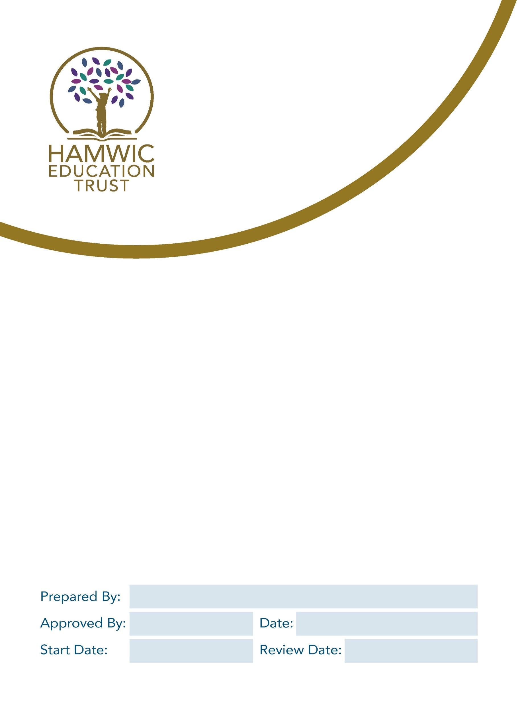

Hamwic Education Trust & Sholing Junior School
Pupil Privacy Notice

Head of Compliance

September 24

September 27

1. Why are we giving this to you? 3
2. Policy Statement 3
3. What information do we use about you? 3
4. Where do we get this information from? 4
5. Why do we use this information? 4
6. Why do we use special category personal data? 4
7. How long will we hold information in relation to our pupils? 5
8. Who will we share pupil information with? 5
9. Keeping this information safe 5
10. Your rights in relation to your information 6
11. Concerns 6

Why are we giving this to you?
As your school and as your Trust, we need to use information about you. We do this for a number of reasons. This document tells you what information we use about you and why we use it. It is very important that information about you is kept safe. We explain below how the school keeps your information safe.
If you want to know anything about what we do with information about you then please ask your teacher or speak to your parents/carers and ask them to contact the school. The school wants you to feel free to raise any questions at all.
We also have a person called the Data Compliance Officer at the school. They can answer any questions you have about what the school does with your information. If you or your parents/carers want to speak to them, then you can do at:
- Liane Taylor, liane.taylor@sholing-jun.co.uk

You can also contact the Trust's Data Protection Officer, Gemma Carr, Deputy CEO.
Email: compliance@hamwic.org. Telephone: 023 8078 6833.
Address: Hamwic Education Trust, Unit E, The Mill Yard, Nursling Street, Southampton, Hampshire SO16 0AJ.

Policy Statement
We are Sholing Junior School and we are part of the Hamwic Education Trust (HET). During your time with us, we will use information that we gather in relation to you for various purposes. Information that we hold in relation to you is known as “personal data”. This will include data that we obtain from you directly and data about you which we obtain from other people and organisations. We might also need to continue to hold your personal data for a period of time after you have left the school. Anything that we do with your personal data is known as “processing”.
This document sets out what personal data we will hold about you, why we process that data, who we share this information with, and your rights in relation to your personal data processed by us.

What information do we use about you?
We will collect, hold, share and otherwise use information about you set out in the boxes below:
- Name | - Telephone and email contact details | - Date of Birth
- Address | - Assessment information | - Details of previous/future schools
- Unique pupil number | - Behavioural information | - Language(s)
- Nationality | - Country of birth | - Eligibility for free school meals
- Photographs | - Attendance information | - CCTV images

We will also collect, hold, share and otherwise use some information about you which is special “special category personal data” and we will take extra care to make sure that this is kept safe:
- Racial or ethnic origin | - Religious beliefs | - Special educational needs and disability information
- Medical / health information | - Genetic and biometric data | - Information relating to keeping you safe
- Sexual life | - Sexual orientation | - Dietary requirements

Where do we get this information from?
- You
- Your parents/carers, and other children’s parents/carers
- Teachers and other staff
- People from other organisations, like doctors or the local authority.

Why do we use this information?
We use this information for lots of reasons, including:
- To make sure that we give you a good education and to support you through this
- To make sure that we are able to address and support any educational, health or social needs you may have
- To make sure everyone is treated fairly and equally
- To keep you and everyone at the school safe and secure
- To deal with emergencies involving you
- To celebrate your achievements
- To provide reports and additional information to your parents/carers

Some of these things we have to do by law. Other things we do because we need to so that we can run the school.
Sometimes we need permission to use your information. This includes taking pictures or videos of you to be used on our website or in the newspaper. Before we do these things, we will ask you or if necessary, your parent/carer for permission.

Why do we use special category personal data?
We may need to use the information about you which is special (mentioned above) where there is a specific interest to do so for example health and social care purposes or to provide you with equal opportunities and treatment. We will also use this information where you have given us permission to do so.
There may also be circumstances where we need to use your information in relation to legal claims, or to protect your vital interests and where you are unable to provide your consent.

How long will we hold information in relation to our pupils?
We will hold information relating to you only for as long as necessary. How long we need to hold on to any information will depend on the type of information. Where you change school, we will usually pass your information to your new school.

Who will we share pupil information with?
We may share information about you with:
- Other schools or educational institutions you may attend or require support from
- Local Authorities, to assist them in the exercise of their responsibilities in relation to education and training, youth support and safeguarding purposes
- The Department for Education [and/ or ESFA] as required by the law

Keeping this information safe
It is very important that only people who need to use your information can see it. The school keeps you information safe by putting in place measures to protect the security of your information (i.e. against it being accidentally lost, used or accessed in an unauthorised way.
Our security measures include:
- We make sure we comply with Data Protection laws and all school staff receive annual training around data protection principles and recognising cyber threats and phishing attacks.
- We have policies and procedures in place, which are regularly updated, to make sure all staff understand their data protection responsibilities and we keep pace with evolving threats and changes in law.
- There is a central Hamwic IT team, along with IT support in your school. They work together to ensure the school has secure data handling, and data storage, and robust network security (including firewalls and antivirus software).
- We hold most of our pupil data electronically on the school’s management information system. This can only be accessed by individual personal logins for those members of staff who have a legitimate need for access. Staff logins are also limited to the specific pupil data categories required to carry out their work.
- When we need to share personal data with a third party, we carry out due diligence and take reasonable steps to ensure it is stored securely and adequately protected.
- IT equipment users must ensure that individual monitors do not show confidential information to passers-by and that they log off from their PC when it is left unattended.
- Paper records are stored in locked filing cabinets that are only accessible to those members of staff who have a legitimate need to access them.
- Papers containing confidential personal data must not be left on office and classroom desks, on staffroom tables, pinned to notice/display boards, or left anywhere else where there is general access.
- Except as required by law, pupil information is only retained for as long as necessary in accordance with timeframes imposed by law and our Record and Retention Policy.

Your rights in relation to your information
You can ask to see the information we hold about you. If you wish to do this, you should contact the Data Compliance Officer in our school Liane Taylor, liane.taylor@sholing-jun.co.uk

You also have the right to:

- Object to what we are doing with your information
- Have inaccurate or incomplete information about you amended
- Ask us to stop doing certain things with your information in some cases
- Ask that decisions about you are not made using automatic systems
- Claim against the school in certain circumstances where you have suffered as a result of the school breaching your data protection rights

If you feel it necessary to do any of the above, you can speak with the school Data Compliance Officer or Trust Data Protection Officer.

The school does not have to meet all of your requests, and we will let you know where we are unable to do so.

Concerns
If you are concerned about how we are using your personal data, then you should speak with the Data Compliance Officer in your school in the first instance; they have day-to-day responsibility for data protection issues in our school.
The Trust's Data Protection Officer: Gemma Carr, Deputy CEO, who can be contacted by email at compliance@hamwic.org, by telephone on 023 8078 6833, or at the following address:
Hamwic Education Trust, Unit E, The Mill Yard, Nursling Street, Southampton, Hampshire SO16 0AJ.
Or if necessary, you or your parent/ carer can contact an outside agency - the Information Commissioner’s Office who could also help at https://ico.org.uk/concerns/.

