

Attendance Policy

Danielle Lebbern – Attendance Lead

July 2027
November 2024
November 2024
Matt Abbott
Contents
1. Statement of Intent 4
2. Roles and responsibilities 5
Responsibilities of staff 5
Responsibilities of parents/carers 5
3. Rewarding Good and Improving Attendance 6
School Strategies to Improve and Support attendance 6
Interventions for poor and declining attendance 7
4. How We Can Support Our Children to Attend 10
Strategies employed by the school. 10
APPENDIX 2 – BCP Fixed Penalty Notice Guidance 13
APPENDIX 3 – Dorset Fixed Penalty Notice Guidance 14
APPENDIX 4– Southampton Fixed Penalty Notice Guidance 15
APPENDIX 5– Portsmouth Fixed Penalty Notice Guidance 16
APPENDIX 6 - What your child missing out on 17
APPENDIX 7 – Process for Leavers 17
APPENDIX 8 – Possible Exceptions to Unauthorised Absence 17

Attendance Policy

Attendance Champion: Danielle Lebbern

Attendance Officers: Vicki Randall, Carley Attrill

School opens: 08:40am

Registration begins: 08:50am

Present mark given until: 08:50am

Late mark given between: 08:50am – 09:10am

U code, un-authorised absence, applied after: 09:10am

School closes: 15:25pm

How to report when your child is absent

First Day Absence
A child not attending school is considered a safeguarding matter. This is why information about the cause of any absence is always required.

- Contact the office on 02380447448 as soon as possible on the first day of absence.
- If contact is not made by the parent/carer, then the school will phone, email and/or text the contacts listed for the child to endeavor to make contact.
- If we are unable to make contact or ascertain sufficient reason for absence, a member of staff may make a home visit.
- Records of the above will be made available to social care in the event of any Missing in Education investigation.

If your child is absent, we will:
Telephone on the first day of absence if we have not heard from you; this is because we have a duty to ensure your child’s safety as well as their regular school attendance. If we are unable to reach you and do not hear from you by 10am, your child’s absence will be recorded as unauthorised and we will:

- Invite you into the school to discuss the situation with Danielle Lebbern (Deputy Headteacher) if absences persist.
- Follow all DfE guidance and our graduated response if absence is unauthorized and attendance falls below 90%.

Please note after three days of absence, if your child is not seen and contact has not been established with any of the named parents/carers, the school is required to start child missing in education procedures as per the DfE guidance Stat guidance template (publishing.service.gov.uk). We will make all reasonable enquiries to establish contact with parents/carers and the child, including making enquiries to known friends and/or wider family.

Statement of Intent

We recognise that good attendance (above 96%) is key to good pupil outcomes. The links between regular attendance, reaching potential attainment and future life opportunities are well researched. For this reason, the school will encourage good attendance and be robust in monitoring attendance data and take action when attendance falls below the expected level. Good attendance impacts significantly on progress, learning, friendship groups and the child’s overall happiness at school.

Good attendance is important because:

- regular attenders make better progress both socially and academically
- regular attenders find school routines, schoolwork and friendships easier to cope with
- regular attenders find learning more satisfying
- statistics show a direct link between under-achievement and absence below 95%
- regular attenders are more successful in transferring between primary school, secondary school and higher education and training.
We understand that there are many reasons why children may be absent or late for school. Please speak to staff about ways that we can support you with this.

Legal framework/ responsibilities

This policy adheres to Department of Education guidance found here Working together to improve school attendance (applies from 19 August 2024) (publishing.service.gov.uk). Parents are responsible for making sure that their children of compulsory school age receive a suitable full-time education as stated here Summary table of responsibilities for school attendance (applies from 19 August 2024) (publishing.service.gov.uk)

Parents and carers are responsible for ensuring that children attend and stay at school. It is the responsibility of the school to support attendance and to take problems seriously which may lead to non-attendance.

Penalty Notices may be used under the Local Authority’s Code of Conduct for the use of Penalty Notices in Cases of Non-Attendance at school. A copy of this Code of Conduct can be obtained from the Attendance Officer at the school or the Local Authority. For more information please see School attendance and support (southampton.gov.uk) Parents can also refer to Appendix 2-5

Unauthorised absence of more than 10 sessions (a session being one morning or one afternoon) in a ten-week period can result in a penalty notice. A penalty notice can be issued per parent for each child that is absent. Only two penalty notices will be issued to the same parent for the same child within a 3-year period. Following this the Local Authority can consider instigating Court Proceedings via the Single Justice Procedure. under the new national framework, all schools will be required to consider a fine when a child has missed 10 or more sessions (5 days) for unauthorised reasons. From August 2024, the fine for school absences across the country will be £80 if paid within 21 days, or £160 if paid within 28 days. This rate is in line with inflation and is the first increase since 2012.In the case of repeated fines, if a parent receives a second fine for the same child within any three-year period, this will be charged at the higher rate of £160. Fines per parent will be capped to two fines within any three-year period. Once this limit has been reached, other action like a parenting order or prosecution will be considered. If you’re prosecuted and attend court because your child hasn’t been attending school, you could get a fine of up to £2,500. Money raised via fines is only used by the local authority to cover the costs of administering the system, and to fund attendance support. Any extra money is returned to the government.

Roles and responsibilities

We will work together to help every pupil’s attendance improve. Pastoral workers, the Pupil Premium Lead and the SENDCo may be involved in supporting attendance improvement for the cohorts that need the most support.

Responsibilities of staff

Staff will:

- Promote and reward good and improving attendance with pupils at all appropriate opportunities.
- Liaise with the attendance staff on matters of attendance and punctuality.
- Communicate any concerns or underlying problems that may account for a child’s absence.
- Warmly welcome and support pupils to reengage with learning on their return.
- Work with parents and local authorities to remove barriers to attendance.

Responsibilities of parents/carers

Ensuring your child’s regular attendance at school is a parent/carer’s legal responsibility (Section 444 of the 1996 Education Act) and permitting absence from school that is not authorised by the school creates an offence in law.

Parents/Carers will:

- Inform the school on the first day of absence
- Discuss with the class teacher or attendance staff any planned absences
- Discuss with the class teacher or attendance staff if they need any support to help their child to attend.
- Support the school with their aim to improve attendance
- Make sure that any absence is clearly accounted for by phoning school on the first day and subsequent days of absence
- Avoid taking their children out of school for non-urgent medical or dental appointments.
- Only request leave of absence in very exceptional circumstances.

Local Authority will:

- Have a strategy to improve attendance for their whole area.
- Have an Attendance Support Team to work with all schools in the area.
- Provide a named point of contact.
- Provide opportunities for sharing effective practice.
- Hold termly conversations with every school around attendance.
- Work jointly with schools and relevant agencies to facilitate support for families and remove barriers to attendance particularly for those pupils who are missing out on education.

Rewarding Good and Improving Attendance

We will recognise the effort that families make to get pupils into school each day by rewarding good and improving attendance at every opportunity.

- Attendance displays
- Termly certificates
- Celebrations in assembly (raffle etc)
- Individual rewards

School Strategies to Improve and Support attendance

The school will follow the DfE guidance below outlined in Working together to improve school attendance (applies from 19 August 2024) (publishing.service.gov.uk)
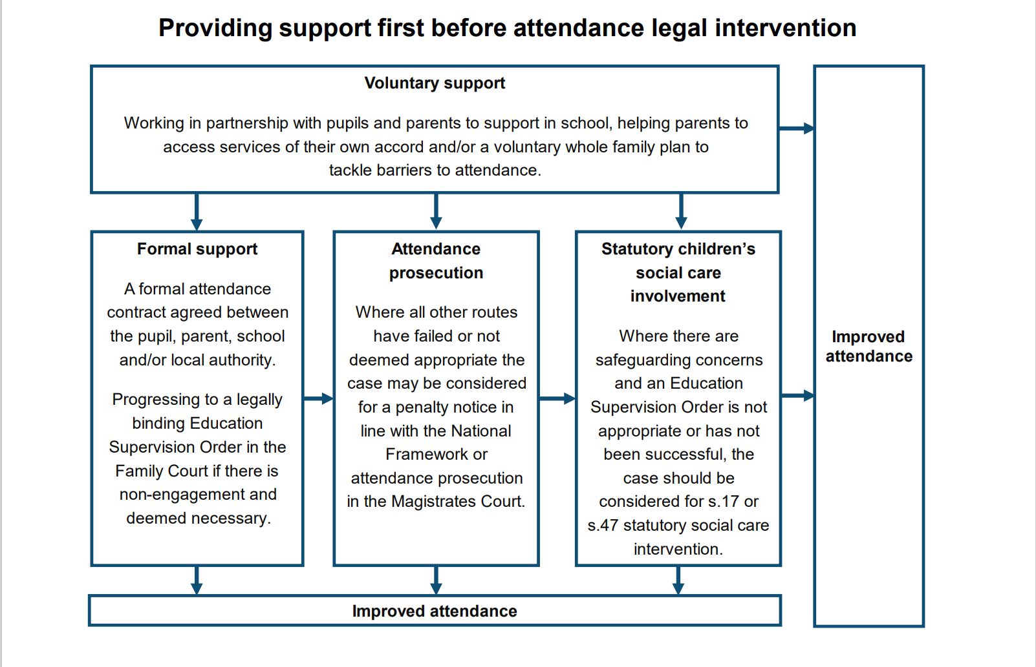

Interventions for poor and declining attendance

100% attendance: This is excellent attendance
99.9% - 96% attendance: Your child’s attendance is good, and you are giving them the best chance of success.
95.9% - 91.1% attendance: Attendance at this level is becoming a concern and may trigger an intervention listed below.

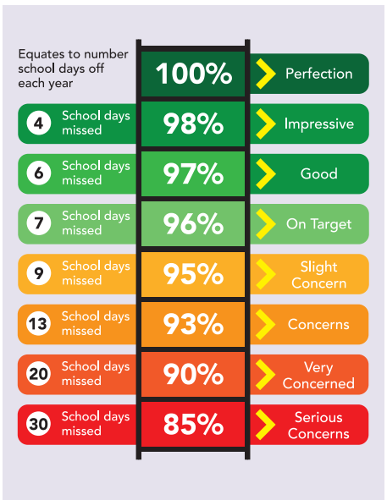

Attendance below 95% will be monitored closely and may result in the following:

- Contact home to discuss how to support the child back into school.
- Request for evidence if unwell where appropriate.
Below 90% attendance: Your child is considered a Persistent Absentee and attendance is a serious concern. If your child misses 10% (three weeks/30sessions) or more schooling across the school year, for whatever reason, they are defined as persistent absentees. Absence for whatever reason disadvantages a child by creating gaps in their learning. Research shows these gaps affect attainment when attendance falls below 95%. As such, we monitor all absence thoroughly and all attendance data is shared with the local authority and the Department for Education. If your child is still absent, has had absence and their attendance level is falling towards 90%, we will contact you and, depending on the reasons for the absence, will contact you to inform you of our next steps. Our persistent absentee pupils and their parents are subject to an Attendance contract written in co production with the school and home.
Our aim is to support with reintegration, and this might include the following:
Home visits to bridge the gap between home and school.
Regular meetings between school and parents.
Contact with FISO/ELSA team.
Contact from Educational Welfare Team.
Individual attendance plans where necessary.

Below 50% attendance: Your child is considered a Severe Absentee and will be subject to intervention from the Local Authority, legal interventions, statutory action including fixed term penalties, court proceedings and possible referral to other outside agencies for a supported return.

Absence Due to Illness

It is recognised that children can become ill and may occasionally need to have time off school. If the school feel that the pupil may need further support with maintaining good health or there are concerns around the number of times the pupil is ill, school will request parents to provide medical evidence to support the family and school in implementing effective support.
Letters and recommendations from medical professionals will be considered on a case-by-case basis but will not automatically be seen as a reason to authorise an absence.
Absences due to parents/carers health or medical procedures will not be authorised as standard.
If your child is unwell and you are unsure of whether to send them in to school a useful site to check is https://www.nhs.uk/live-well/healthy-body/is-my-child-too-ill-for-school/

The school may be able to administer some over the counter medications with parental consent, to help your child manage minor illness when in school. This will be decided on a case-by-case basis.

Medical Conditions

Pupils attending our Schools may have medical conditions, either long or short term that will affect their attendance at some stage in their school career. We understand that students with medical conditions are more vulnerable and have greater needs than the majority of their mainstream counterparts. This means that they may have more genuine absences from school for medical reasons or experience greater social needs than others. It is our responsibility as educators to do all we can to encourage and support regular and frequent school attendance whilst they are facing the challenge of ill health and remove the in-school barriers these pupils face, including considering external support and reasonable adjustments, for example, supporting their ongoing learning.

One of our aims is to support children back into school as soon as their health allows because we know that this is best for the child. We aim to help ensure that the reintegration process encourages maximum attendance is resumed as quickly as possible. This includes working with families, ensuring that they understand how important regular attendance is to their child’s development and health. We will support routines where school transport is regularly being missed and work with other partners to encourage the scheduling of additional support interventions or medical appointments outside of the main school day.

We give high priority to conveying to parents/carers and pupils the importance of regular and punctual attendance. We recognise that parents have a vital role to play and that there is a need to establish strong home-school links and communication systems that can be utilised whenever there are concerns about attendance. If there are problems which affect a pupil’s attendance we will investigate, identify and strive in partnership with parents/carers and pupils, to resolve those problems as quickly and efficiently as possible.

It is crucial that our schools receive and fully consider advice from healthcare professionals and listen to and value the views of parents and pupils. We understand that some children with medical conditions may be considered to be disabled under the definition set out in the Equality Act 2010. Some pupils may also have special educational needs (SEN) and may have a statement, or Education, Health and Care (EHC) plan which brings together health and social care needs, as well as their special educational provision. We will ensure that staff are properly trained to provide the support that pupils need, their healthcare plan is closely monitored and implement an Individual Healthcare plan if needed. We do not, however, do not have to accept a child in school at times where it would be detrimental to the health of that child or others to do so.

We are committed to ensuring that all relevant staff are made aware of a child’s condition, that there are cover arrangements in place in case of staff absence or turnover and any supply staff are briefed fully. Parents/carers should provide the school with sufficient and up-to-date information about their child’s medical needs. Our attendance policy should be applied fairly and consistently but in doing so we will always consider the individual needs of pupils and their families who have specific barriers to attendance.

Welcome Back

On returning from absence, all pupils are made to feel welcome, helped to catch up on missed work and brought up to date with any information that has been passed to the other pupils.

Request for leave of absence

The DfE states: ‘Head teachers should only authorise leave of absence in exceptional circumstances. If a head teacher grants a leave request, it will be for the head teacher to determine the length of time that the child can be away from school. Leave is unlikely, however, to be granted for the purposes of a family holiday as a norm.’

Headteachers may not grant any leave of absence during term time unless there are exceptional circumstances only and this is not the norm. It is important to note that Headteachers can determine the length of the authorised absence as well as whether the absence is authorised at all.
The fundamental principles for defining ‘exceptional’ are rare, significant, or unavoidable circumstances (which means the event could not reasonably be scheduled at another time). Circumstances will vary from family to family.

There is no legal entitlement for time off in school time to go on holiday and, in the vast majority of cases, holiday will not be authorised.

Parents/Carers wishing to apply for a leave of absence need to fill in an application form (available on request from the school office) in advance and before making any travel arrangements. If term time leave is taken without prior permission from the school, the absence will automatically be unauthorised and if the number of sessions absent exceeds 10 sessions, the school may request the Local Authority to consider issuing a fine or a warning letter.

Taking holidays in term time will affect your child’s schooling as much as any other absence and as such, we expect parents to help us by not arranging holidays during school time. Unauthorised absence of more than 10 sessions (a session being one morning or afternoon) in a ten-week period can be issued with a penalty notice.

School work for pupils that are absent will only be provided during exclusions or long-term medical absences and not during unauthorised absences.

Religious Observance

We recognise that pupils of certain faiths may need to participate in days of religious observance. Where a day of religious observance:
- falls during school time and
- has been exclusively set apart for religious observance by the religious body to which the pupil belongs.
The absence will be authorised. We ask that the parents/carers notify the school in advance.

How We Can Support Our Children to Attend

Strategies employed by the school.

The school will:

- Set high expectations for attendance and punctuality for all pupils.
- Provide additional support for those families and pupil cohorts that need it most.
- Make sure attendance improvement is approached as a whole staff team.
- Provide an attendance policy that outlines clear process for reporting and recording absence.
- Record registers accurately.
- Monitor attendance data to enable early intervention where needed.
- Treat absence as a safeguarding concern where necessary.
- Provide a physical environment that is warm, safe and meets need.
- Provide an enticing curriculum
- Establish strong communication channels with parents, varying methods according to need.
- Provide clubs, activities and wraparound care to encourage attendance, engagement and belonging.

My child is trying to avoid coming to School. What should I do?

Children are sometimes reluctant to attend school. Any problems with regular attendance are best dealt with between the school, the parents and the child.

If a child is reluctant to attend, it is never better to enable them to stay away from school. This may give the impression that attendance does not matter and may make things worse.

Please do contact your child’s class teacher, pastoral worker or attendance staff as soon as possible to openly discuss your worries. Your child could be avoiding school for a number of reasons such as difficulties with schoolwork, friendship problems, family difficulties, special educational needs or bullying issues. It is important that we communicate effectively to identify the reason for your child’s reluctance to attend school and work together to tackle the problem.

In some cases, you may find it helpful to discuss the circumstances of your child’s difficulties with another professional and we may be able to make referrals or signpost you towards further assistance.

What can parents do to encourage their child to attend school?

- Make sure your child gets enough sleep and gets up in plenty of time each morning.
- Ensure that they leave home in the correct clothes and are properly equipped. (contact the school if you require assistance with this)
- Show your child, by your interest, that you value their education.
- Be interested in what your child is doing in school, chat to them about the things they have learnt, their progress towards rewards, their friendships, and even what they had for lunch!
- Speak positively about school at home.
For many parents, a child starting school may be their / your first experience of being separated from them. This can seem daunting at first but thinking and speaking of it as a new and exciting adventure will help you both. The transition into a settled and happy school life also depends on routine and regular, punctual attendance can help as much as any other intervention.

Record preservation

School registers are legal documents. We will ensure compliance with attendance regulations by keeping attendance records for at least 3 years. Computer registers will be preserved as electronic back-ups.

Criteria for success

- Improved attendance percentage for persistent absentees (10% or higher of their possible sessions missed)
- Improved attendance data across all years.
- Attendance rate increases
- Authorised absence rate decreases
- Unauthorised absence and persistent absence rate decreases
- Improvement in individuals' attendance
- The profile of good attendance within the school community is raised


APPENDIX 1 - Attendance on a page



APPENDIX 2 – BCP Fixed Penalty Notice Guidance
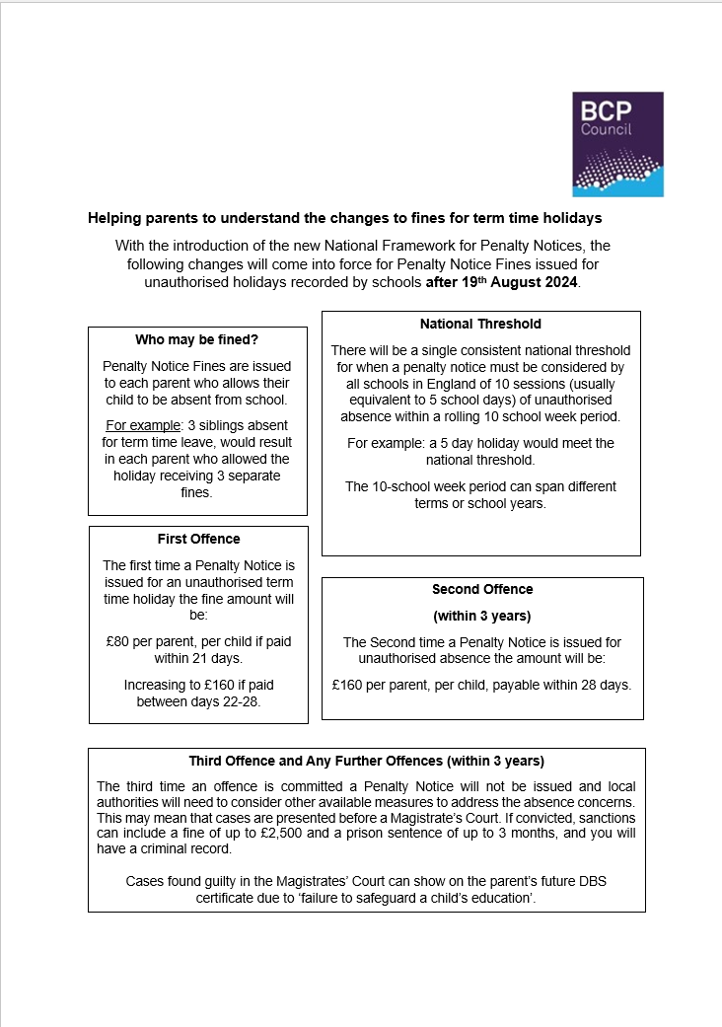

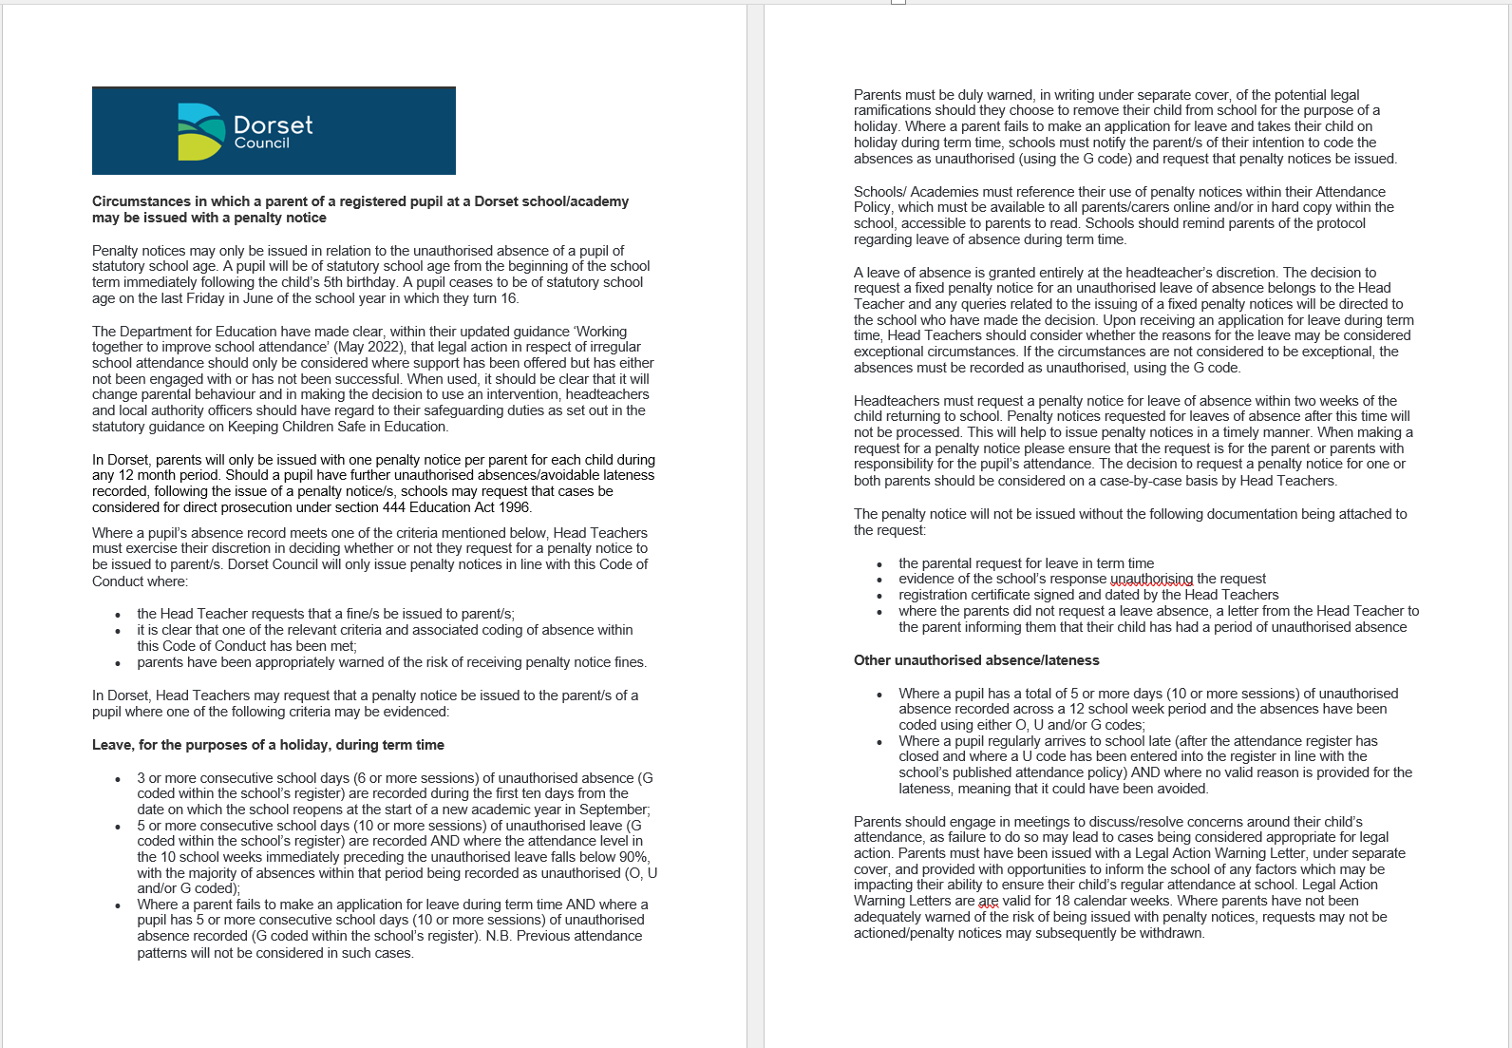
APPENDIX 3 – Dorset Fixed Penalty Notice Guidance

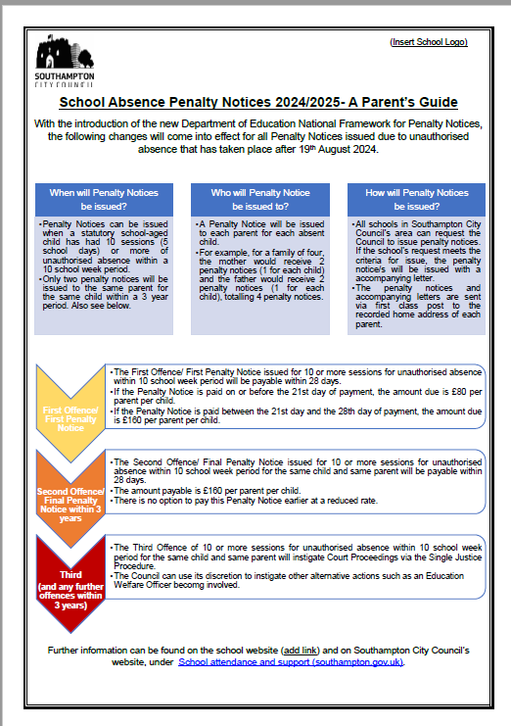
APPENDIX 4– Southampton Fixed Penalty Notice Guidance

APPENDIX 5– Portsmouth Fixed Penalty Notice Guidance
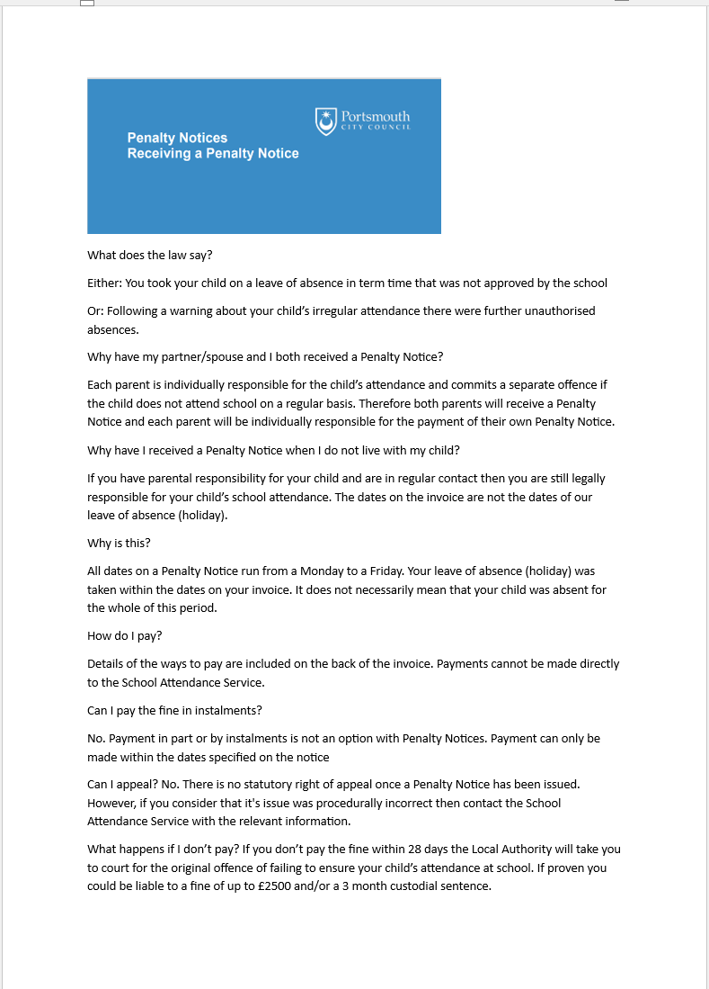

APPENDIX 6 - What your child missing out on

No Absence | 10 days absence | 12 days absence | 19 days absence | 29 days absence | 38 days absence
100% | 95% | 94% | 90% | 85% | 80%

The effect on progress

No Absence | 10 days absence | 12 days absence | 19 days absence | 29 days absence | 38 days absence
190 days of education | 180 days of education | 178 days of education | 171 days of education | 161 days of education | 152 days of education
100% | 95% | 94% | 90% | 85% | 80%
Very Good | Acceptable | Worrying | Very worrying | Serious Concern
Best chance of progress and success. More likely to be socially happy |  | Harder to progress, experience success or make friends |  | This is persistent absence. Very hard to make progress and social outcomes are often poor.

APPENDIX 7 – Process for Leavers

If your child is leaving our school (other than when transferring to the secondary school) parents are asked to give the school office comprehensive information about their plans including any date of a move and your new address and telephone numbers, your child’s new school and the start date when known. This should be submitted to our school in writing.

If pupils leave and we do not have the above information, then your child is considered to be a ‘Child Missing in Education’.

This requires schools and Local Authorities to carry out investigations to try and locate your child, which includes liaising with Children’s Services, the Police and other agencies. By giving us the above information, these investigations can be avoided.

- Parent/Guardian is required to notify the Headteacher in writing, giving the leaving date, new address and phone numbers and detailed reasons.
- Parent/Guardian to complete the Southampton City Council in year transfer application In-year transfer (southampton.gov.uk)
- Parent(s)/Guardian(s) need to ensure that they have cleared all payments on the Parent Pay system.
- The school will contact the child’s new setting on the date stated they will start to confirm that this transfer has taken place.

APPENDIX 8 – Possible Exceptions to Unauthorised Absence

Absence through child participation in public performances, including theatre, film or TV work and modelling.

Parents/carers of a child performer can seek leave of absence from school for their child to take part in a performance. They must contact the Headteacher to discuss the nature and frequency of the work, whether the child has a valid performance licence and whether education will be provided by the employer during any future leave of absence. Any absence approved by the Headteacher as being part of a child’s participation in a public performance is recorded as an authorised absence.

Absence through competing at regional, county or national level in sport.

Parents/carers of able sportsmen and women can seek leave of absence from school for their child to take part in a regional, county, national and international events and competitions. It is however, down to the Headteacher’s discretion whether to authorise this. They will wish to discuss with you the nature and frequency of the absence and how learning will continue if absence occurs. Permission for your child to leave early or arrive late to attend coaching and training sessions are also at the discretion of the Headteacher and are not likely to be approved if it is a regular event, unless the sports club or association are providing an education tutor as part of their coaching.

Service Families

The Ministry of Defence (MoD) issue additional guidance to schools with regards to term time absences for the children of service families. This is provided because it is acknowledged that the operational needs of the Armed Forces may legitimately prevent a service family from taking holidays within the school holidays. Ultimately the decision on whether to authorise leave in term time still lies with the Headteacher, however further clarification regarding the exact circumstances may be sought from Unit Commanding Officers and their welfare staff. When deciding whether to authorise an application for a leave of absence from a service family, the Headteacher will take into account the circumstances, the child’s attendance record and the school year which the child is in.

Gypsy Roma and Traveller families

Absence of a child from a traveller family that has left the area may be authorised if the absence is for work purposes only and it is believed that the family intends to return. To ensure the continuity of learning for traveller children, dual registration is allowed. That means that a school cannot remove a traveller child from the school roll while they are travelling. When the traveller is away the home school holds the place open and records the absence as authorised through the T code. Distance Learning packs for traveller children are not an alternative to attendance at school.

