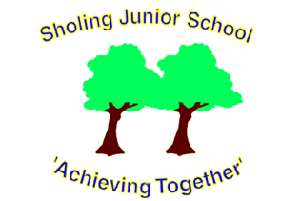

Sholing Junior School

Charging and Remission Policy

|  |  |
| --- | --- |
| Prepared By | Business Manager |
| Approved By | Full Governing Body |
| Approval Date | 24/11/23 |
| Policy Review Date | November 2024 |

Policy Statement

The Governing Body recognises the valuable contribution that the wide range of additional activities, including trips, clubs and residential experiences can make towards pupils’ education.

The Governing Body aims to promote and provide such activities both as part of broad and balanced curriculum for the pupils of the school and as additional optional activities.

CHARGES:

The school’s first preferred method of payment is online.

The Governing Body reserves the right to make a change in the following circumstances for activities organised by the school;

**School Journeys in School Hours**

The board and lodging element of approved residential activities deemed to take place in school hours.

**Activities outside School Hours**

The full cost to each pupil of all approved activities deemed to be optional extras taking place outside school hours.

**Individual Instrumental Tuition**

The cost of the pupil for providing any instrumental tuition not part of normal LEA peripatetic provision.

**Charging in Kind**

The cost materials, ingredients, equipment (or the provision of them by parents) for the following subjects:

Design & Technology, Art & Craft.

The Governing Body reserves the right to charge for ingredients and materials or require them to be provided if the parents have indicated in advance that they wish to own the finished product.

**School Trips in School Hours (curriculum based)**

Parents will be advised of the cost of such trips and that a contribution would help towards the activity, however no child will be excluded from a curriculum based trip if a voluntary contribution has not been received.

When trips that are deemed as an “extra” and not part of the curriculum, then parents will be asked for a contribution, and advised that the continuance of an activity may depend upon voluntary contributions.

**REMISSIONS**

Where the parents of a pupil are in receipt of Universal Credit, or are in family hardship, the Head Teacher may offer to remit the deposit of the cost of bull board and lodging for any residential activity which is deemed to take place in school hours where it forms part of the syllabus for the National Curriculum.

This offer is limited to one residential activity per child during their time at Sholing Junior School and is at the discretion of the Headteacher.

Authorisation for such remission will be made by the Headteacher in consultation with the Business Manager and the Chair of Governors.