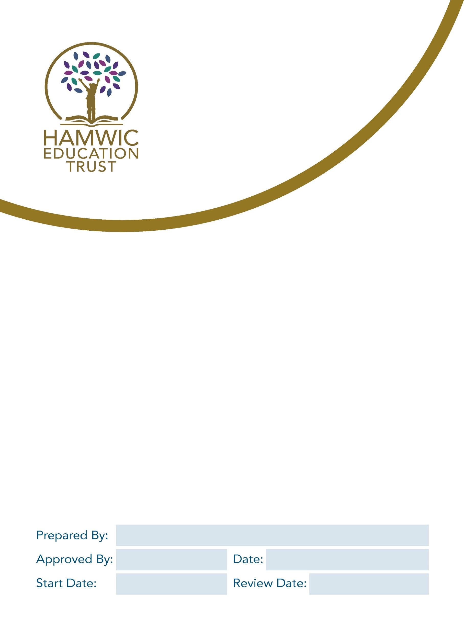

Sholing Junior School
Parent and Visitor Conduct Policy

M. Abbott

Jane Butler CoG
September 24
September 24
September 27

Introduction
- Sholing Junior School is founded on the principle of a positive and successful partnership between our school and parents; this is reflected in our approach to supporting learning, ensuring good attendance, providing enrichment and extra-curricular activities and working together to support pupils’ welfare.
- We understand that in some situations when working together to support children, parents and schools will have different views about what the approach should be. Usually, we find that constructive dialogue leads to a shared understanding of a situation and agreement about the way forward.
- On rare occasions, when parents or visitors behave inappropriately or unacceptably towards our staff or pupils, we need to take steps to resolve this, and this policy outlines our approach to this.

Purpose and scope
We will act to ensure Sholing Junior School is a safe place for pupils, staff and all other members of our school community.

We believe it is important to maintain positive relationships with all members of our school community and value our strong relationship with parents/carers which together helps us achieve the very best for the pupils in a mutually supportive partnership between parents, class teachers and the school community. If a parent/carer/visitor has concerns, we will always listen to them and seek to address them.
Our school staff strive to:
- Develop a positive partnership with parents to support the learning of our pupils.
- Create a safe, respectful and inclusive environment for pupils, staff and parents.
- Always model appropriate behaviour for our pupils.

To help us do this, we set clear expectations and guidelines on behaviour for all members of our community. This includes staff (through our staff code of conduct) and pupils (through our behaviour policy). This policy aims to help us work in partnership with parents, carers and other visitors by setting guidelines on appropriate behaviour.

This policy covers breaches of our code of conduct which occur:
- In the school buildings or on the school site
- By telephone to the school
- By email to the school
- On social media referring to the school
- In any other setting which, in the reasonable opinion of the school leader/chair of governors/HET, should be regulated by this policy.

Our expectations of parents/carers/visitors
We expect parents, carers and other visitors to:
- Respect the caring ethos, vision and values of our school.
- Work together with staff in the best interests of our pupils.
- Seek a peaceful solution to all issues.
- Communicate with the school in a respectful manner using appropriate non-aggressive or derogatory language.
- Treat all members of the school community with respect – setting a good example with speech and conduct.
- Correct their own child’s behaviour (or those in their care), particularly in public, where it could lead to conflict, aggression or unsafe conduct.
- Approach the right member of staff to help resolve any issues of concern.

Unacceptable conduct
Any form of communication that threatens the safety or well-being of our staff or pupils will be taken seriously and addressed immediately, with the goal of protecting our school community.

The following behaviours are considered unacceptable by the school:
- Disrupting, or threatening to disrupt, school operations (including events on the school grounds and sports team matches)
- Swearing or the use of other abusive, offensive or threatening language
- Displaying a temper, or shouting at members of staff, pupils or other parents
- Verbal or written threats of violence or harm to any member of the school community
- Physical violence, including damage to school property or injury to others
- Approaching someone else’s child to discuss or chastise them because of the (perceived/actual) actions of this child towards their own child
- Discriminatory conduct or use of discriminatory language (sexist, racist, other)
- Frequent, unwarranted and/or unnecessary correspondence which is hindering the proper running of the school
- Making deliberately false, malicious or vexatious accusations
- Defamatory, offensive or derogatory comments regarding the school or any of the pupils/parents/staff, at the school on Facebook or other social media sites
- Smoking or drinking alcohol on the school premises (unless alcohol has been allowed at a specific event).
- Possessing or being under the influence of alcohol or drugs while on the school premises.
- Bringing dogs onto the school premises (other than guide dogs).
- Any behaviour that violates the law or school policies
- Incitement of others to do any of the above

This is not an exhaustive list but seeks to provide illustrations of such conduct. It will ultimately be for the school to determine whether conduct is deemed to be unacceptable.

Note: Can parents please ensure they make all persons responsible for collecting their children aware of this policy
Inappropriate use of social network sites
- Any concerns you may have about the school, or your child must be made through the appropriate channels by speaking to the school or following the school complaints policy and procedure.
- Any inappropriate comments (including libellous or defamatory) made about the school, staff or pupils on any social media site will be reported to the appropriate ‘report abuse’ section of the site and the parent/carer will be asked to remove any such comment.
- The school take very seriously the use of cyber bullying by one child or a parent to publicly humiliate another by inappropriate social network entry. We will take and deal with this as a serious incident of school bullying.
- The school will consult with HET, to consider its legal options to deal with any such misuse on social networking and other sites.

Covert recordings
- Unless explicitly agreed in writing, the school does not consent to parents making audio or video recordings of any member of staff, governor or school volunteer, including during in-person meetings, remote/virtual meetings or telephone conversations.
- Making covert recordings without the consent of members of staff is regarded as a breach of the relationship of mutual trust and confidence between the parent and the school.
- If a parent is found to be recording a discussion, all members of staff have the right to terminate the meeting or telephone call immediately.
- A parent that records a member of staff, governor or school volunteer, without consent may be issued with a restricted communication plan (see below).
- If a parent is found to have recorded any audio or video footage on the school site without consent of any individual, this may result in the parent being immediately banned from the school premises and the involvement of external agencies.

Breaching the code of conduct
If the school suspects, or becomes aware, that someone has breached our code of conduct, we will gather information from those involved and speak to the person about the incident. The school leader will always try to respond to an incident in a proportional way.

Depending on the nature of the incident(s), the school may then:
- Invite the person into school to meet with a senior member of staff or the school leader
- Send a warning letter to the person
- Contact the appropriate authorities (in cases of criminal behaviour)
- Seek advice from Hamwic regarding further action
- Implement a restricted communication plan, stating the staff member(s) and communication method the person is allowed to use to contact the school
- Ban the parent from the school site; revoke their license to attend the premises

Whilst these sanctions are set out in the policy by way of a sequential process, they can be initiated at any stage if, in the reasonable judgement of the school, the severity of the behaviour warrants such a level of intervention. Where the behaviour is so extreme that it threatens the immediate safety and welfare of staff or others, the matter will be referred immediately to the police and trust.

A decision to ban a parent from the school site is a very serious one but unfortunately is necessary occasionally. The school leader will consult the chair of governors and/or trust before making such a decision. Decisions to ban are taken within the framework of the DfE Guidance and will be reviewed by the school. The letter banning the person from the school site will make clear how communications with the school can be maintained.

Linked Policies:
- Behaviour and Relationship Policy
- Child Protection and Safeguarding Policy
- Staff Code of Conduct Policy
- Health and Safety Policy
- Whistleblowing Policy

Other relevant guidance:
- DfE guidance for schools: Controlling access to school premises - GOV.UK (www.gov.uk)

This policy will be regularly reviewed considering changing circumstances.

Summary of actions in response to breaches of the Parent and Visitor Code of Conduct
Breach of Parent and Visitor Code of Conduct

Serious Criminal Act
All other breaches of the Code of Conduct

Police to be contacted immediately
Interaction, conversation or meeting terminated immediately.
Person asked to leave the school premises.

Following gathering of facts, all significant incidents will be reported to HET and shared with the Chair of Governors

Serious Criminal Act or Serious Breach

Person temporarily banned from the school premises and restricted communication plan may also be put in place
Minor Breach

Person issued with a warning letter and meeting may also be arranged to discuss the incident.

Information gathering and review of incident(s) by Chair of Governors and/or HET
Repeated breaches
of the code

Incidents involving alleged harassment or libel
Letter sent by Chair of Governors/HET confirming decision following review

School to seek legal advice via HET
(ban or restricted communication plan may be imposed)
Person coming onto school site once ban is imposed
plan
School will notify the police and seek legal advice via HET

